**Kubernetes:**

Docker and Kubernetes are two different technologies that server different purposes in modern software development.

Docker is a containerization platform that allows developers to package an application and its dependencies into a single unit called a container. This makes easy to deploy and run the application consistently across different environments.

Kubernetes, on the other hand, is an orchestration platform that helps manage and scale containerized applications. It automates the deployment, scaling and management of containerized applications and provides features such as load balancing, auto-scaling.

while docker provides a way to package and distribute applications, Kubernetes provides a way to manage and scale those applications in a distributed environment. Kubernetes also supports other container runtimes.

Kubernetes was initially designed by google and now it is maintained by CNCF (Cloud native computing foundation). It is written in Go Lang.

**Basic work of Kubernetes**:

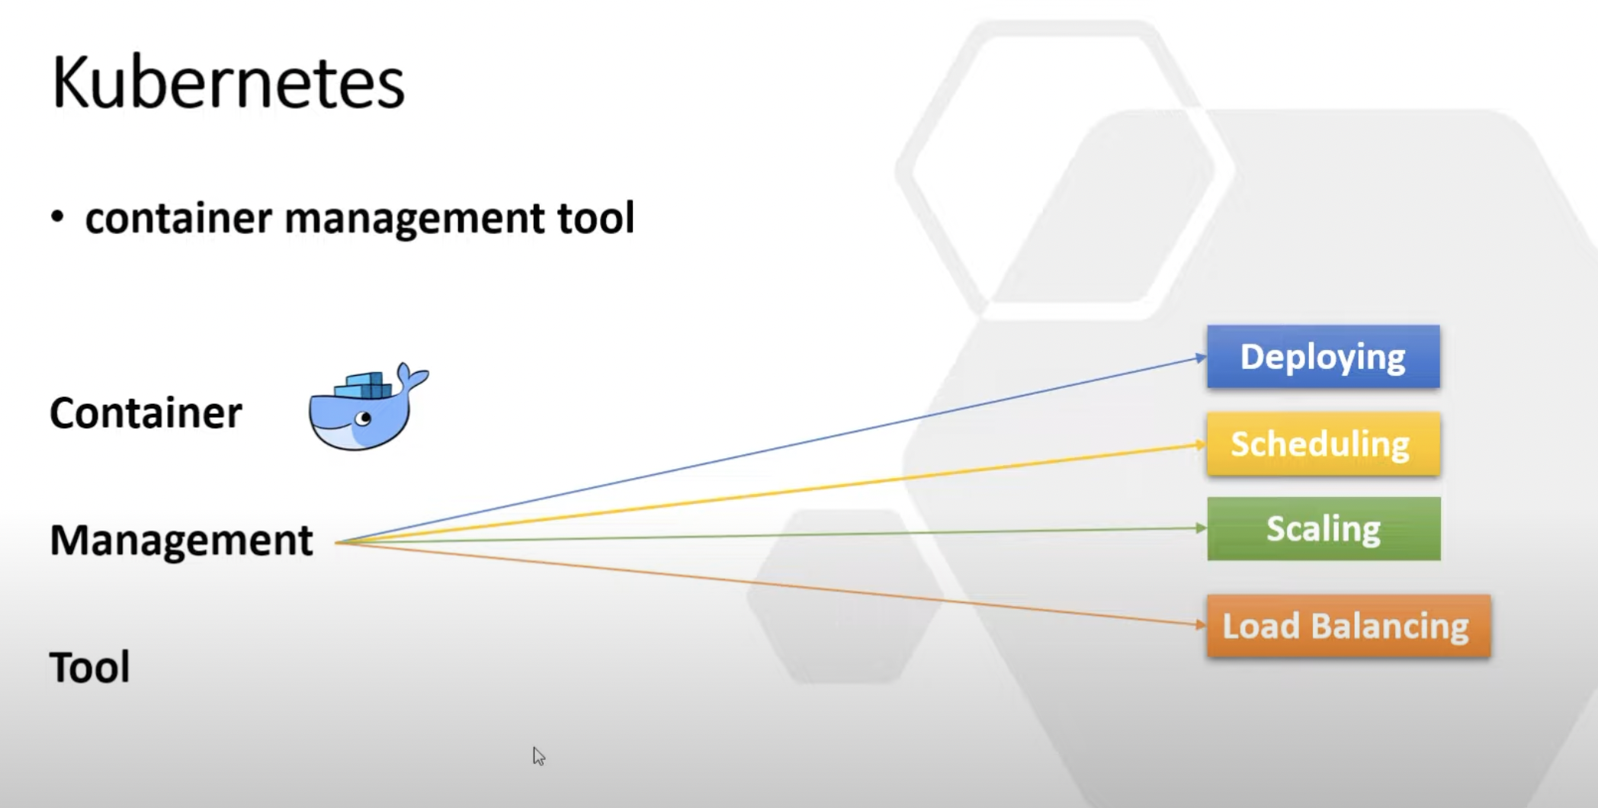

**Why Kubernetes comes into picture:**

Let’s take an example, we have 2 microservices and using one DB and these microservices are communicating with each other using Kafka. So, total we have 4 docker images:

1. Microservice1
2. Microservice2
3. Kafka
4. DB

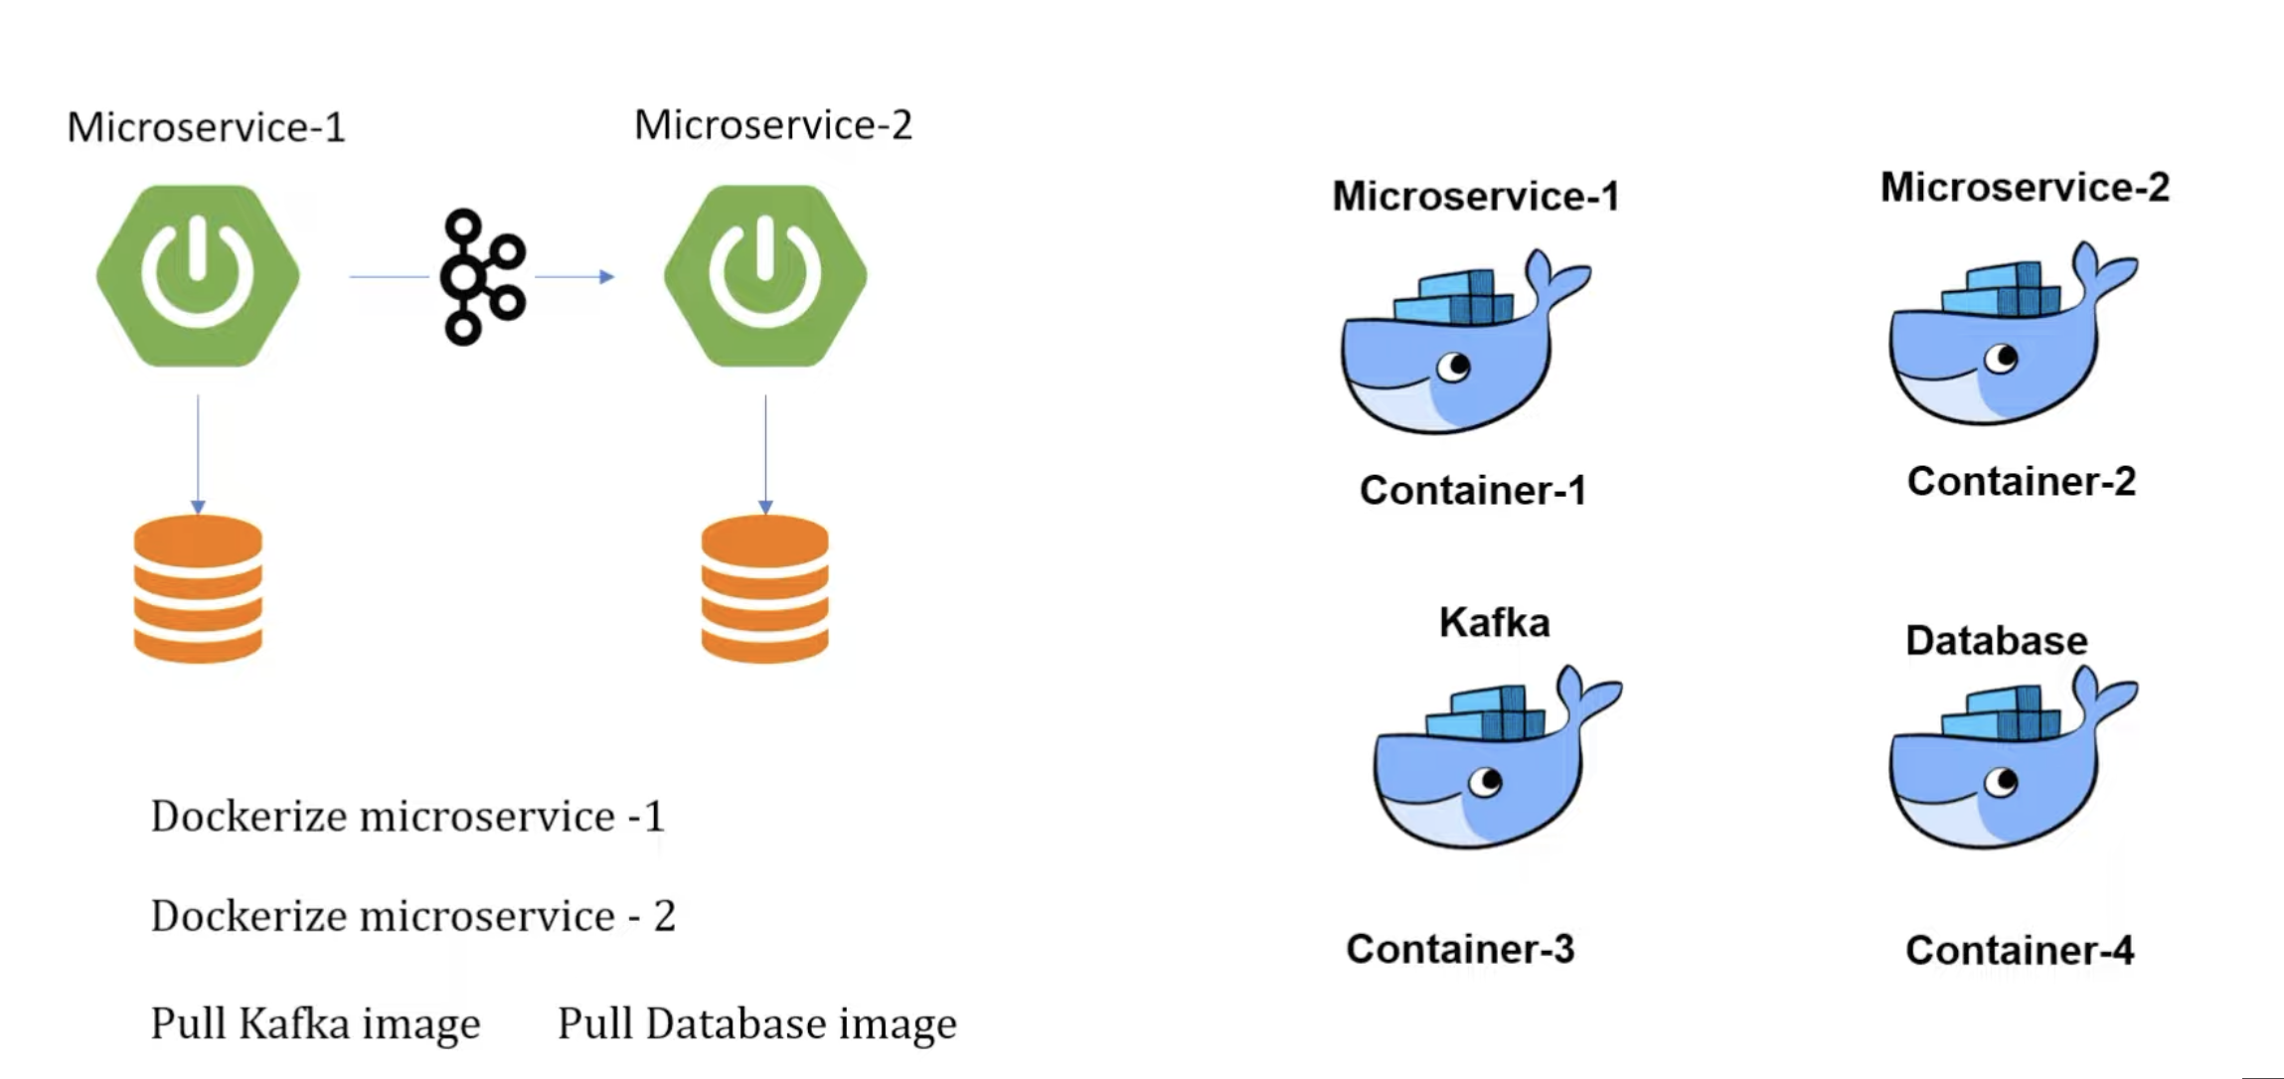

We can create the docker images of these 4 instances and deploy it to the containers. Now, we have only 4 containers so we can manage it but in actual like Walmart, amazon there are multiple containers which are communicating with each other and it’s very difficult to manage. When we are talking about managing the things, we are doing below things:

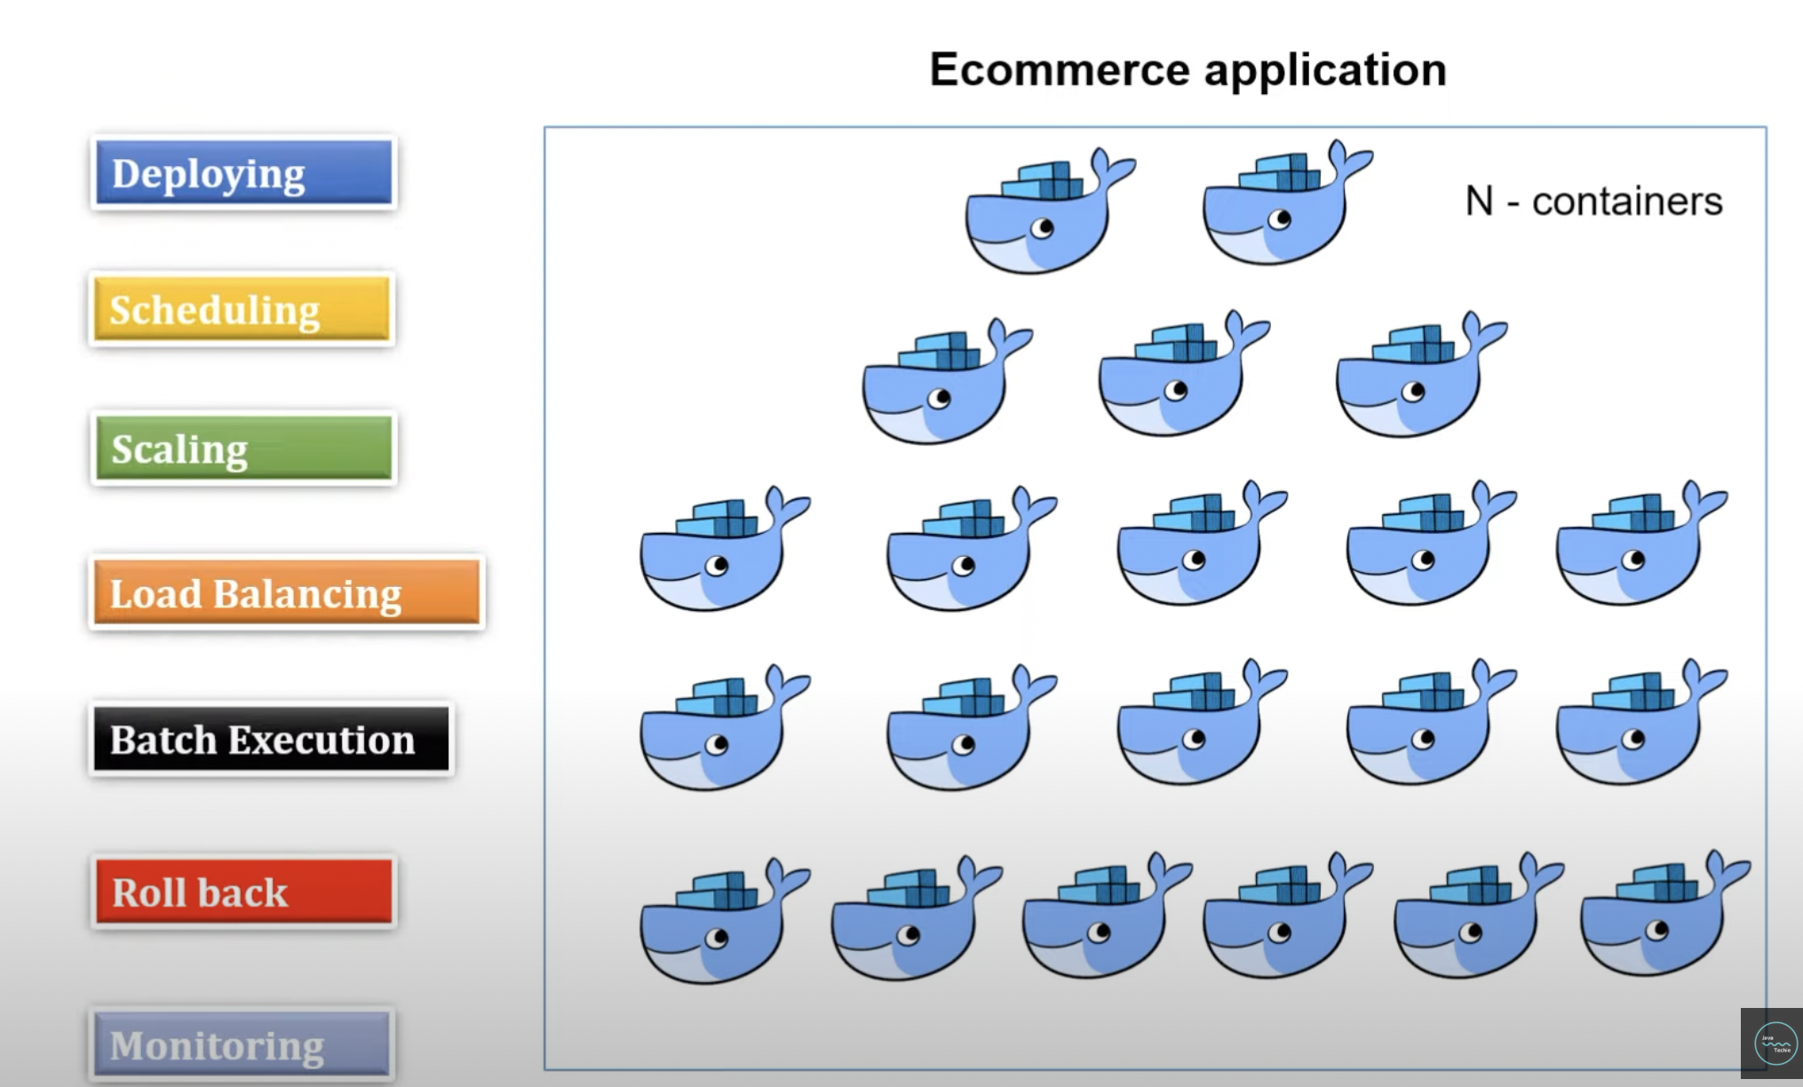

You just need to create the docker image everything else will be manage by Kubernetes itself. There are other tools like docker-compose, marathon is also available in the market, but Kubernetes is widely used in the market because it also provides deploying, scheduling, scaling etc. features.

**Components of Kubernetes:**

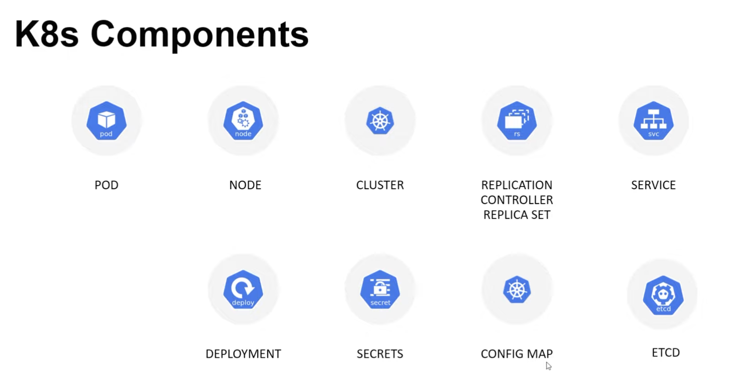

**Let me explain these components:**

1. **Pod**: Kubernetes don’t interact with containers directly. When we are talking about container it means the docker image that we deploy on some container. First, we create the docker image of spring boot application and after that we deploy it on some container. So, these containers are managed by the Kubernetes, but Kubernetes don’t interact with these containers directly. Containers are wrapped into the functional unit that is called pod. Pod can have one or many containers and each pod has IP address on the behalf of this IP address they interact with other pods.

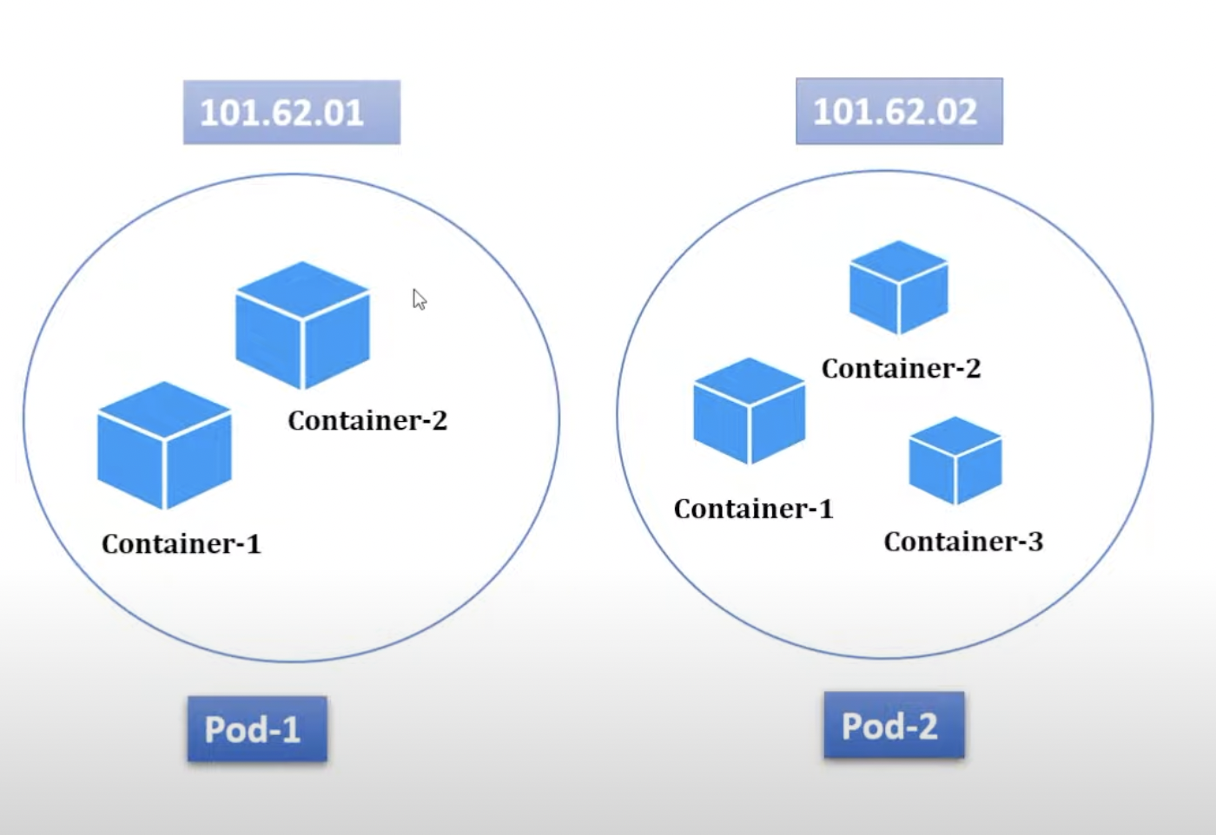

1. **Node:** There is another virtual machine, where all pods are wrapped into single unit that is called node. Node can have single pod or many.

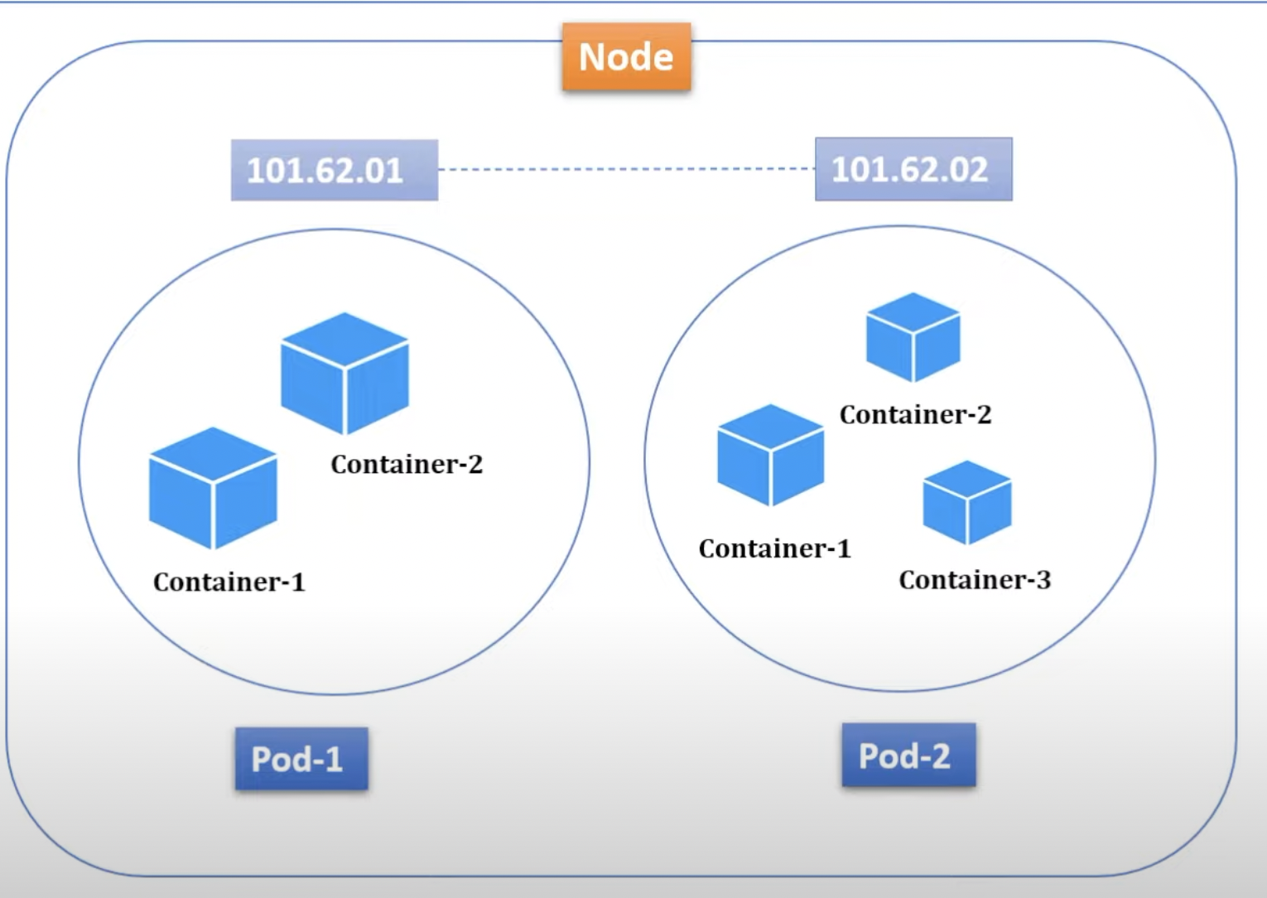

1. **Cluster**: Multiple nodes are wrapped into one unit is called cluster. Cluster can either have single or multiple nodes. Cluster is comprised of one **master node** and multiple **worker nodes**. These nodes either can have physical computers or virtual machines depending on the cluster you have created.
2. **Replication Controller/ Replica sets**: As we discussed pods run under the node and each pod is associated with unique IP address. Suppose I have one Database docker image into one pod. Our spring boot is interacting with this DB pod but to some reason suppose network issue this pod got crashed so how our spring boot app with interact with this pod? So, to avoid this issue there is a concept of replica sets, in which we mention that we need n number of replicas of this pod. In-case, it got crashed at the same time, it creates a new pod and assign IP to it and our spring boot app will interact with that pod. So, this way there is no downtime for spring boot app.

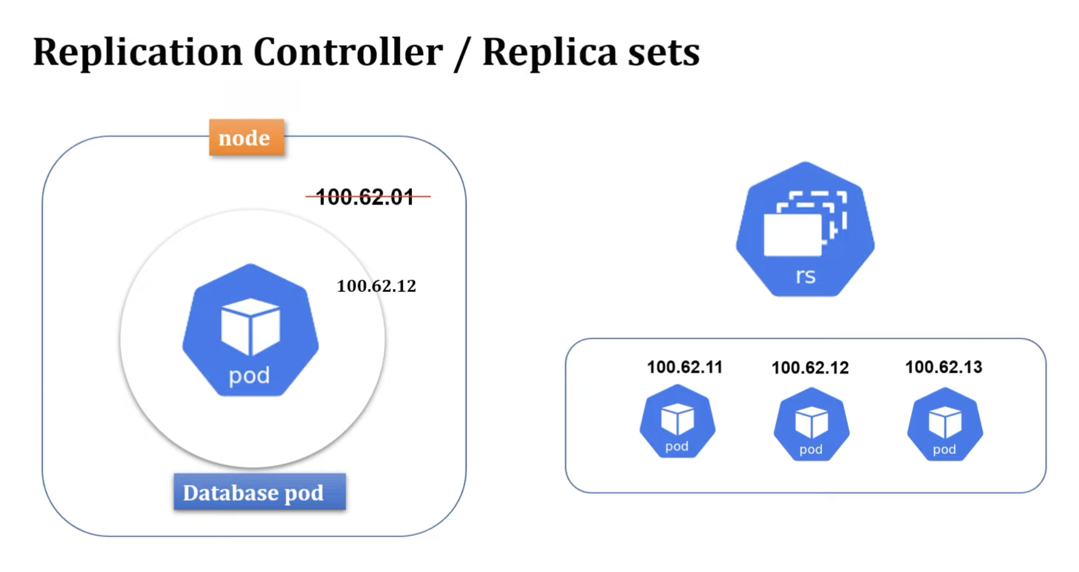

1. **Service**: Suppose we have a node, in which we have 2 pods (frontend, backend). Frontend connects with backend to display the things but due to some reason our backend app goes down. We know, in this case replica set will start the new pod and new IP will assign to it and now fronted will use this pod to connect with to display the things but suppose it goes down continuously so IP address will change suddenly, and, in this way, our frontend will not work. So, to avoid this issue, service comes into the picture. It will provide the DNS name so instead of using IP address we can use the DNS name and it will not change even though our IP address changes continuously.

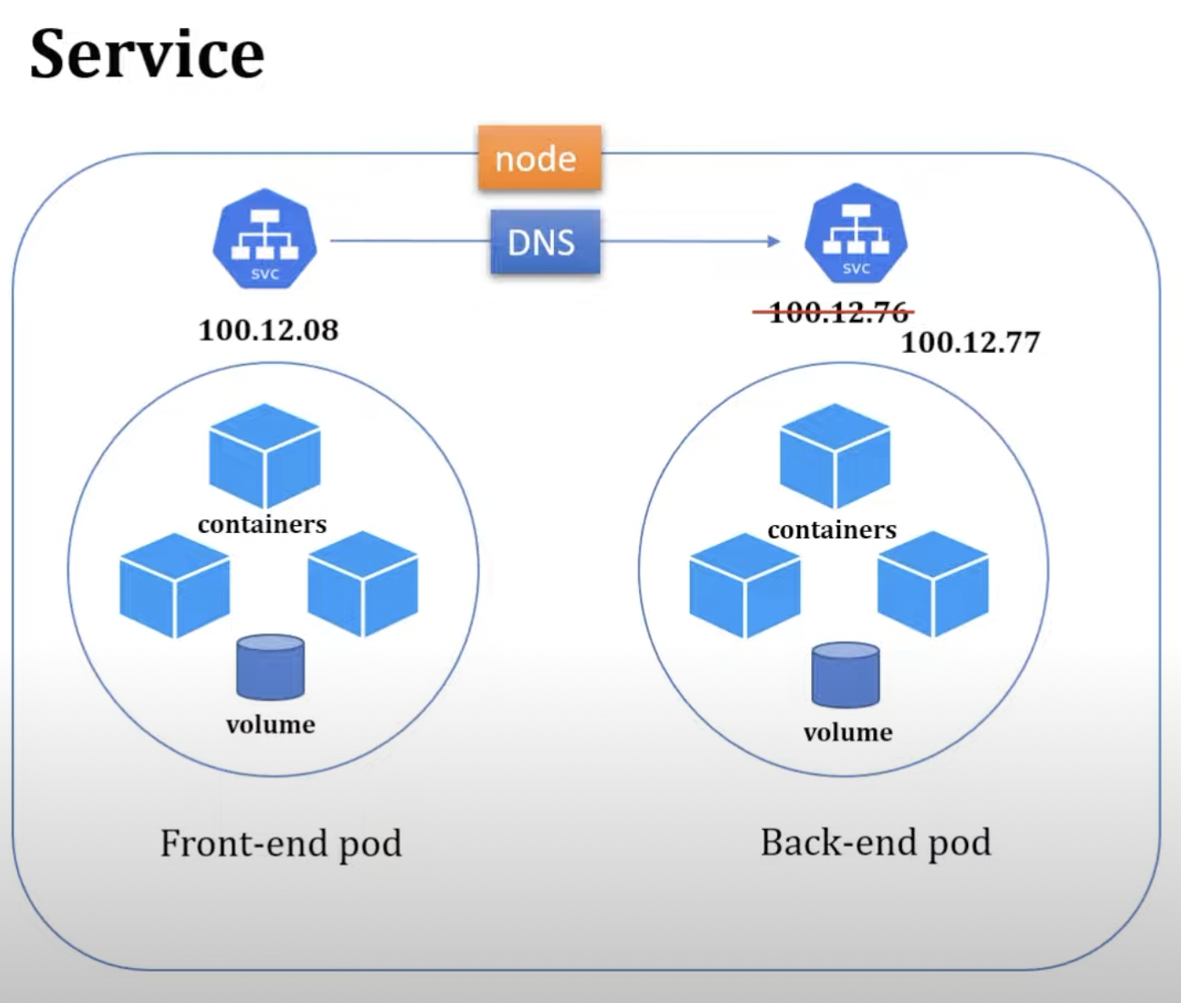

Service also plays the role of load balancer where traffic coming to the service will handle and it redirect to the available pod. There are different types of service available.

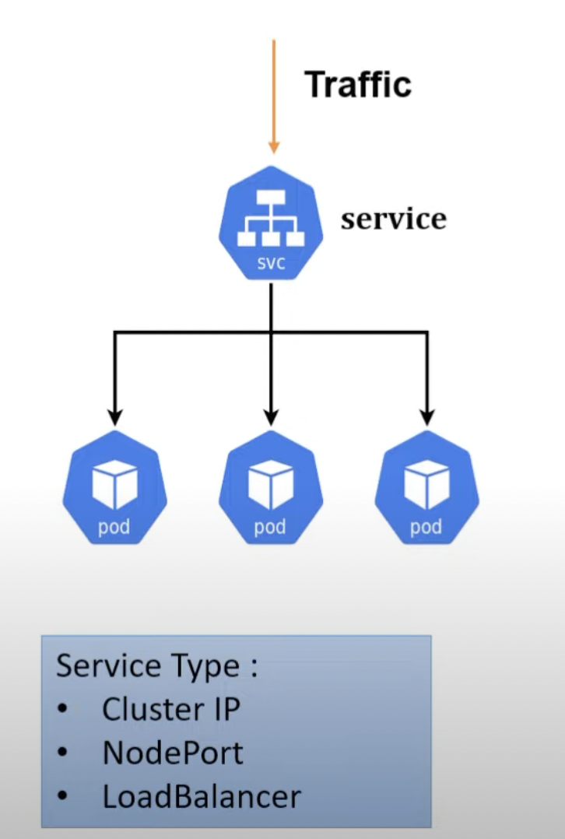

1. **Deployment**: are the Kubernetes object that are used for managing the pods. You can scale your application by increasing the number of running pods or update the running application using deployment object:



1. **Secrets and ConfigMap**: These properties are external from pod. There is a reason behind this. Suppose we want to change the credentials and after changing credentials we need to create the docker image of spring boot and then containerized it and then we will create the pod for it. So, just changing of credentials we are doing everything from scratch so it’s good to put credentials somewhere on different location instead of putting it inside the pod. Moreover, due to security reason, it’s not a right approach to put credentials in the **application. properties** file. Suppose we have MySQL credentials so we will save the username, driver inside the ConfigMap because it is in plain text and password we will save into the secret in encrypted form.
2. **ETCD**: Kubernetes uses etcd as a key value database store. It stores the configuration of the Kubernetes cluster in etcd. It stores all the secret and ConfigMap data inside etcd database. The maximum limit to store secrets is 1MB.

**Master node and worker nodes explanation:**

Let’s take an example of Manager. What are the roles and responsibilities of manager:

1. Manager will monitor all projects are running smoothly or not.
2. Manager will check whether all developers are working or not.
3. If any developer left the project, immediately he will assign a new resource.
4. If any project closed/completed, then immediately he will tag all developers to new project.

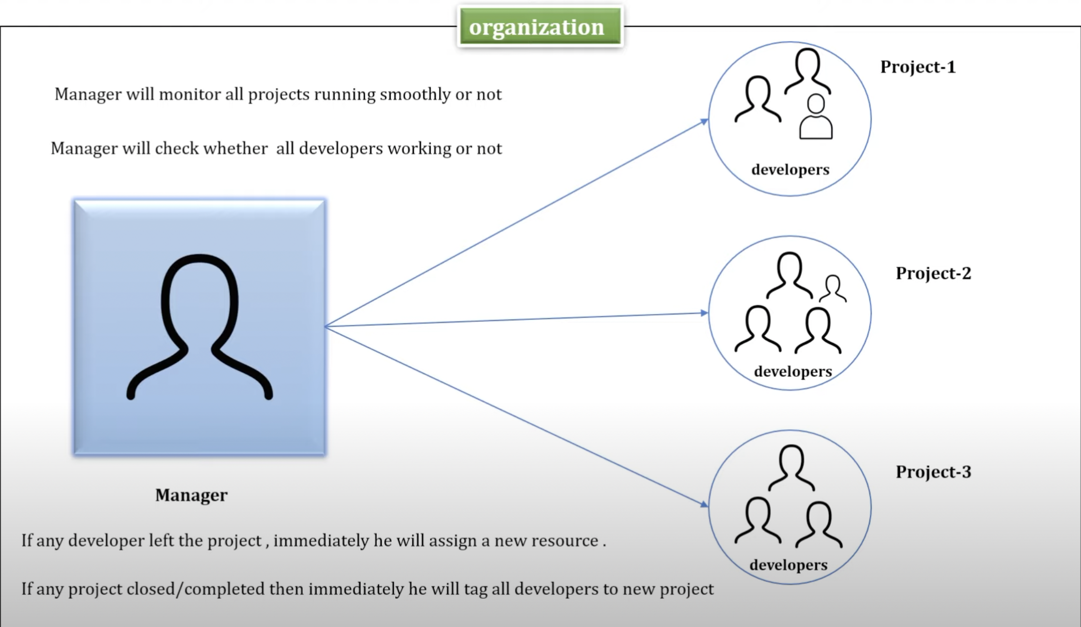

Here are some jobs that is done by master node:

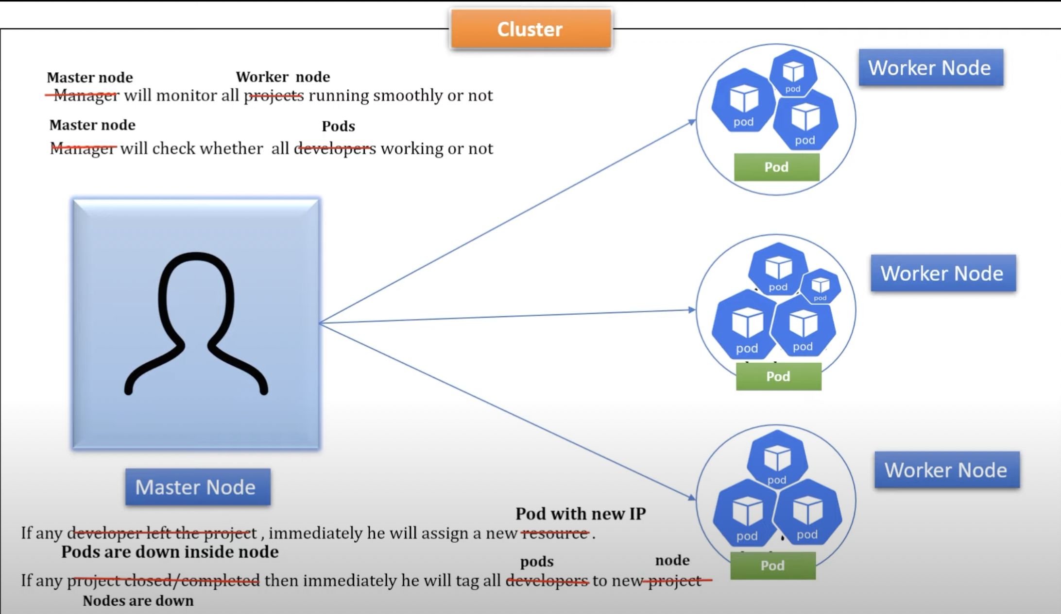

In Kubernetes, there should be at least one cluster, one master node and one worker node. Master node basically manage the cluster and it basically monitor nodes and pods. Master node has 4 components mentioned below:

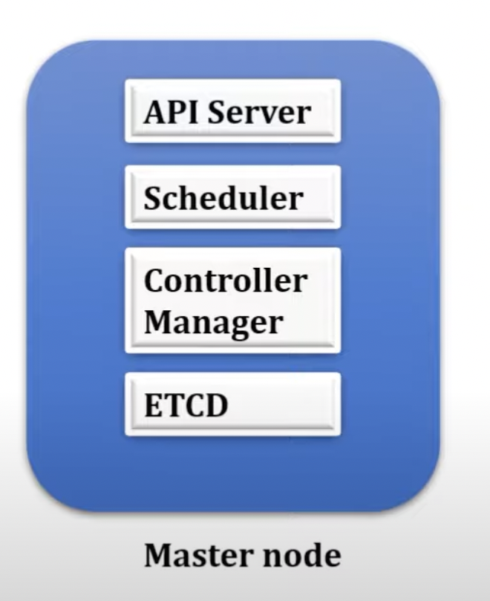

**API server:** It will act as Cluster gateway; the any request comes to the cluster will first come to API server. API servers expose few APIs to access all the operations going under the cluster. You can access API server using command line tool called Kubectl or K8s UI. Suppose I want to check the status of pods and nodes. We can check it using command:

1. Kubectl get nodes
2. Kubectl get pods

When we hit these commands, it will not go directly to the worker node to check the status of nodes and pods. The API server will check the status of nodes and pods using its endpoints and

It will give you the status of nodes and pods.

**Scheduler:** It plays an important role in master node. If you want to scale up your application so in this case scheduler can help you. We know that to scale up the application we need to increase the count of pods. So, it will check the memory usage of nodes. Suppose in one node there are 4 pods and, on another node, only 2 pods are running then it will start the new pod inside the node2 because node1 memory and CPU usage is already more.

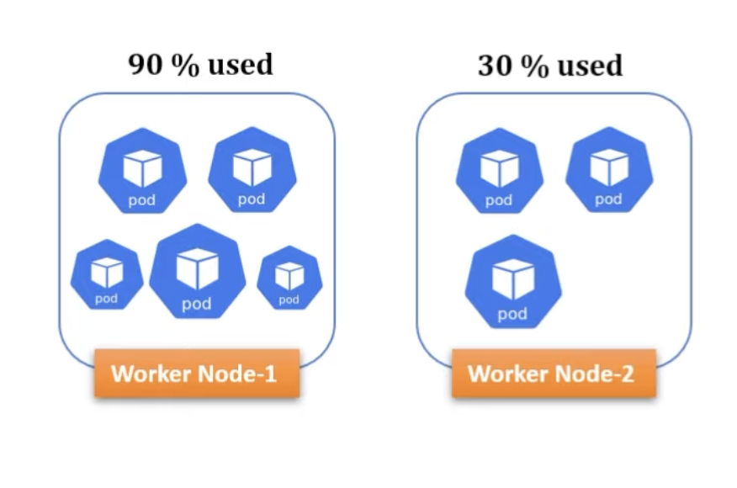

So, now you have question so how scheduler knows all the information about worker nodes CPU and memory usage. We all know that Kubernetes internally use the ETCD database to store the states like cluster, so it knows all the information of nodes and pods. API server using its APIs get this information from ETCD and share this information with scheduler.

**Controller Manager:**

It detects cluster states changes when pod/node is crashed. When pod crashed then Kubernetes bring up a new pod from replica set and then controller manager will talk to the scheduler to add new pod on the available node. Controller manager manages the multiple controllers:

1. Node controller: it monitors all nodes activity.
2. Replication controller: monitor health of pod. If any pod down, then create new.
3. Endpoint controller: manage their communication.
4. Service account & token controller: manage account and api access namespace.

**Worker node:**

It is virtual or physical machine; in worker node we have pods which can be 1 or more than 1.

It has 3 components:

1. Kubelet
2. Kube-proxy
3. Container runtime

**Kubelet**: it is an agent running on each node, and Kubelet communicate with master node using API server.

The Kubelet works in terms of podSpec. A podspec is yaml or json object that describes about your pods.

Kubelet does not manage the containers which were not created by Kubernetes.

**Kube-proxy** is a network agent which runs on each node, and it is responsible for maintaining network configuration & rules. These rules allow network communication to your pods from inside or outside of your cluster.

**Container runtime:**

A container runtime, also known as container engine and it helps to run container inside pods.

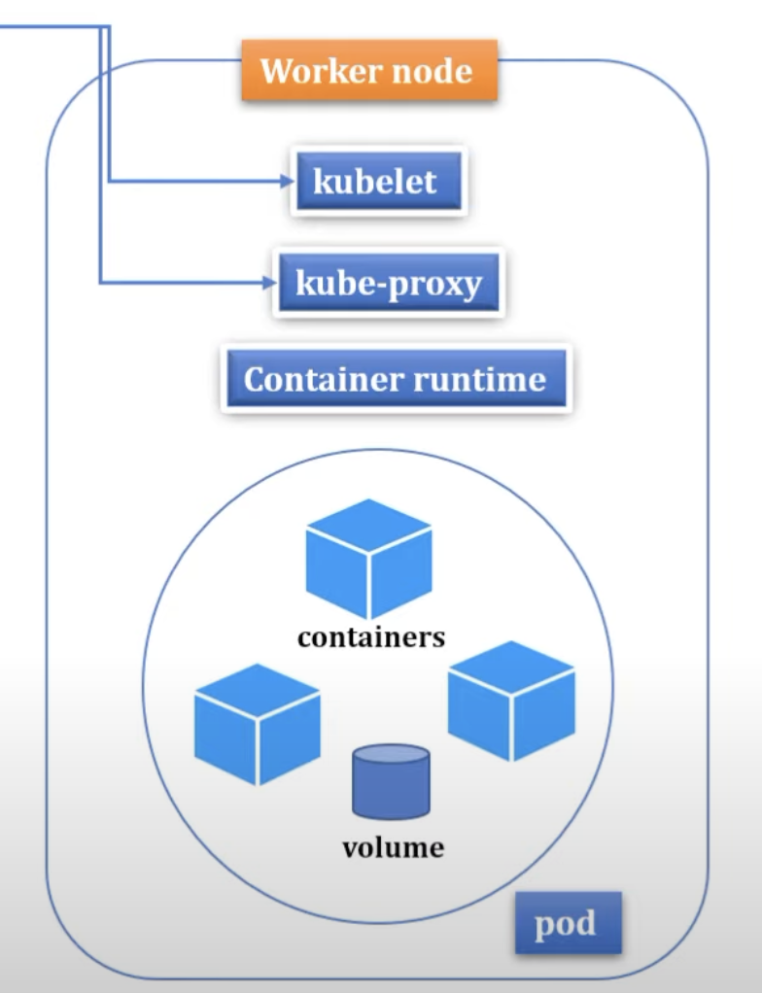

Worker nodes communicate with API server of master node with the help of Kubelet and kube proxy.

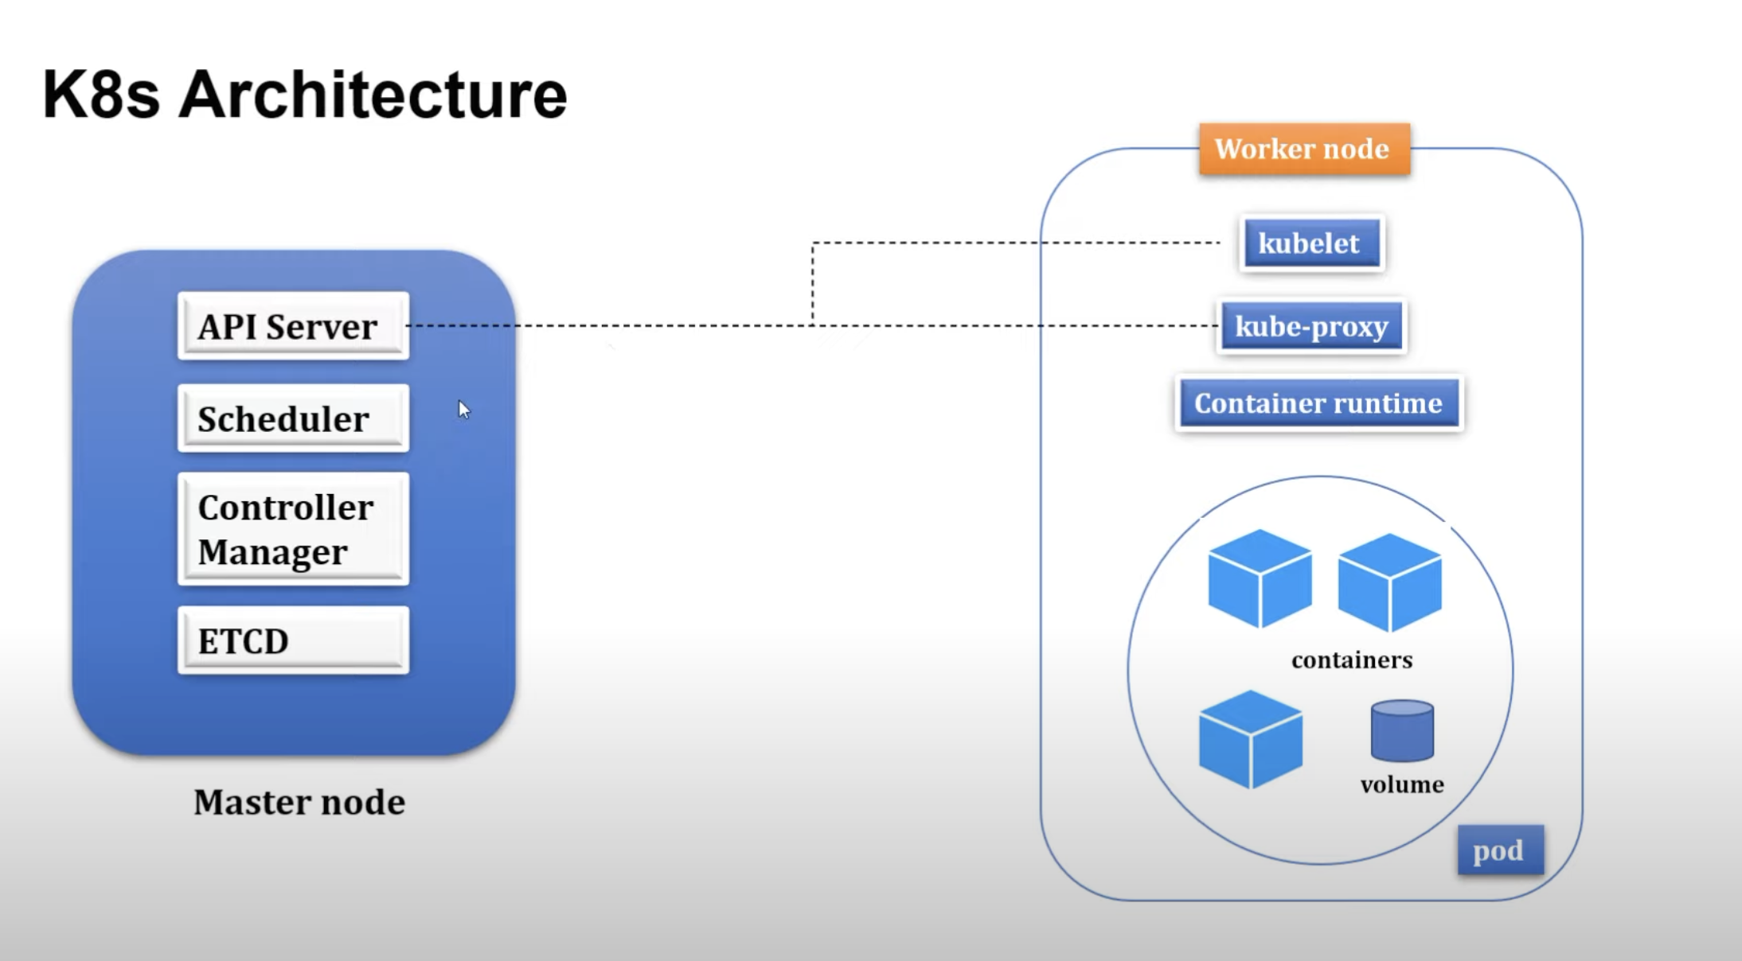

**Spring boot app with Kubernetes**:

Watched video of shiva labs you tube.

1. We are creating spring boot app with java 17  
2. In Controller, we pass the request param as page to get the list in desc order.  
Means, the page added into the last will display first in the list.  
  
For instance:  
  
{  
"id": 5,  
"title": "Maninder5",  
"url": "dataguise5.com",  
"createdAt": "2023-03-31T16:10:40.496042Z"  
},  
{  
"id": 4,  
"title": "Maninder4",  
"url": "dataguise4.com",  
"createdAt": "2023-03-31T16:10:40.495632Z"  
}  
  
id 5 will display first.  
  
In the service layer, we have defined the property for pagination:  
Pageable pageable = PageRequest.of(pageNo,5, Sort.Direction.DESC,"createdAt");  
  
it means that only 5 records will display on one page. Suppose we have 10 records and we set the page  
size to 5. So, first page we will see only 5 records of latest. If you want to see another records  
just pass the page no as 2.  
  
<http://localhost:8080/api/bookmarks?page=2>  
  
it will display the data present on 2 page.  
  
So, in addition to the data display on pages, we need more information like:  
how many pages are available.  
how many total elements.  
current page  
does it has next page or not: return it Boolean  
does it has previous page or not: return it Boolean.  
is it first page: return it true or false.  
is it last page: Boolean return  
  
3. To achieve this, we created one dto class called "BookMarkDto".   
4. And change the return type for method getBookmarks in service layer with BookMarkDto.  
  
Now output will be like this:  
  
{  
"id": 2,  
"title": "Maninder2",  
"url": "dataguise2.com",  
"createdAt": "2023-03-31T17:47:01.532387Z"  
},  
{  
"id": 1,  
"title": "Maninder1",  
"url": "dataguise1.com",  
"createdAt": "2023-03-31T17:47:01.510997Z"  
}  
],  
"totalElements": 10,  
"totalPages": 2,  
"currentPage": 2,   
"hasNext": false, It does not have next page because total pages are 2.  
"hasPrevious": true, //It has previous page called 1.  
"isFirst": false, //Is it first page. Ans is no.   
"isLast": true //Is this last page. Ans is yes.  
}  
  
5. Next step, we will create DTO class, to display the data because meantime we are just displaying  
the entity data and that is not a right approach. Sometimes, we don't want to display  
all the data. We just need to display only the important data. In that we use dto  
concept.  
  
After creating the Mapper, we just pass it in the service layer:  
Converting all the parameters to dto using map  
  
Page<BookmarkDto> bookmarkDtoPage= bookmarkRepository.findAll(pageable).map(bookmarkMapper::toDto);  
  
Still here, we are loading all the data first and then mapping it.  
For instance: bookmarkRepository.findAll(pageable), we are doing this in above query.  
That is not a right approach, because it loads all the data from database first and then  
we map it. Instead of this, we can write new method in repository layer with custom data  
that will load only required data.  
  
we can do this way:  
  
@Query("select new io.reactivestax.kubernetes.dto.BookmarkDto(b.id, b.title, b.url, b.createdAt) from Bookmark b")  
Page<BookmarkDto> findBookmarks(Pageable pageable);  
  
  
benefit of using dto class over entity:  
1. The main benefit of doing so is to avoid exposing sensitive or unnecessary  
information to the outside world.  
2. Entity classes typically represent the persistence layer and are used  
to map objects to database tables. They often contain sensitive information,   
such as primary keys, foreign keys, and other fields that should not be  
exposed to the outside world  
  
3. By creating a separate DTO class, you can control exactly what information  
is exposed to the outside world. This can be particularly important when designing  
REST APIs,as you want to ensure that only the necessary information is being exposed to clients  
  
4. Another benefit of using DTOs is that they allow you to decouple the internal representation  
of your data from the external representation. This means that you can change the internal  
representation of your data (e.g., by adding or removing fields) without affecting the external  
representation (i.e., the DTO).  
  
6. Now, we will write the integration test cases for it. I already added comments for explaining  
the integration test cases.  
  
7. After writing the test cases, It's the time for dockering the spring boot app to docker.  
8. We used to create the DockerFile for dockering the spring boot app and then do docker  
build.  
9. Instead of that, we can follow the new approach for it:  
We already added the maven plugin into the pom file. We can also add  
the image name that we want for this boot app into this plugin like  
below:  
  
<plugin>  
<groupId>org.springframework.boot</groupId>  
<artifactId>spring-boot-maven-plugin</artifactId>  
<configuration>  
<image>  
<name>maninder40407/spring-boot-bookmarks</name>  
</image>  
<excludes>  
<exclude>  
<groupId>org.projectlombok</groupId>  
<artifactId>lombok</artifactId>  
</exclude>  
</excludes>  
</configuration>  
</plugin>  
  
10. Now, we need to run the command for dockering the spring boot app:  
./mvnw spring-boot:build-image  
  
It will created the docker images on spring boot app with name mentioned  
in plugin: "maninder40407/spring-boot-bookmarks"  
  
11. After that, run command:  
docker run -p 8080:8080 maninder40407/spring-boot-bookmarks   
  
12. Our spring boot app is up and working on port 8080.  
  
13. As mentioned above, we created the docker image using maven plugin, the same  
thing we can also achieved through the JIB plugin.  
  
we need to add the JIB plugin first:  
  
<!--JIB plugin configuration-->  
<plugin>  
<groupId>com.google.cloud.tools</groupId>  
<artifactId>jib-maven-plugin</artifactId>  
<version>3.2.1</version>  
<configuration>  
<from>  
<image>openjdk:17-alpine</image>  
</from>  
<to>  
<image>maninder40407/bookmarker-api-jib</image>  
<tags>  
<tag>latest</tag>  
<tag>0.0.1</tag>  
</tags>  
</to>  
<container>  
<ports>  
<port>8080</port>  
</ports>  
</container>  
</configuration>  
</plugin>  
  
In this plugin, we mentioned the docker image name with tags along with the port on which it will run.  
and we are using base image of "openjdk:17-alpine"  
  
After adding this plugin, run the below mentioned commands:  
1. mvn clean package  
2. ./mvnw jib:build  
  
The second command will create the image and will store it into the docker hub not on the local.  
  
if you want to create the image on locally, then run this command:  
1. mvn clean package  
2. ./mvnw jib:dockerBuild  
  
you can also provide the custom name, along with this build for docker image:  
./mvnw jib:dockerBuild -Dimage=maninder40407/bookmarker-api-new-custom  
  
Now run the docker image:  
docker run -p 8080:8080 maninder40407/bookmarker-api-new-custom  
  
15. Meantime, we are applying filter on the behalf of pageNo.Now, we are adding one more  
parameter called query. On the behalf of it, we can filter out the data that we need.  
Suppose, there is list of fruits for example, apple,mango, grapes and we need only  
grapes, so in this case, we can sort out the data on the behalf of grapes.  
  
Using query parameter, we can write query like this:  
  
@Query("""  
select new io.reactivestax.kubernetes.dto.BookmarkDto(b.id, b.title, b.url, b.createdAt)  
from Bookmark b where lower(b.title) like lower(concat('%', :query, '%'))  
""")  
  
  
and using it, we can pass the query in parameter:  
<http://localhost:8080/api/bookmarks?query=boot>  
  
it will return only those titles, in which it gets boot as a word.  
  
In above way, we have writen the query but same thing we can also achieved through the method naming  
conversion provided by the JPA:  
  
Method name should be like. In this case, there is no need of providing the query parameter.  
Page<BookmarkDto> **findByTitleContainsIgnoreCase**(String query, Pageable pageable);

Here, we are doing the Github Action setup as we are providing the docker username and password that is required in yml file:

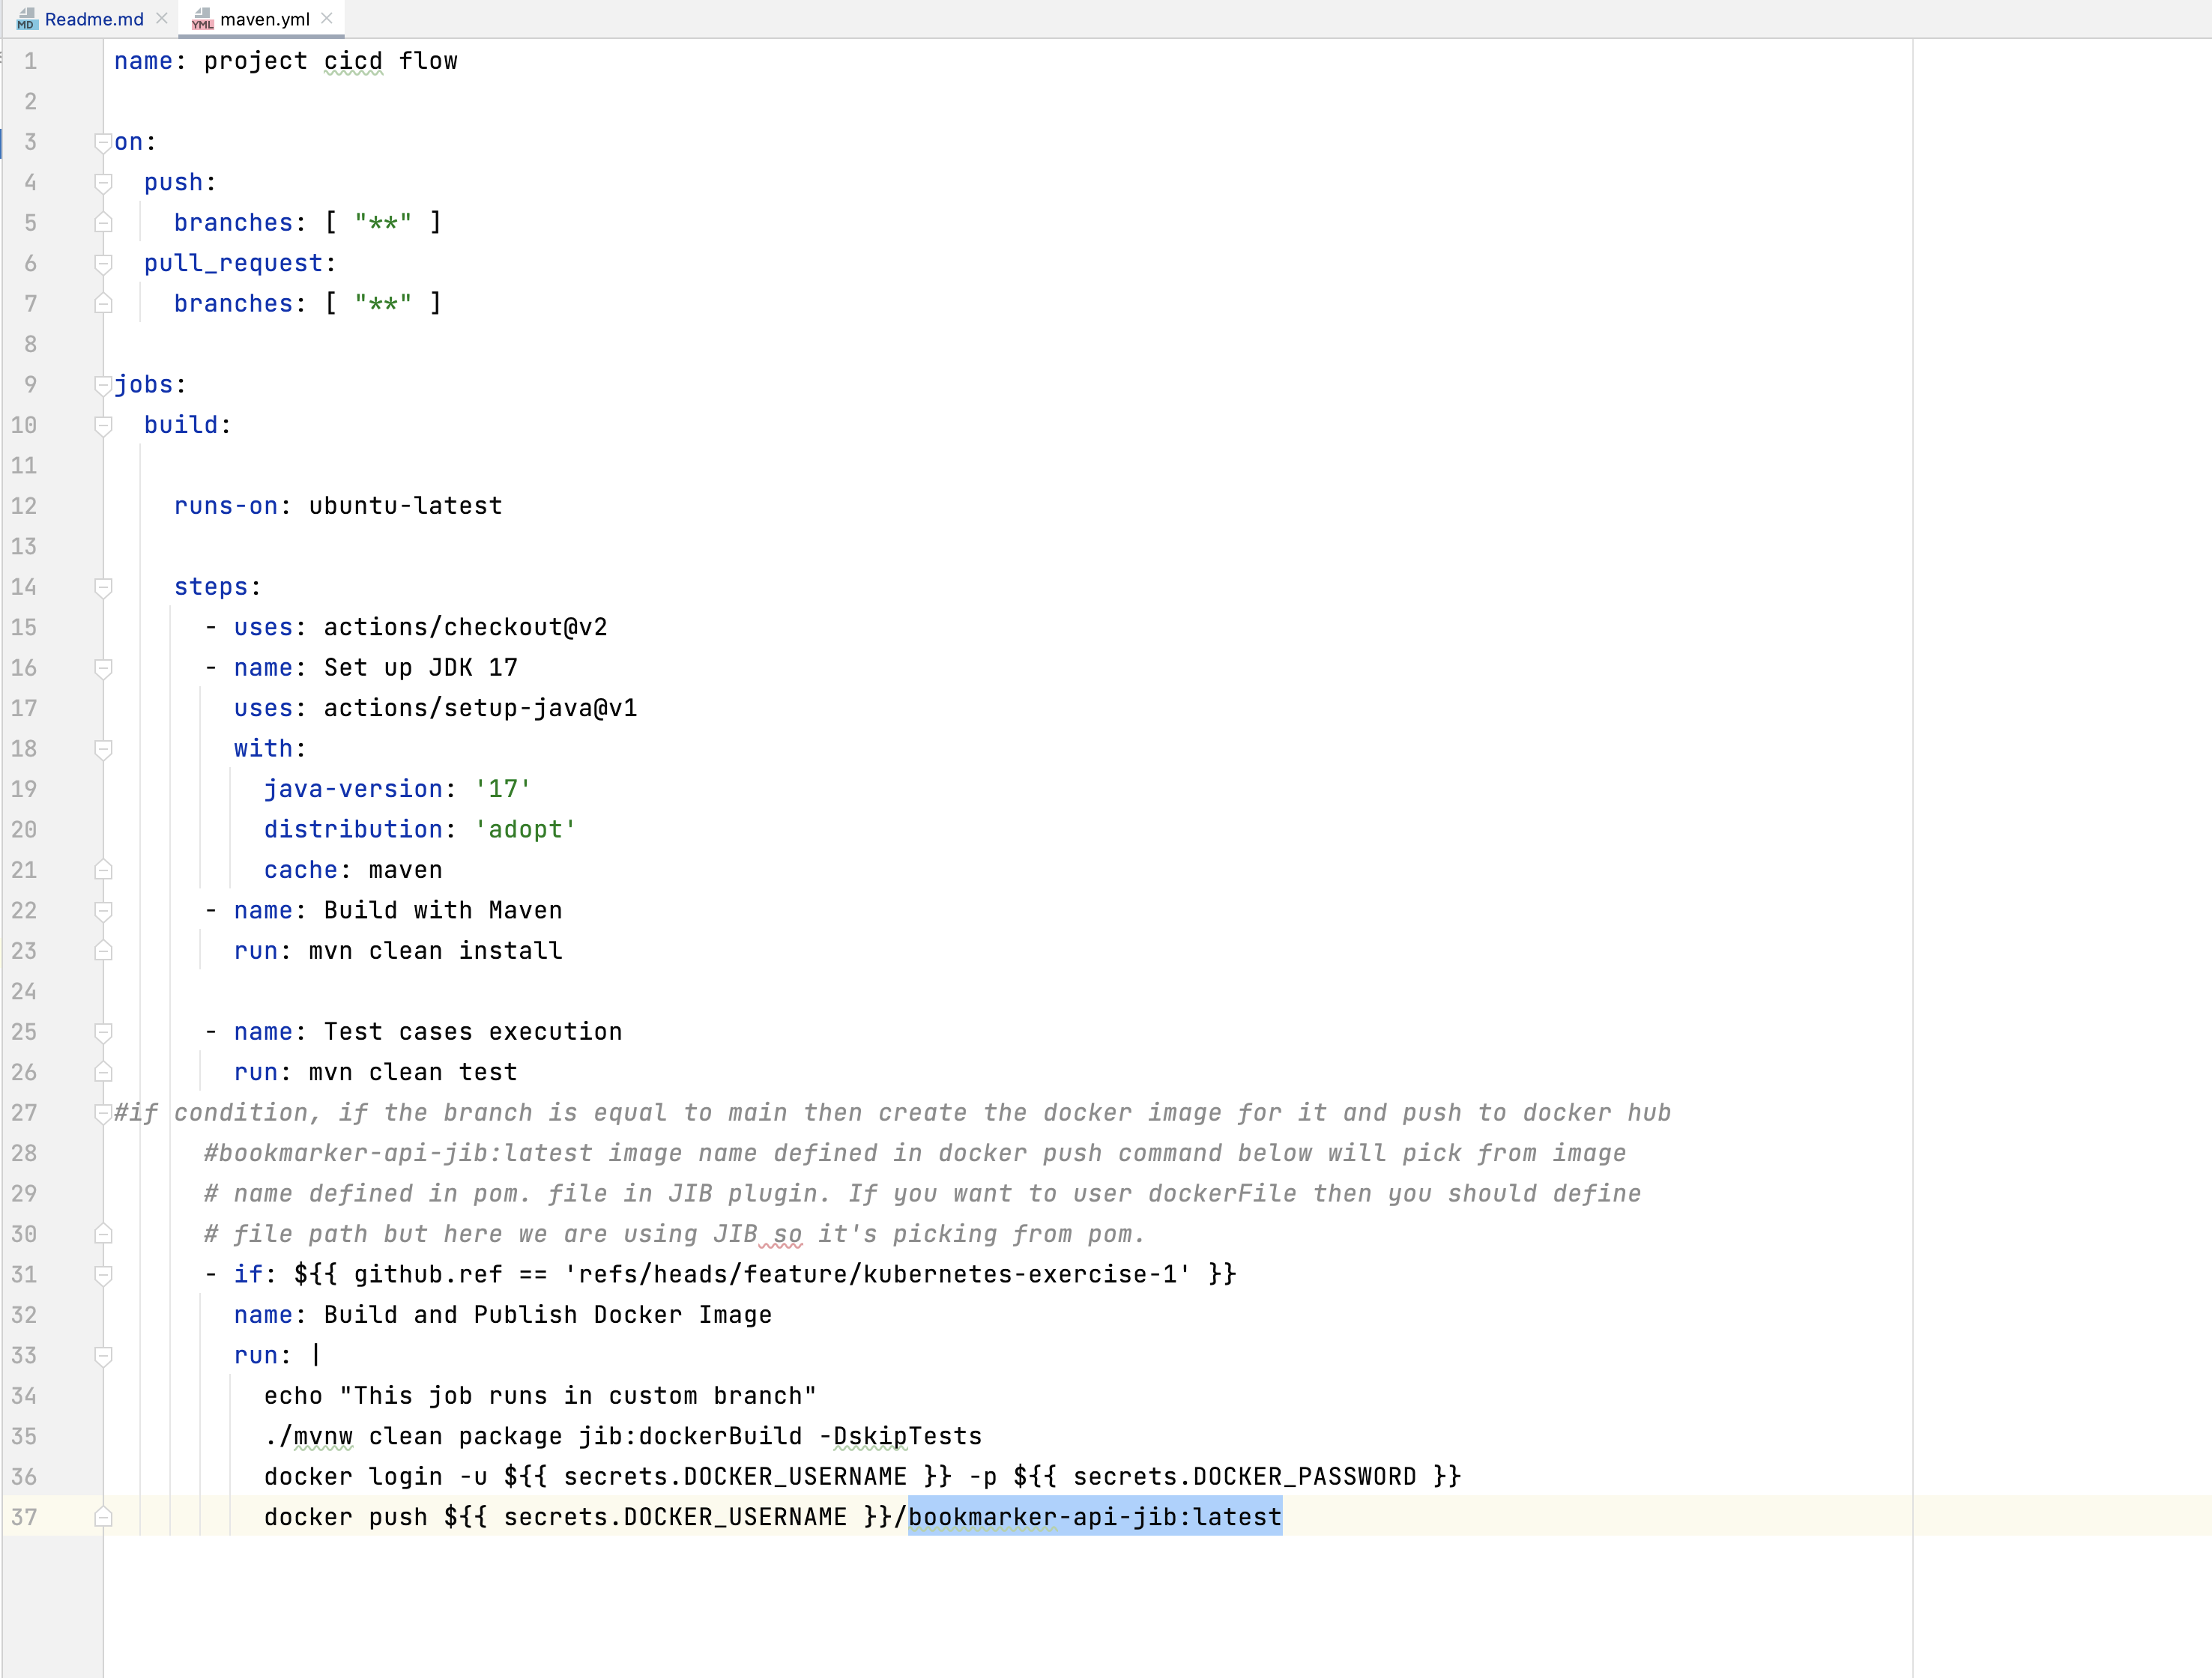

line no, 36, we need docker username and password. That setup we will configure here.

Steps:

1. Go to your repo and go under security.

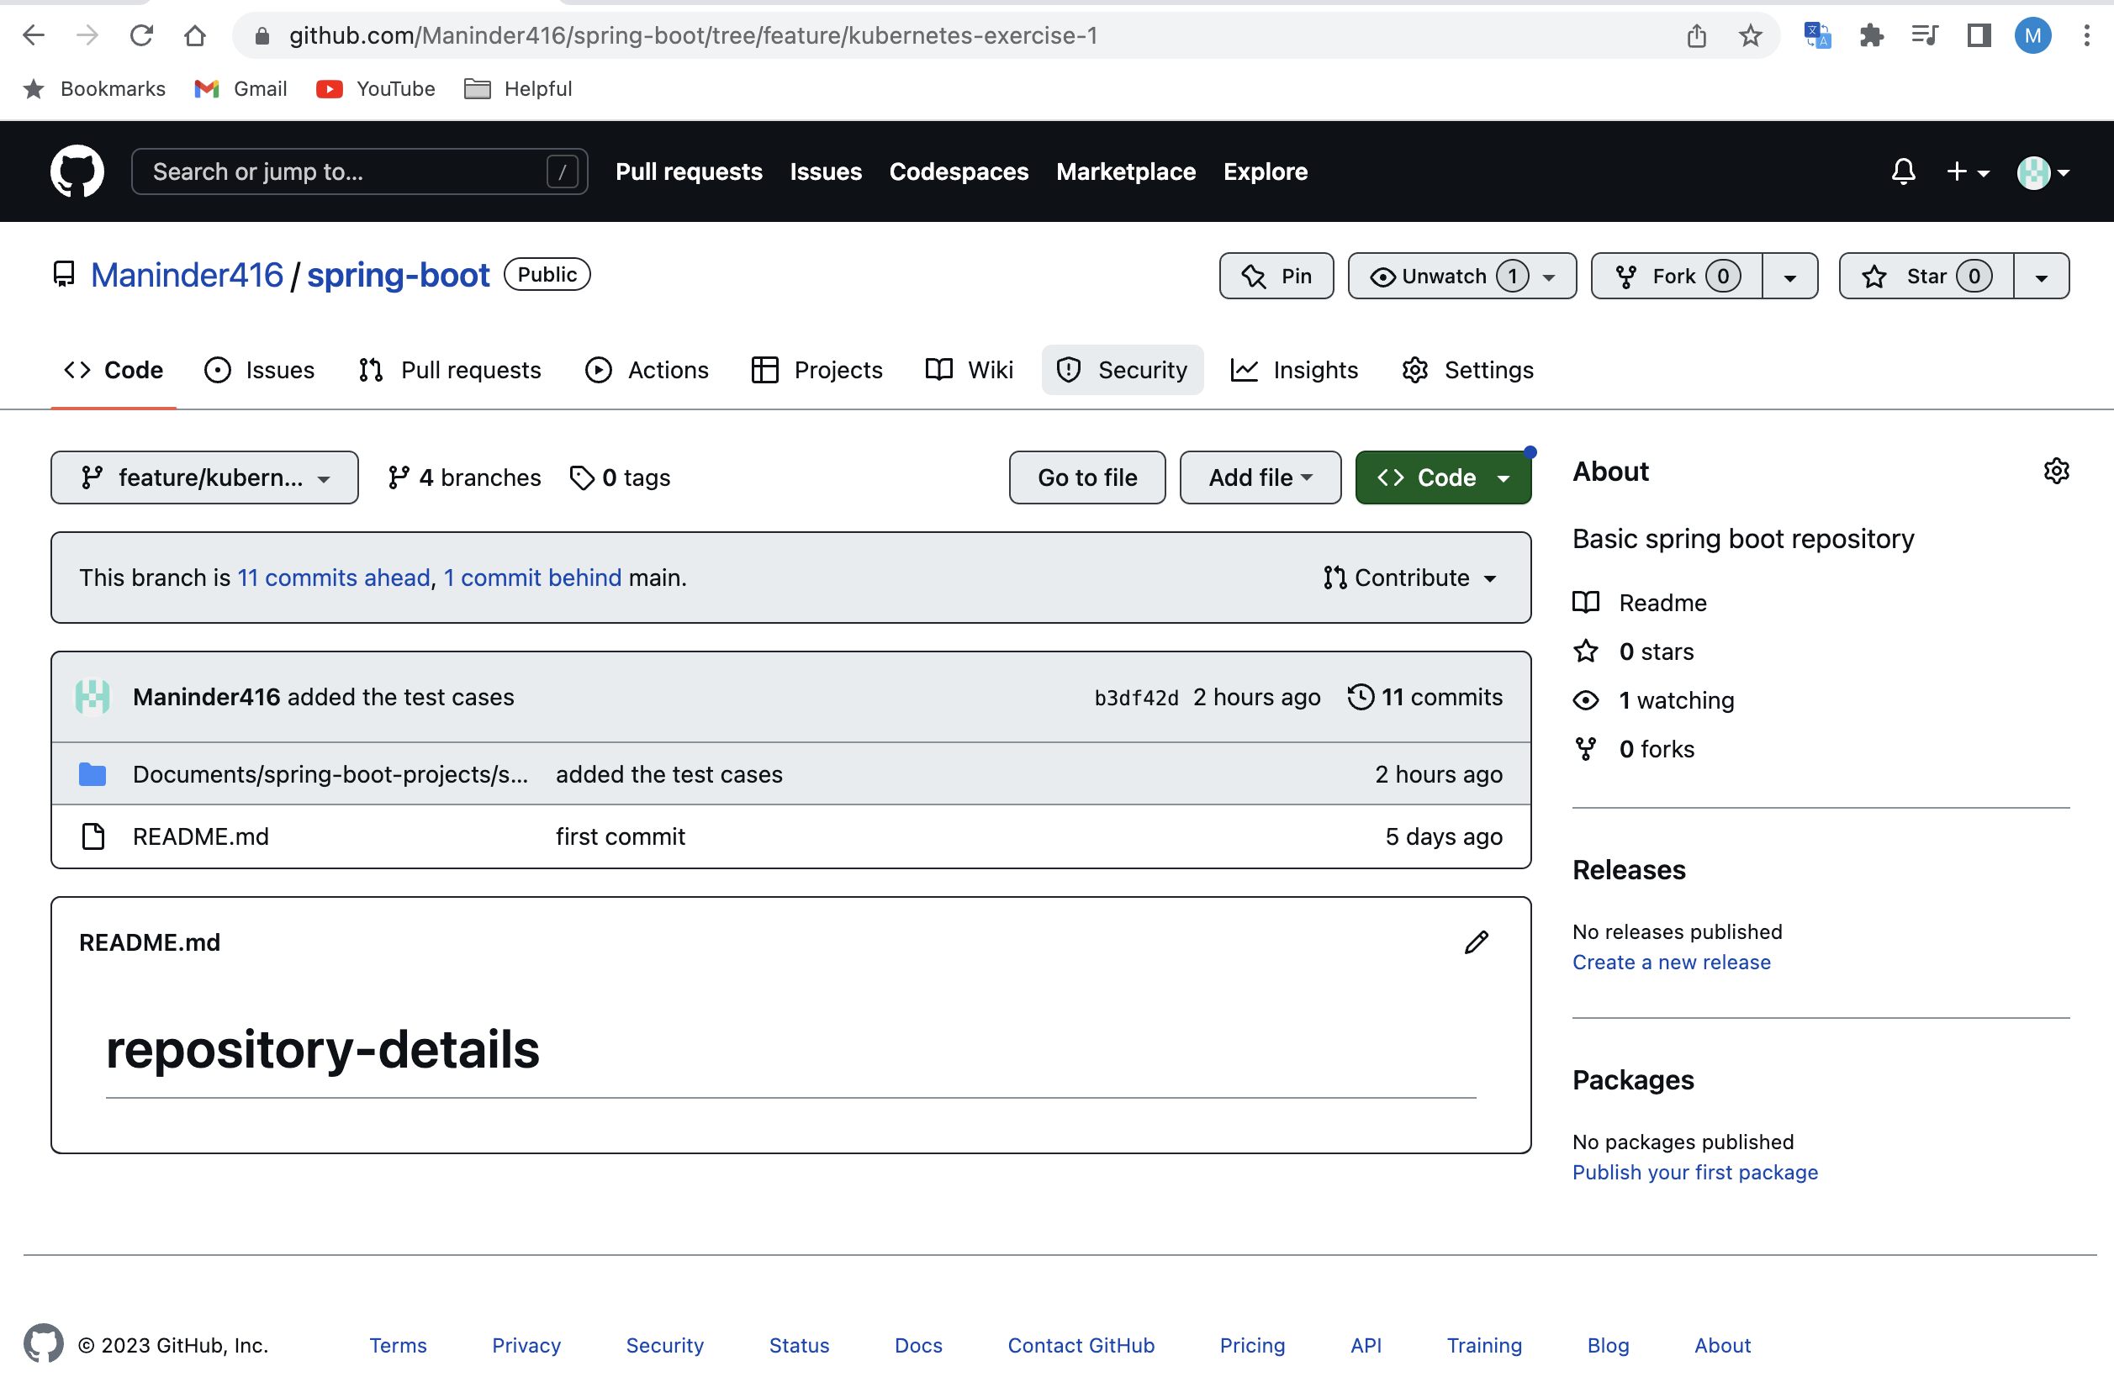

1. Under security tab, click on action under “secrets and variables.”

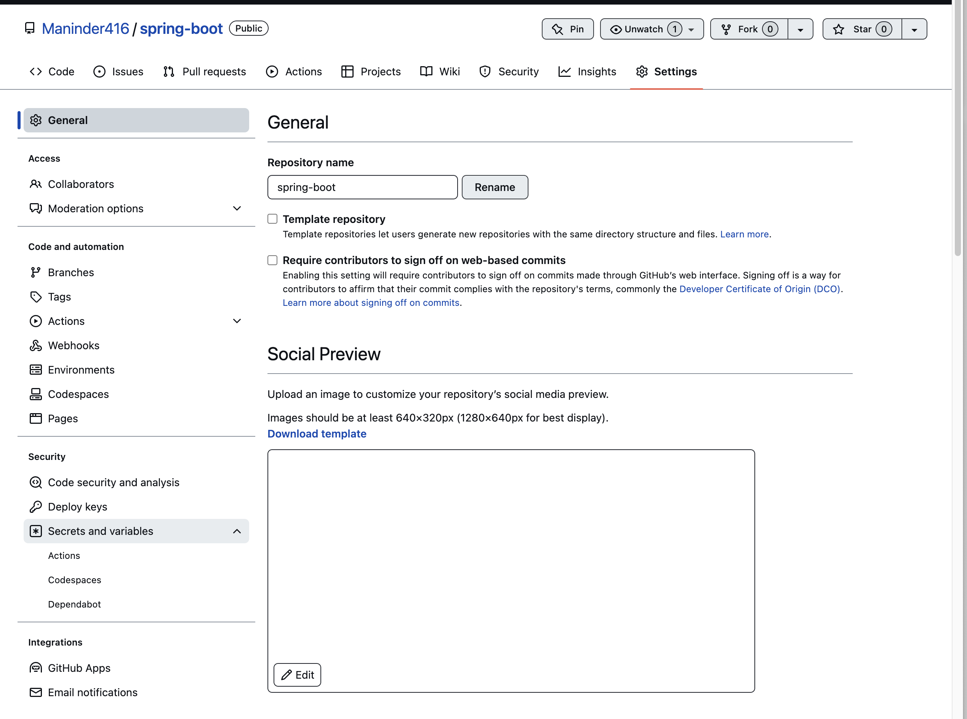

1. Click on “new repository secret.”

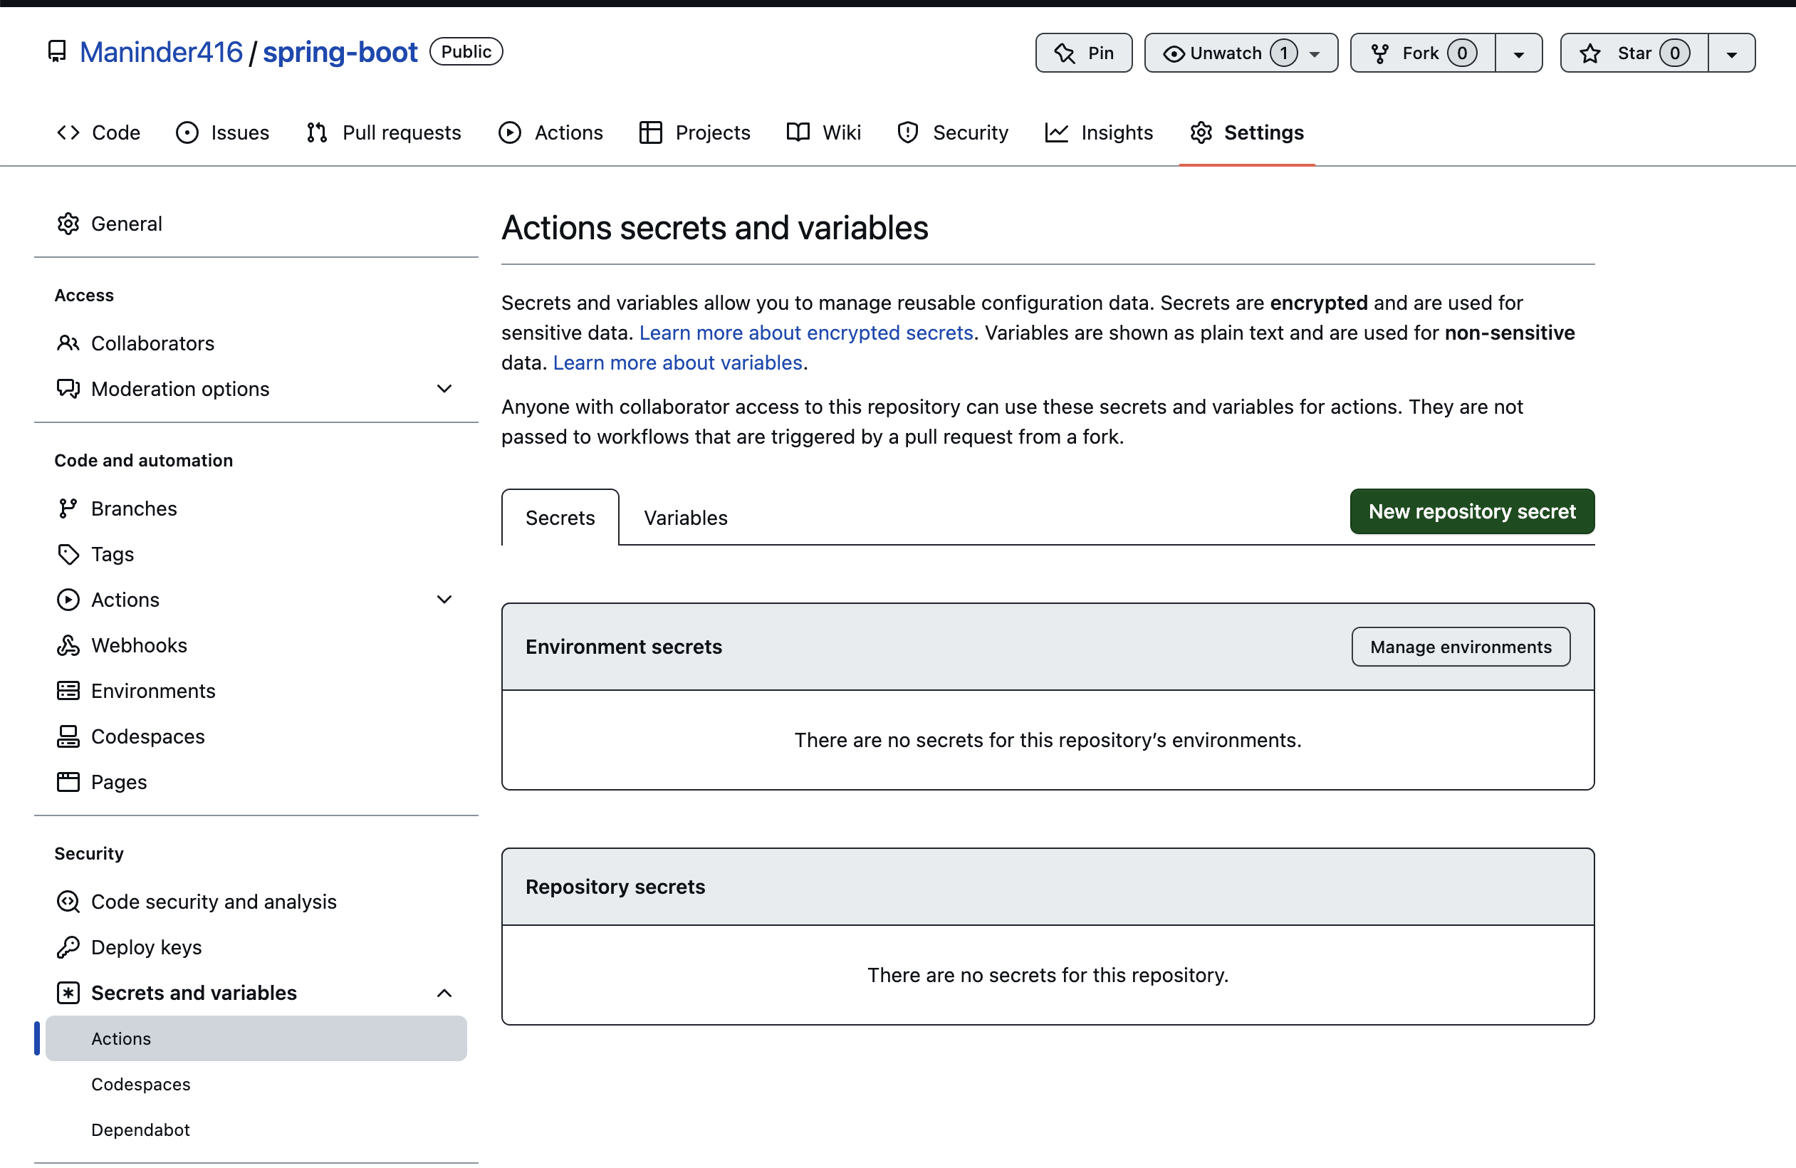

1. Provide the same variable name defined in yml file:

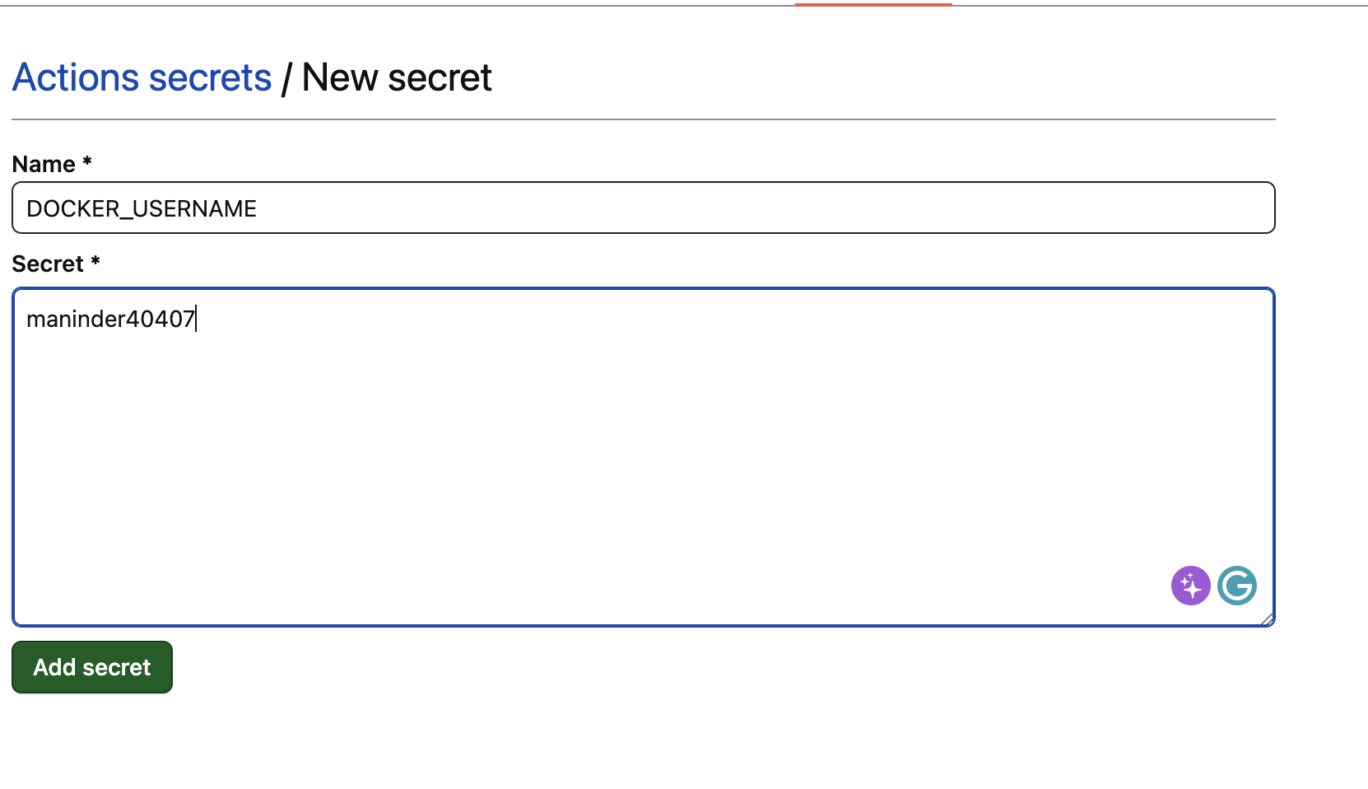

1. Add both username and password for docker hub:

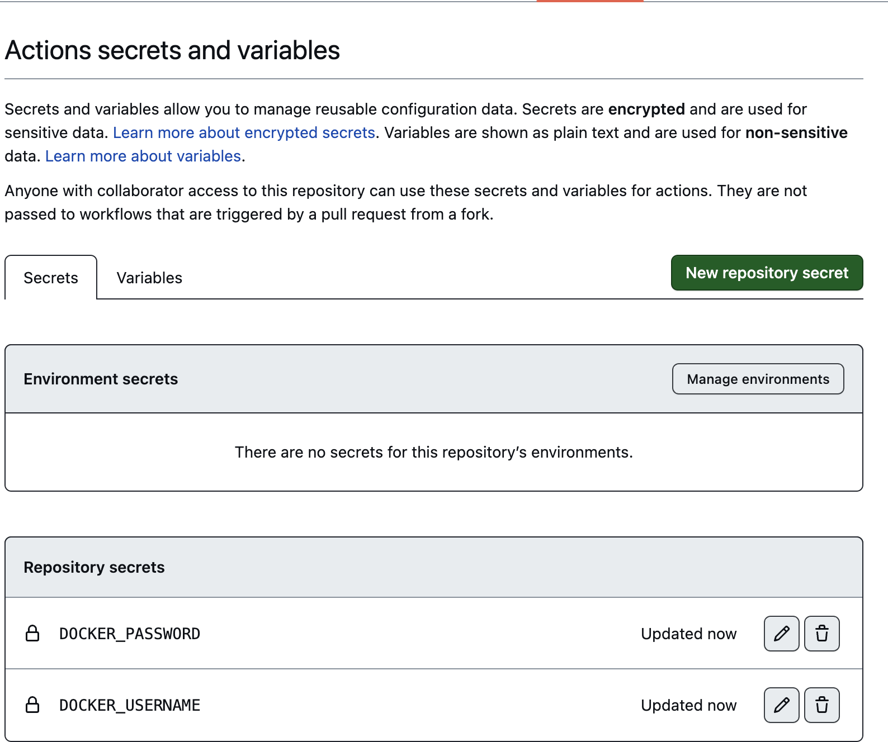

Once this is done, we need to create **“.github/workflows/maven.yml**” file.

**Working maven.yml file:**

name: project cicd flow

on:

push:

branches: [ feature/kubernetes-exercise-1 ]

pull_request:

branches: [ feature/kubernetes-exercise-1 ]

jobs:

build:

runs-on: ubuntu-latest

steps:

- uses: actions/checkout@v2

- name: Set up JDK 17

uses: actions/setup-java@v1

with:

java-version: '17'

distribution: 'adopt'

cache: maven

- name: Build with Maven

run: mvn clean install

- name: Test cases execution

run: mvn clean test

#if condition, if the branch is equal to main then create the docker image for it and push to docker hub

#bookmarker-api-jib:latest image name defined in docker push command below will pick from image

# name defined in pom. file in JIB plugin. If you want to user dockerFile then you should define

# file path but here we are using JIB so it's picking from pom.

- if: ${{ github.ref == 'refs/heads/feature/kubernetes-exercise-1' }}

name: Build and Publish Docker Image

run: |

echo "This job runs in custom branch"

./mvnw clean package jib:dockerBuild -DskipTests

docker login -u ${{ secrets.DOCKER_USERNAME }} -p ${{ secrets.DOCKER_PASSWORD }}

docker push ${{ secrets.DOCKER_USERNAME }}/bookmarker-api-jib:latest

Make sure spring boot project folders like this:

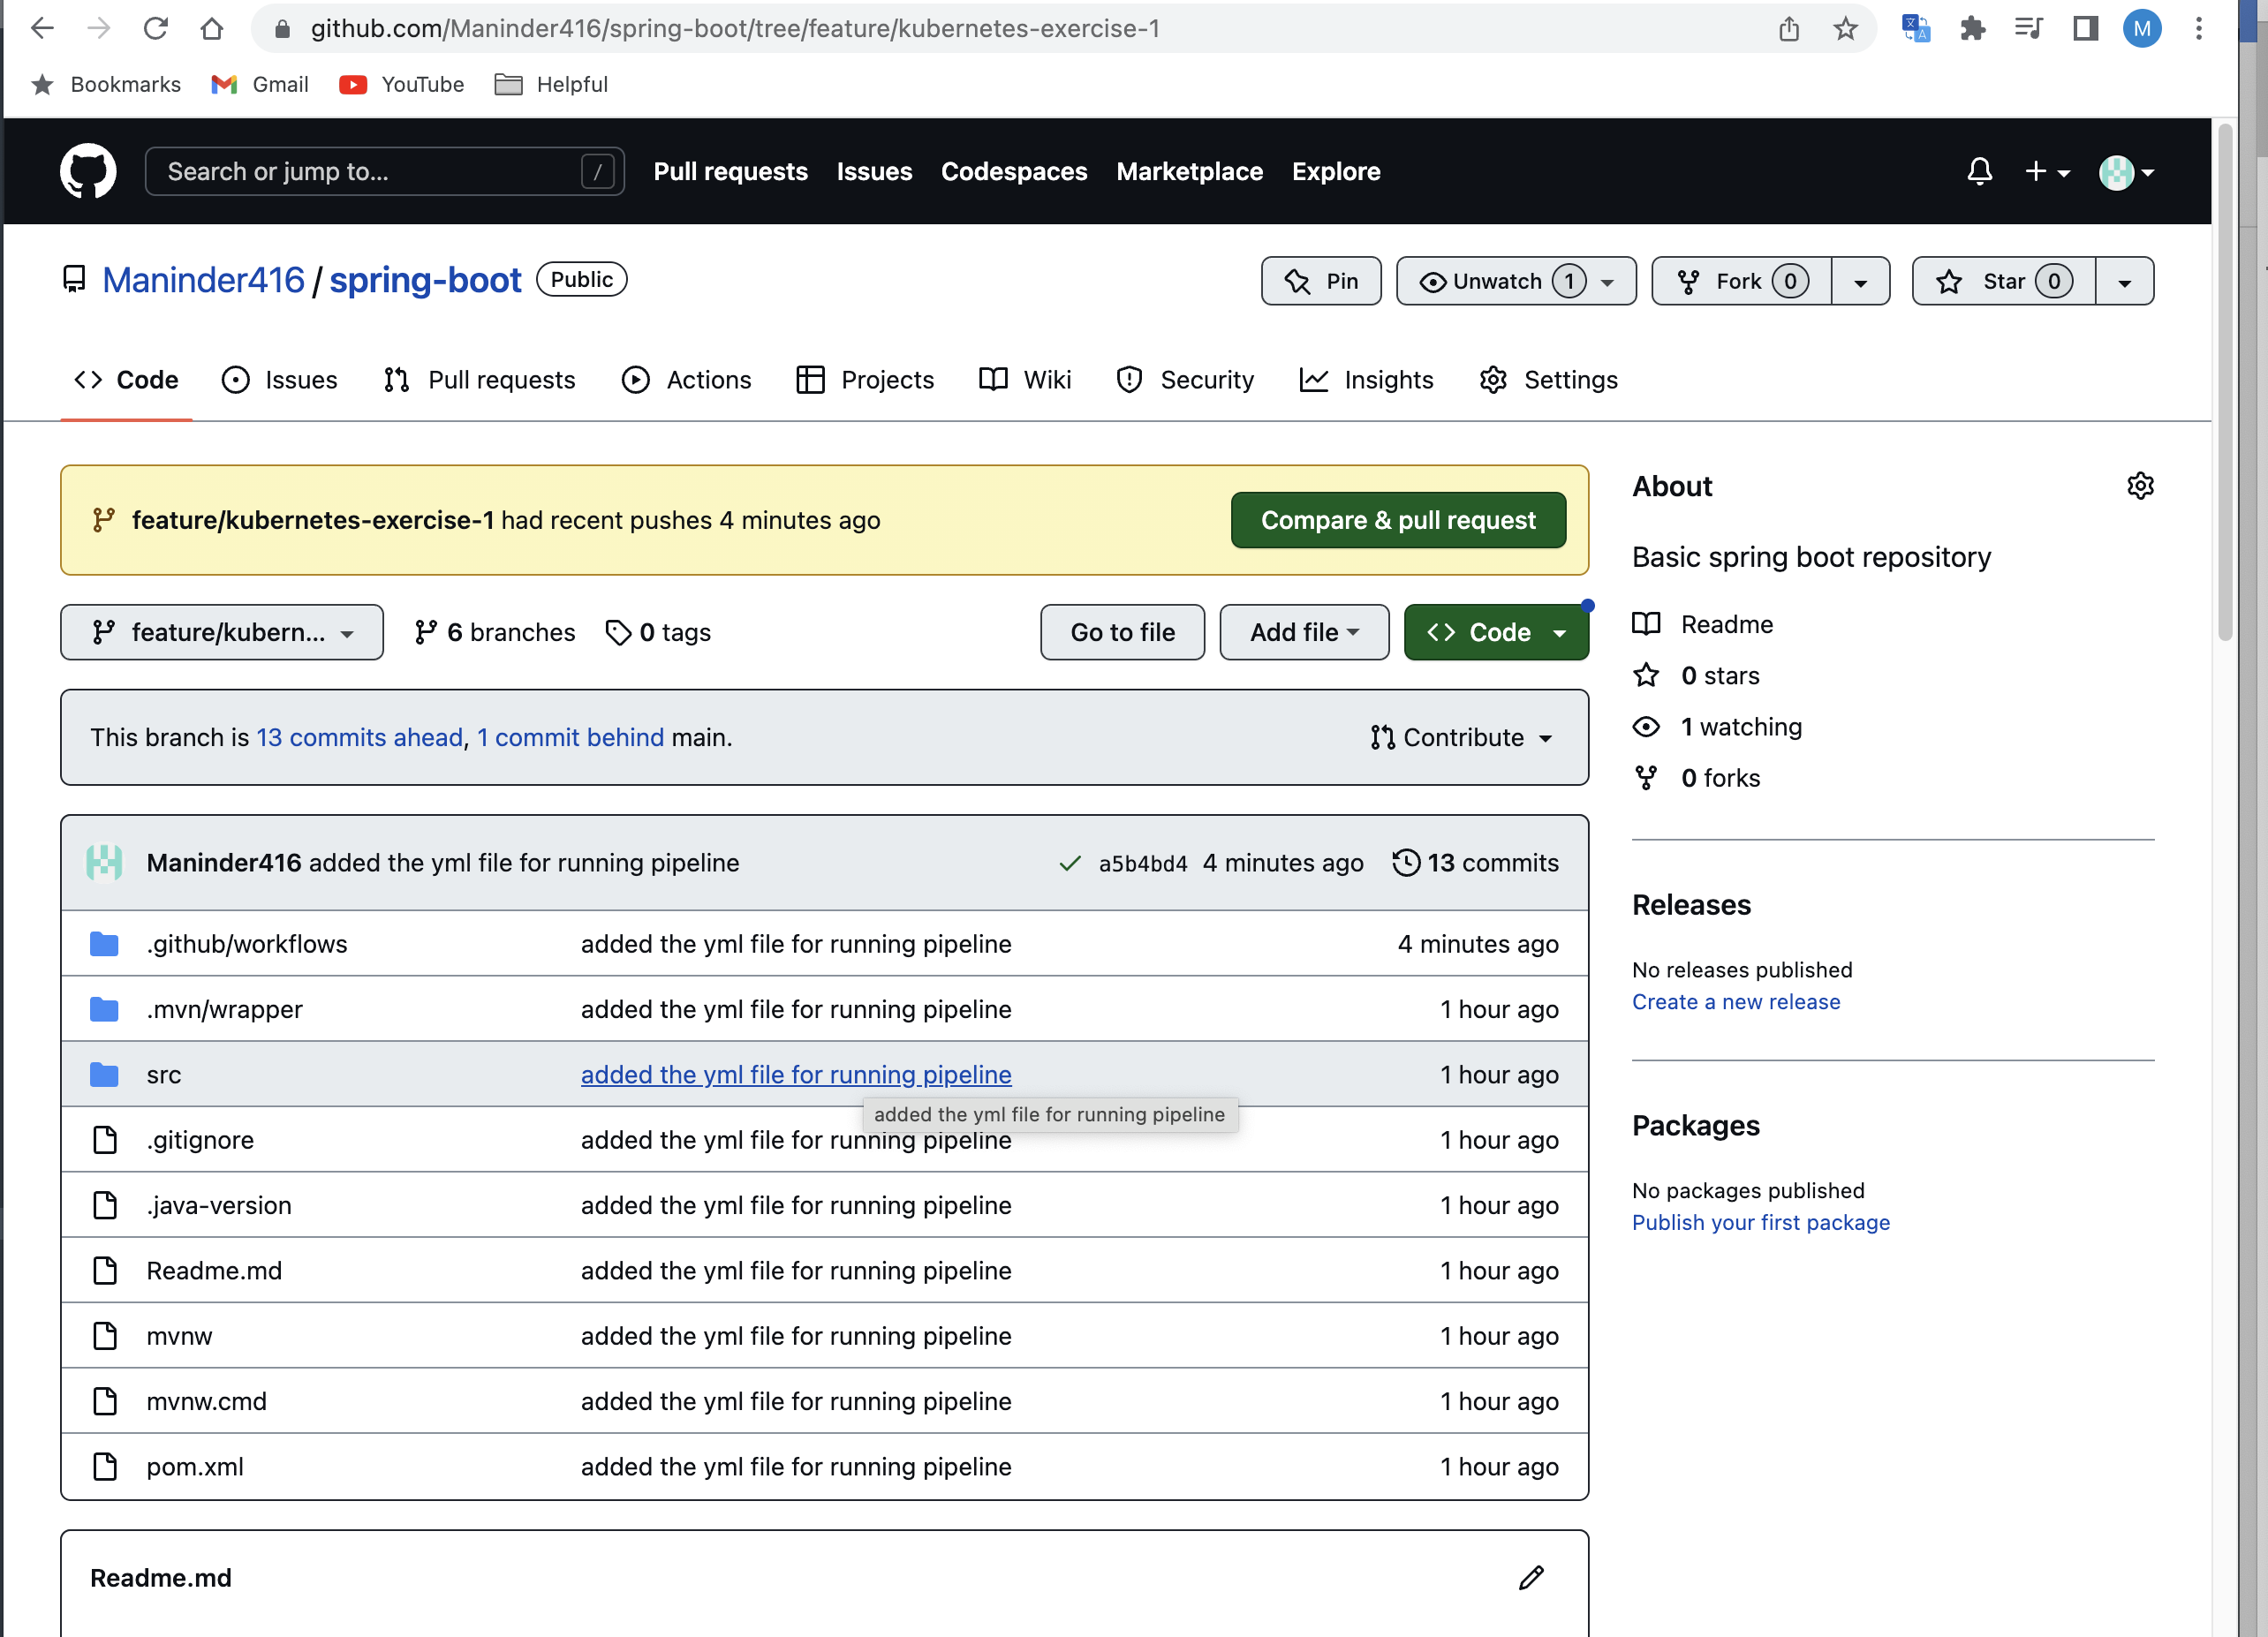

Earlier, I had folder like “Documents/spring-boot-projects/branch name” and due to that my Github action was not working.

The image name we defined online

no 37, picked from pom.xml file jib plugin:

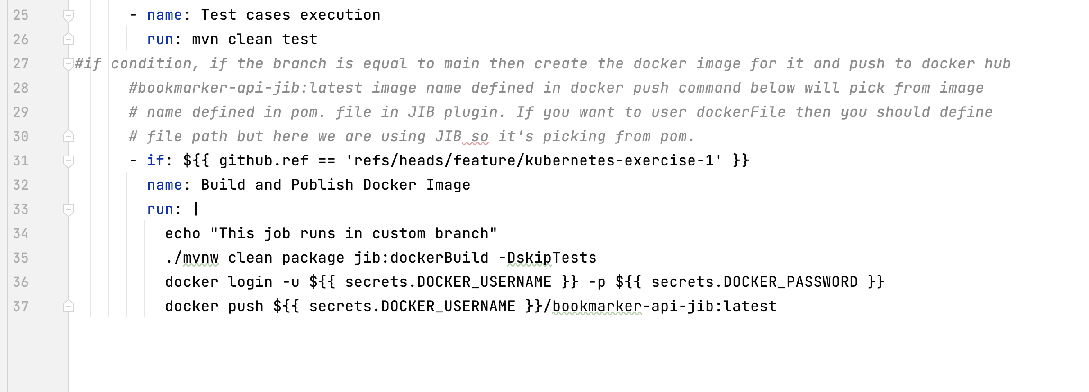

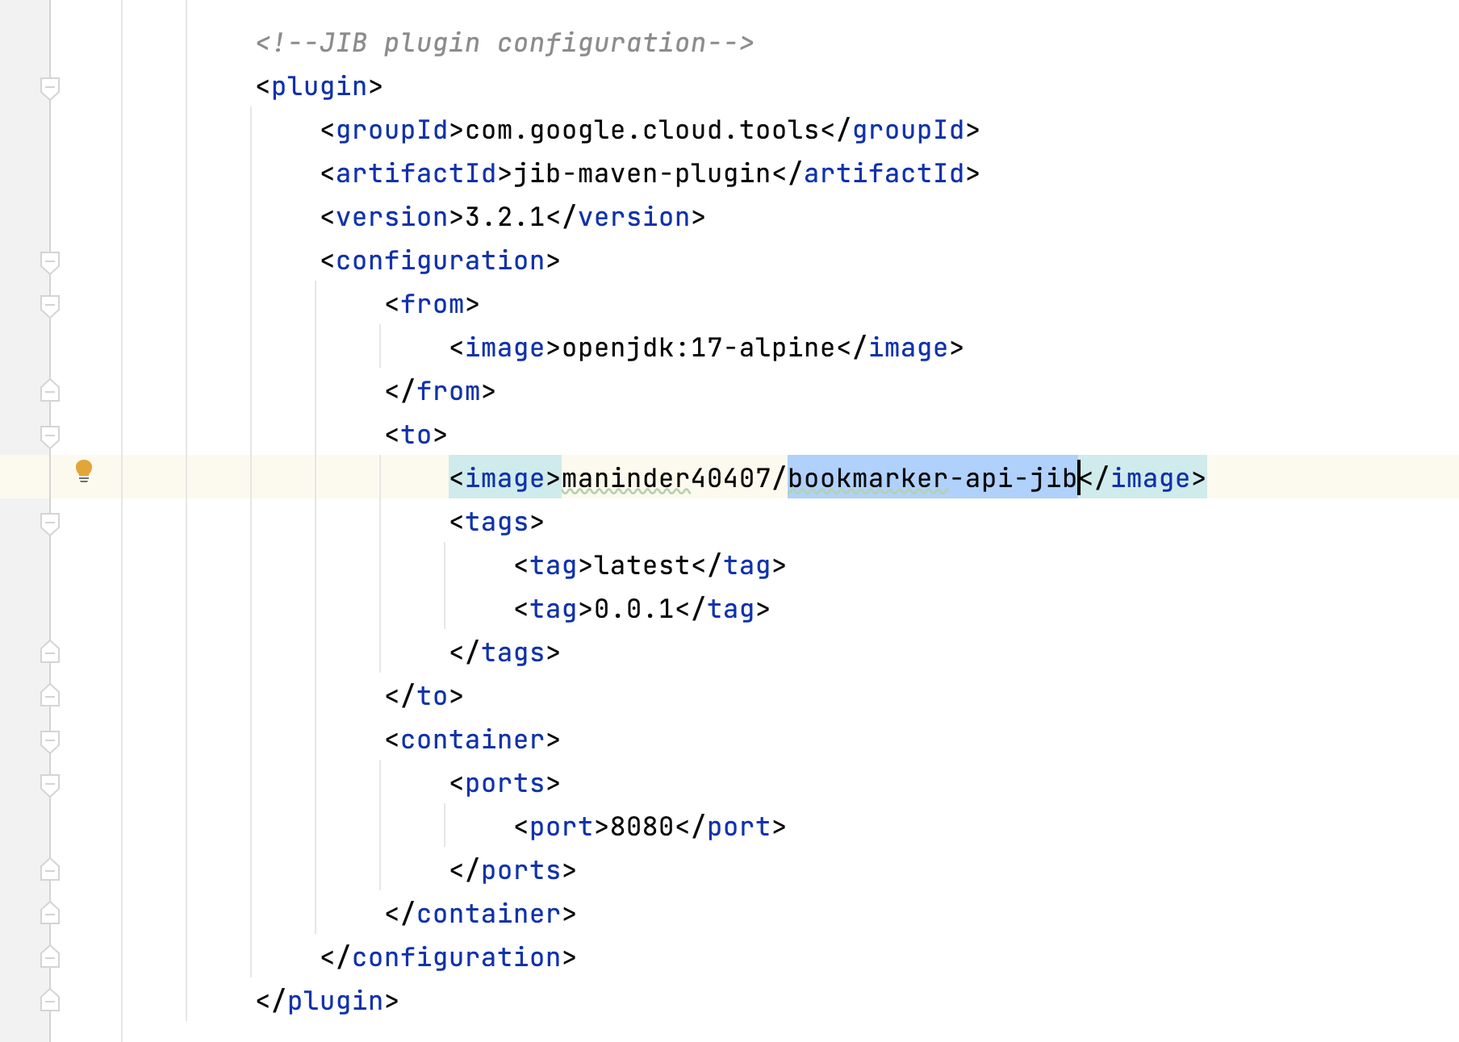

Once that is done, you are good to go….

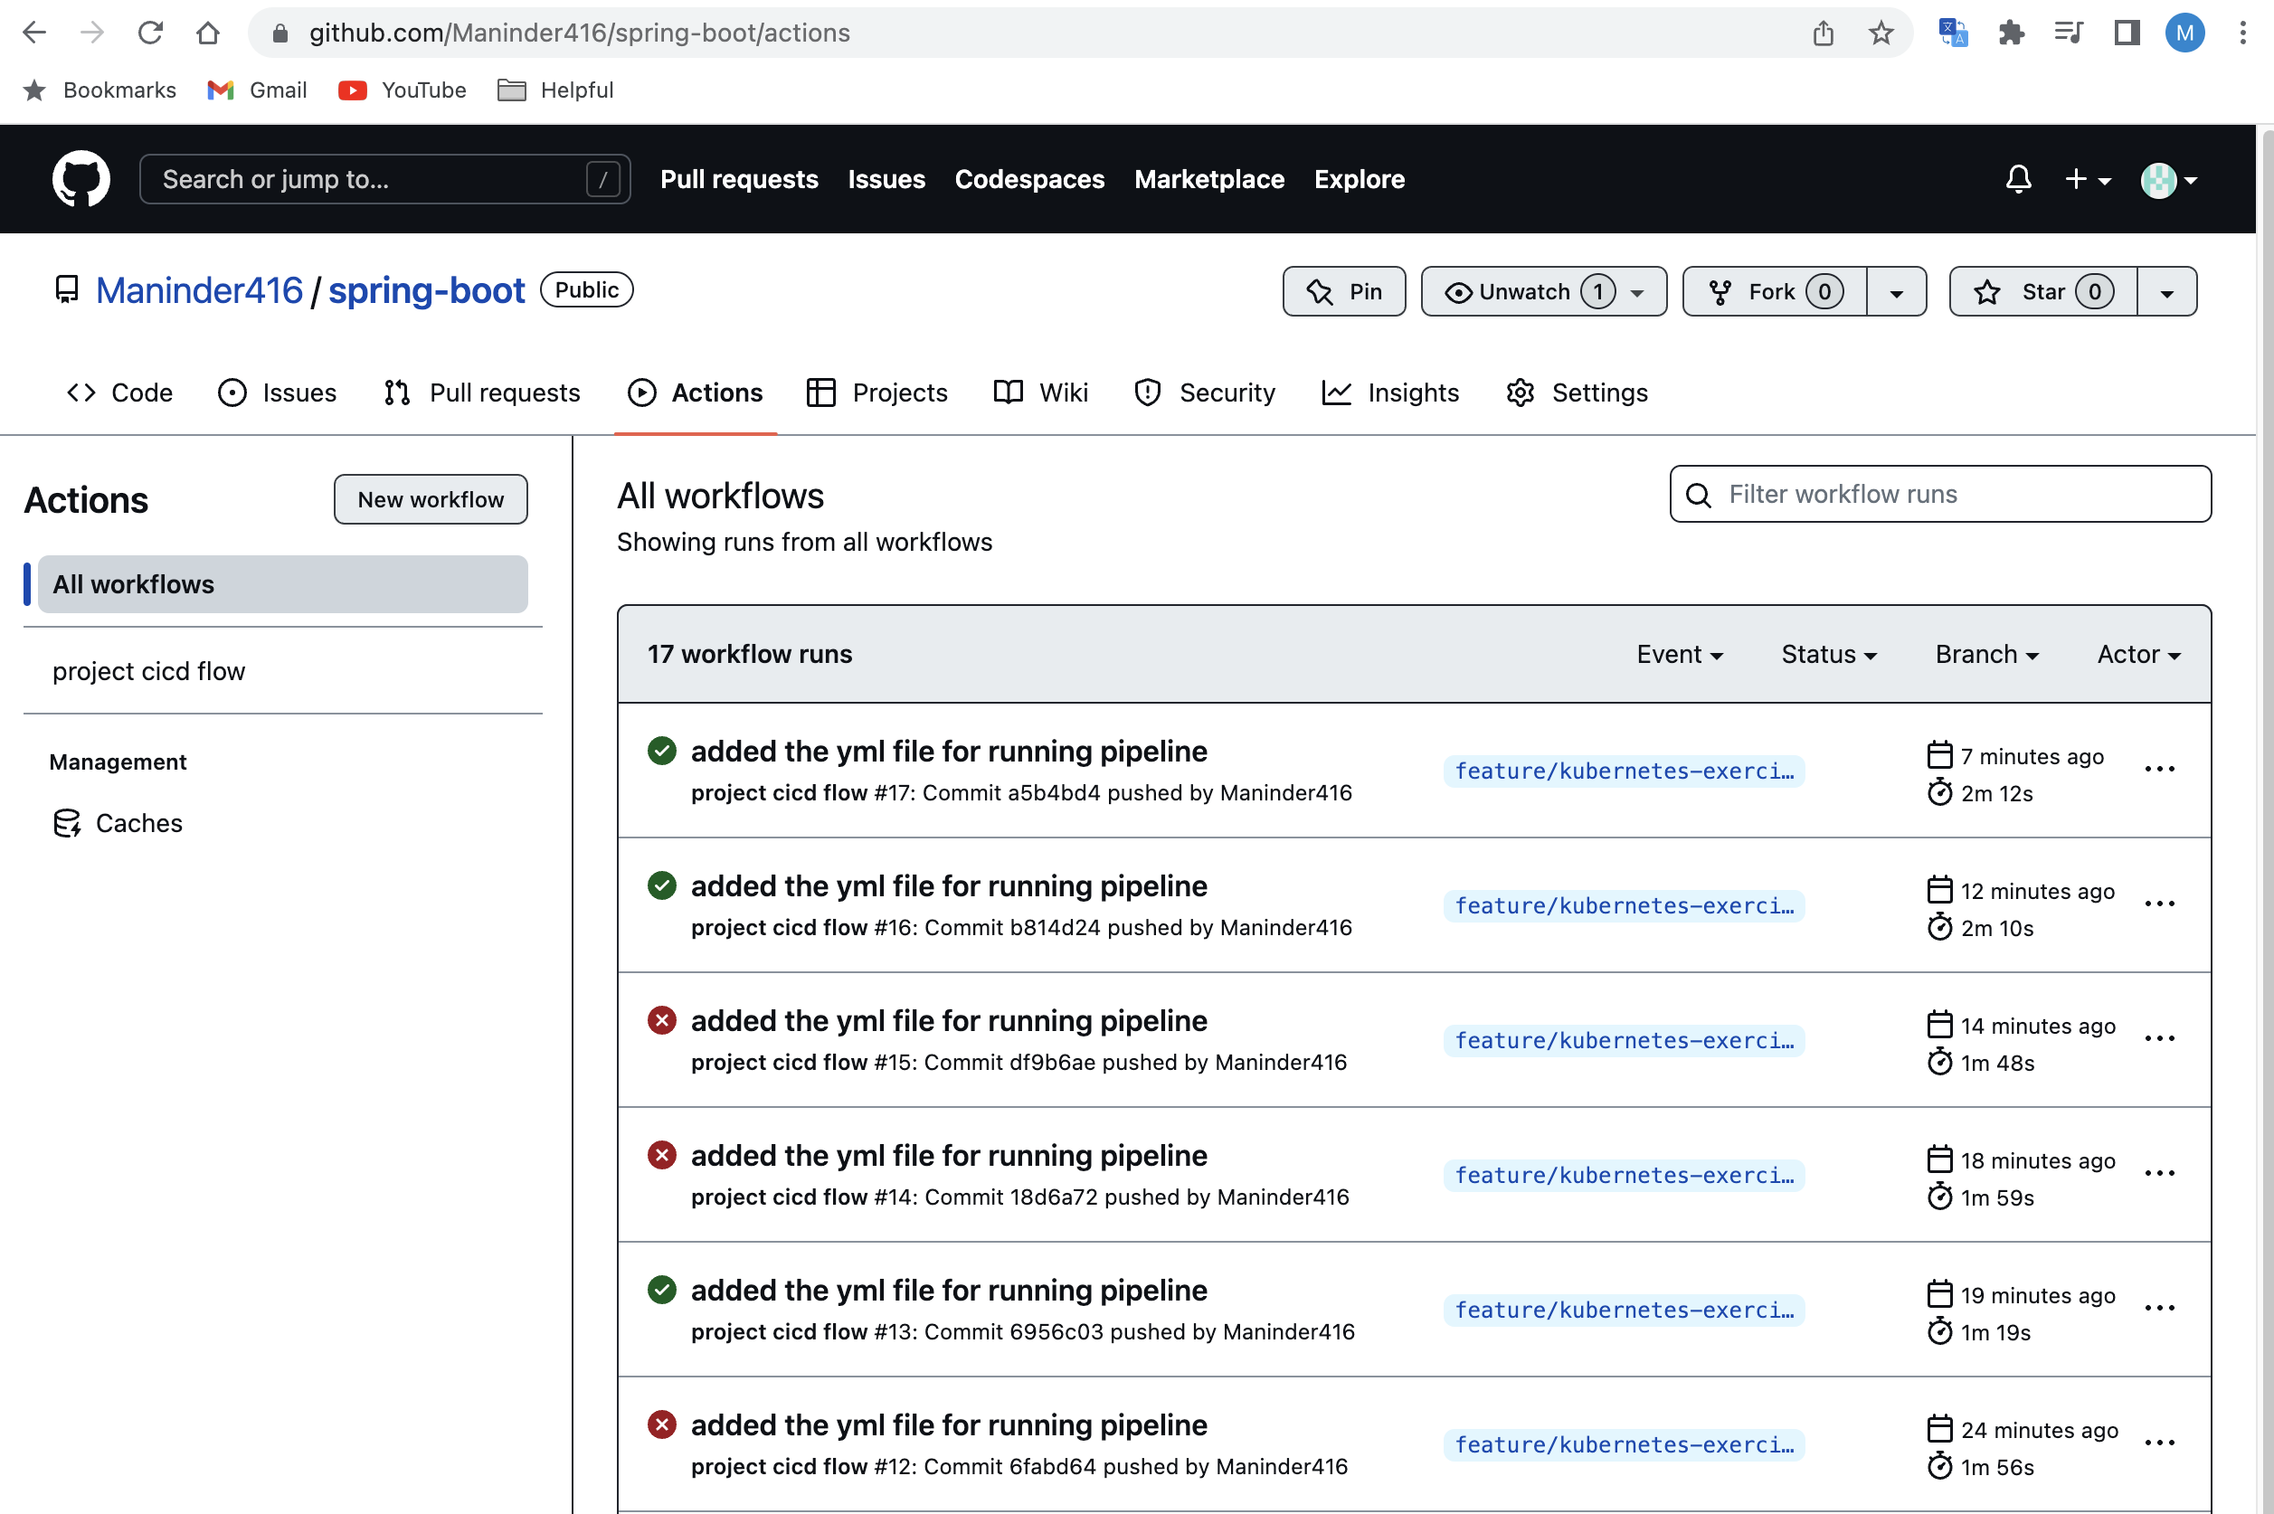

16. Now, we will add post method for bookmark. For bookmark method, we are not giving all details. We are passing only 2 arguments so that's why I have created the "BookmarkRequest" class for taking the input and add @Valid @NotEmpty annotation.

17. Now, if there is something error in your payload then it will through big error, that’s good

but we need an accurate error due to which our post method is failed. So, we need to add one annotation.

**to fix it:**

<problem-spring-web.version>0.27.0</problem-spring-web.version>

**<dependency>**

**<groupId>org.zalando</groupId>**

**<artifactId>problem-spring-web-starter</artifactId>**

**<version>${problem-spring-web.version}</version>**

**</dependency>**

Before applying this annotation, the error will be like this:

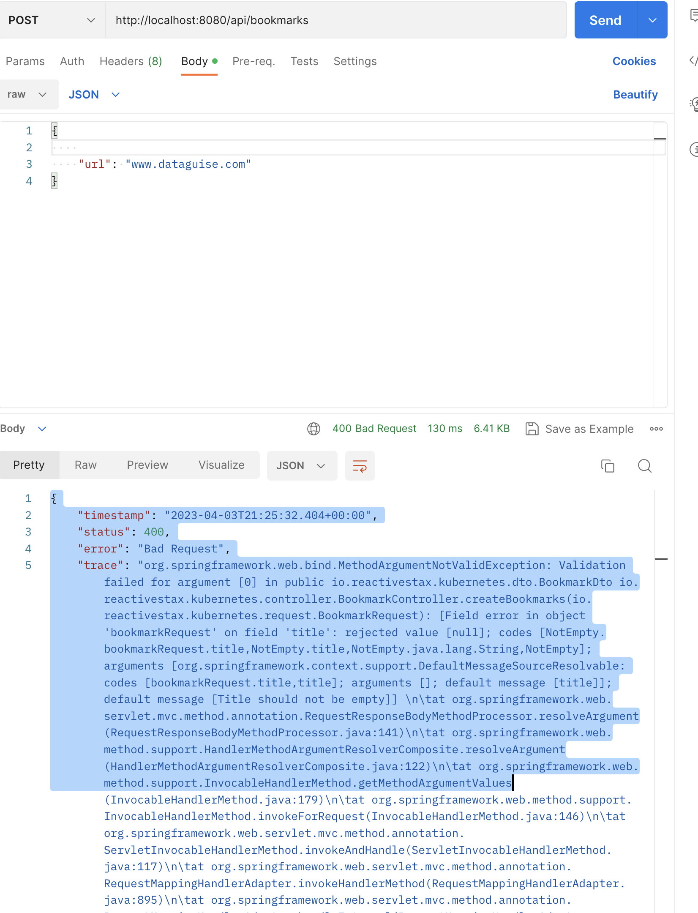

**After adding this dependency:**

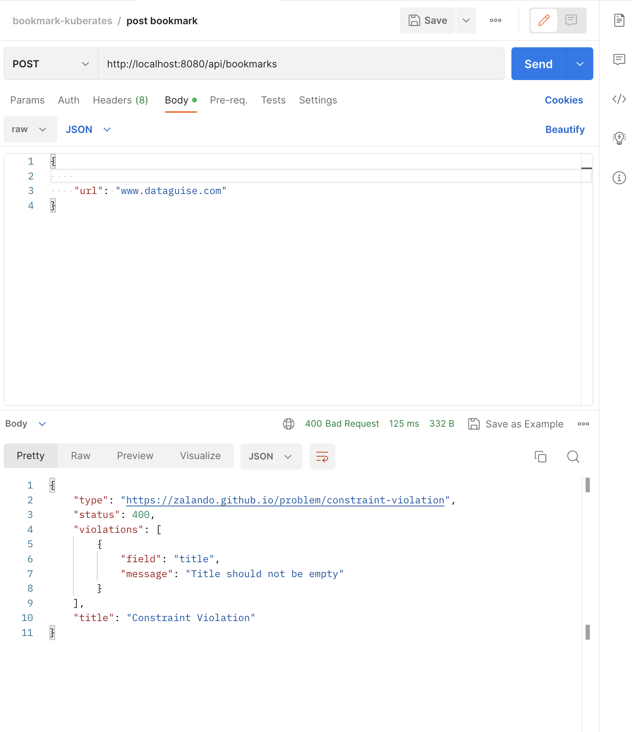

**Docker-Compose.yml:**

Until now, we create the common docker-compose file for all the services like for spring boot app along with databases that we are using. If you want to change anything in your spring boot application, then you down all the services that are running in docker-compose however we just need only application to restart. So, this is not a right approach. Instead of it, we can create 2 docker-compose files in which under one file we mention information regarding the spring boot app and for other services we will create a different docker-compose file.

So, we created 2 files:

1. docker-compose.yml: it contains all the services like DB.
2. docker-compose-app.yml: It contains only spring boot app.

Now, spring boot app is dependent on the service that is present in another docker file. So, here is the way to run multiple docker files together:

**docker-compose -f docker-compose.yml -f docker-compose-app.yml up -d**

**logs:**

**docker-compose -f docker-compose.yml -f docker-compose-app.yml logs -f**

Still, these commands are not easy to remember so we can create a shell script to run these commands:

Now, will create a shell script named as “run.sh”

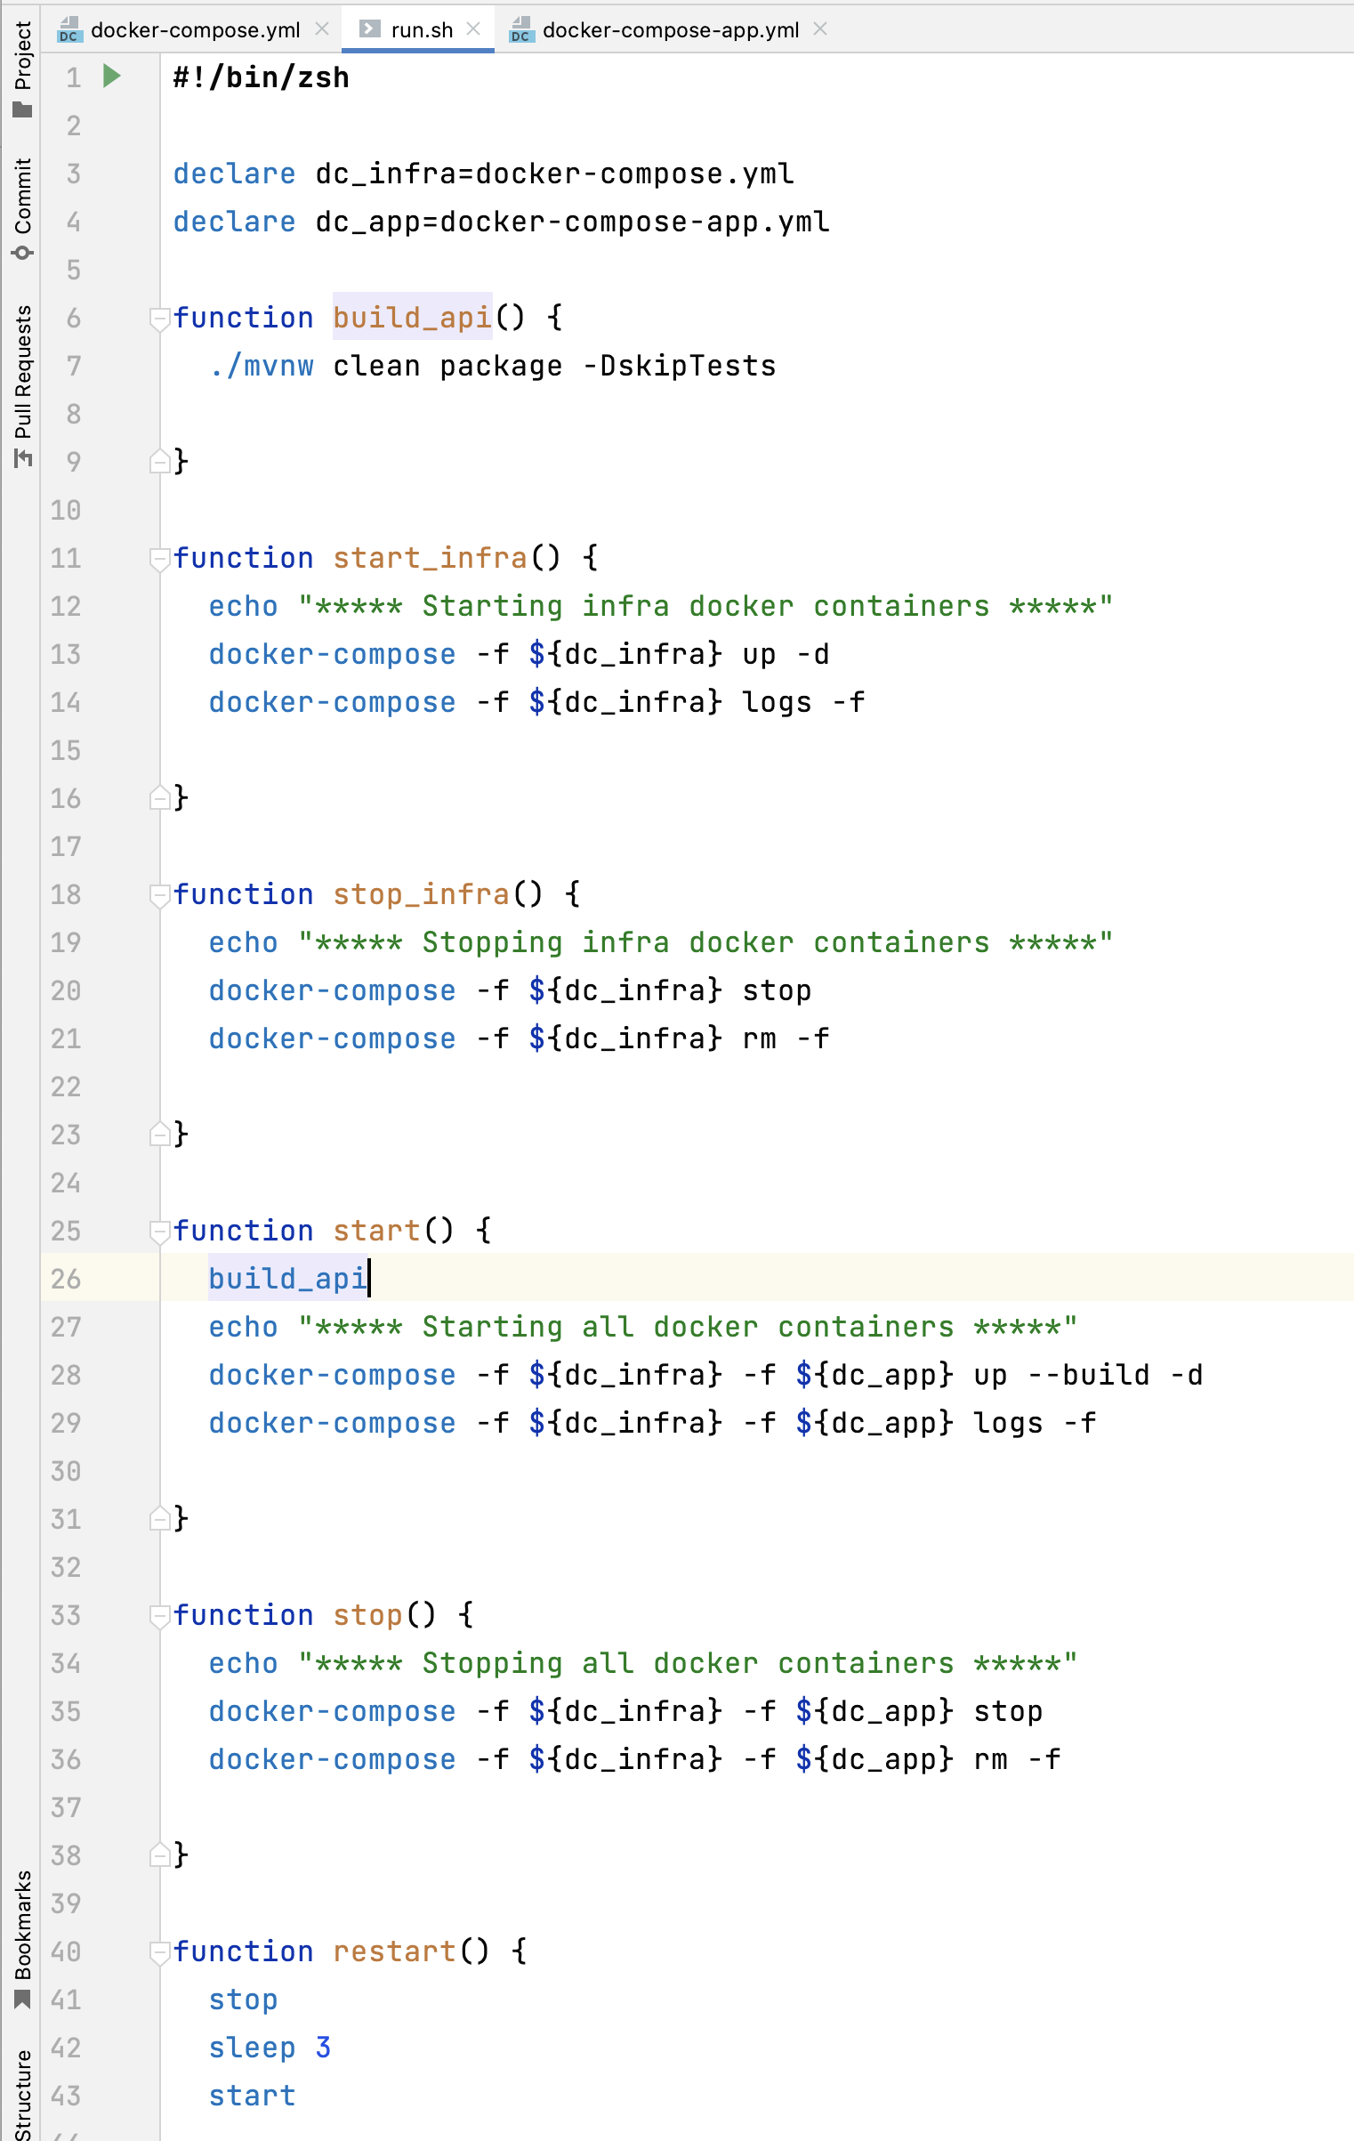

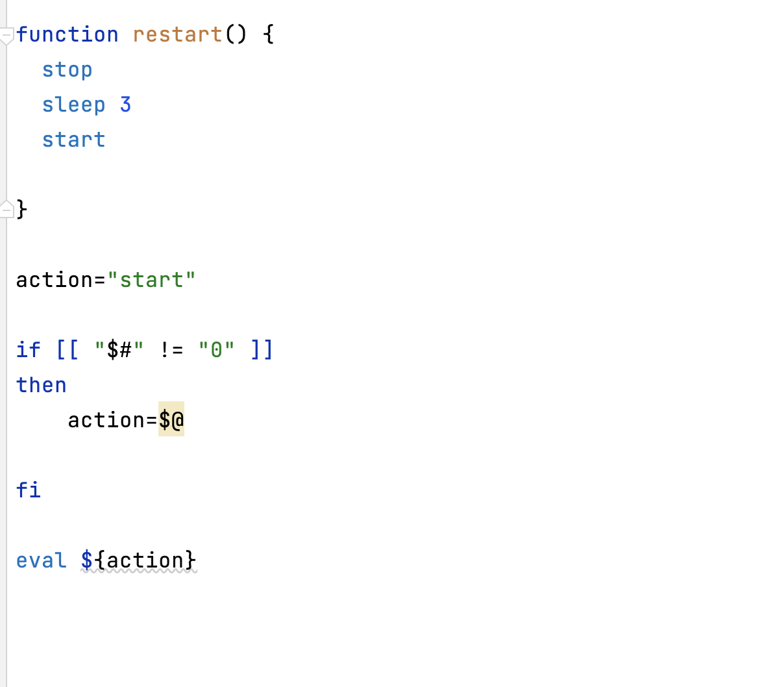

In this file, we will write the different methods to execute our spring boot app.

Steps:

1. create “run.sh” file
2. execute “chmod +x run.sh”
3. run “./run.sh” file

when you execute this file, it will by default call the “start” method written inside this file as we mentioned the default action to the “start” method.

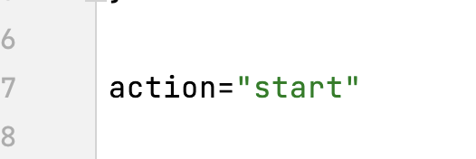

It will run both the docker-compose files and our app will up and work.

But if you want to restart the existing running application then you can do it by providing the method name as:

For stop the containers: **“./run.sh stop”**

For starting only infra: “**./run.sh start_infra”**

Meantime, when we run our application using “run.sh” file, it will run in docker. So, if we want to see tables are getting created or not or if you want to see other things you need to login into the docker container. It is time consuming so to avoid this, we can run spring boot app in local profile.

Steps:

1. Run the “**./run.sh start_infra”** // it will run the docker postgres.
2. Create the “application-local.properties” file.

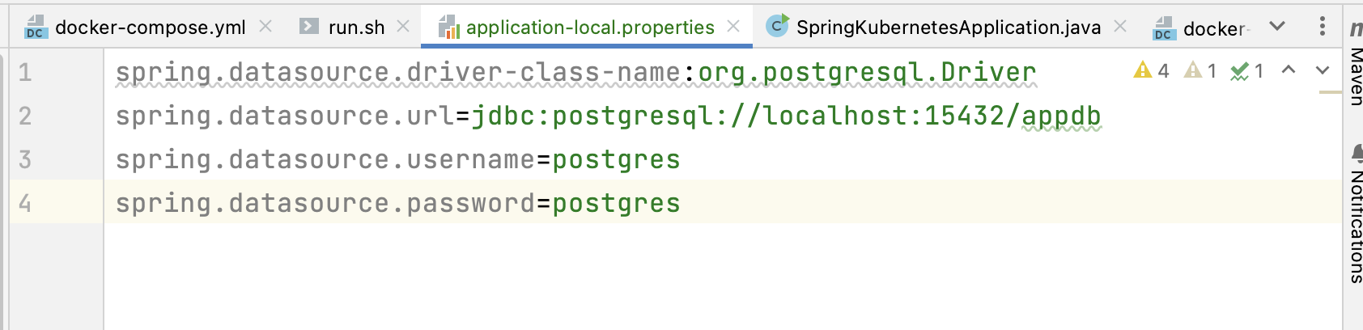

Added the host as localhost because docker postgres DB is running on local docker and assigned the local port to 15432 as we assigned it docker-compose file.

Run the spring boot in local profile: **-Dspring.profiles.active=local**

Now, it’s time to create frontend page for this spring boot app. So, for this we are using “next js”.

Steps:

1. Download <https://nodejs.org/en>
2. After installing node, run this command under our spring boot app folder:

“**npx create-next-app bookmarker-ui-nextjs --ts**”

**Create-next-app** is syntax to create next app.

**bookmarker-ui-nextjs** is our next app name.

**--ts** means we are using typescript over the JavaScript.

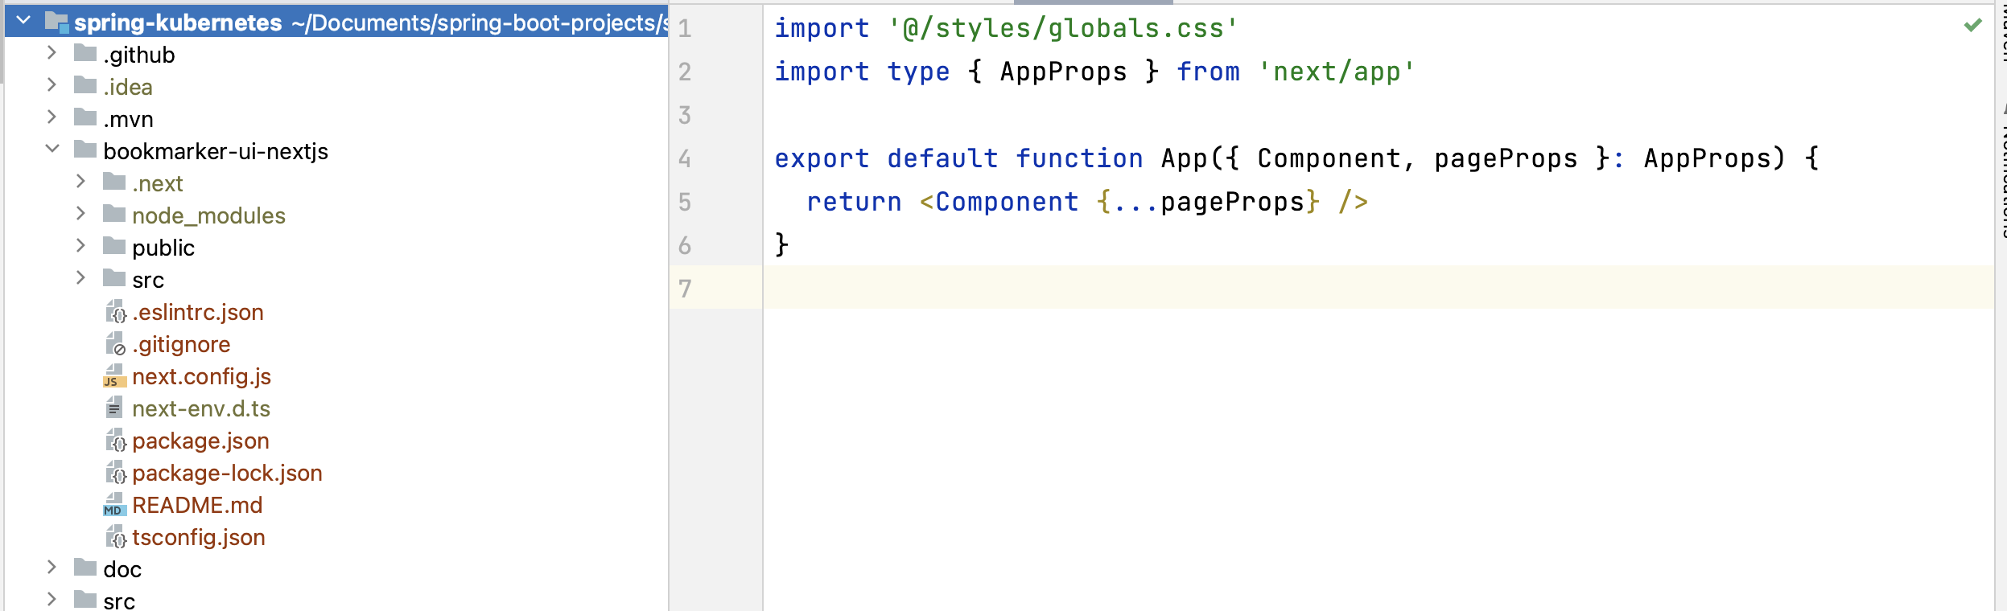

1. Now, go inside this folder “**nextjs-demo**” and run the “**npm run dev**”
2. Our application will start on localhost:3000 port.

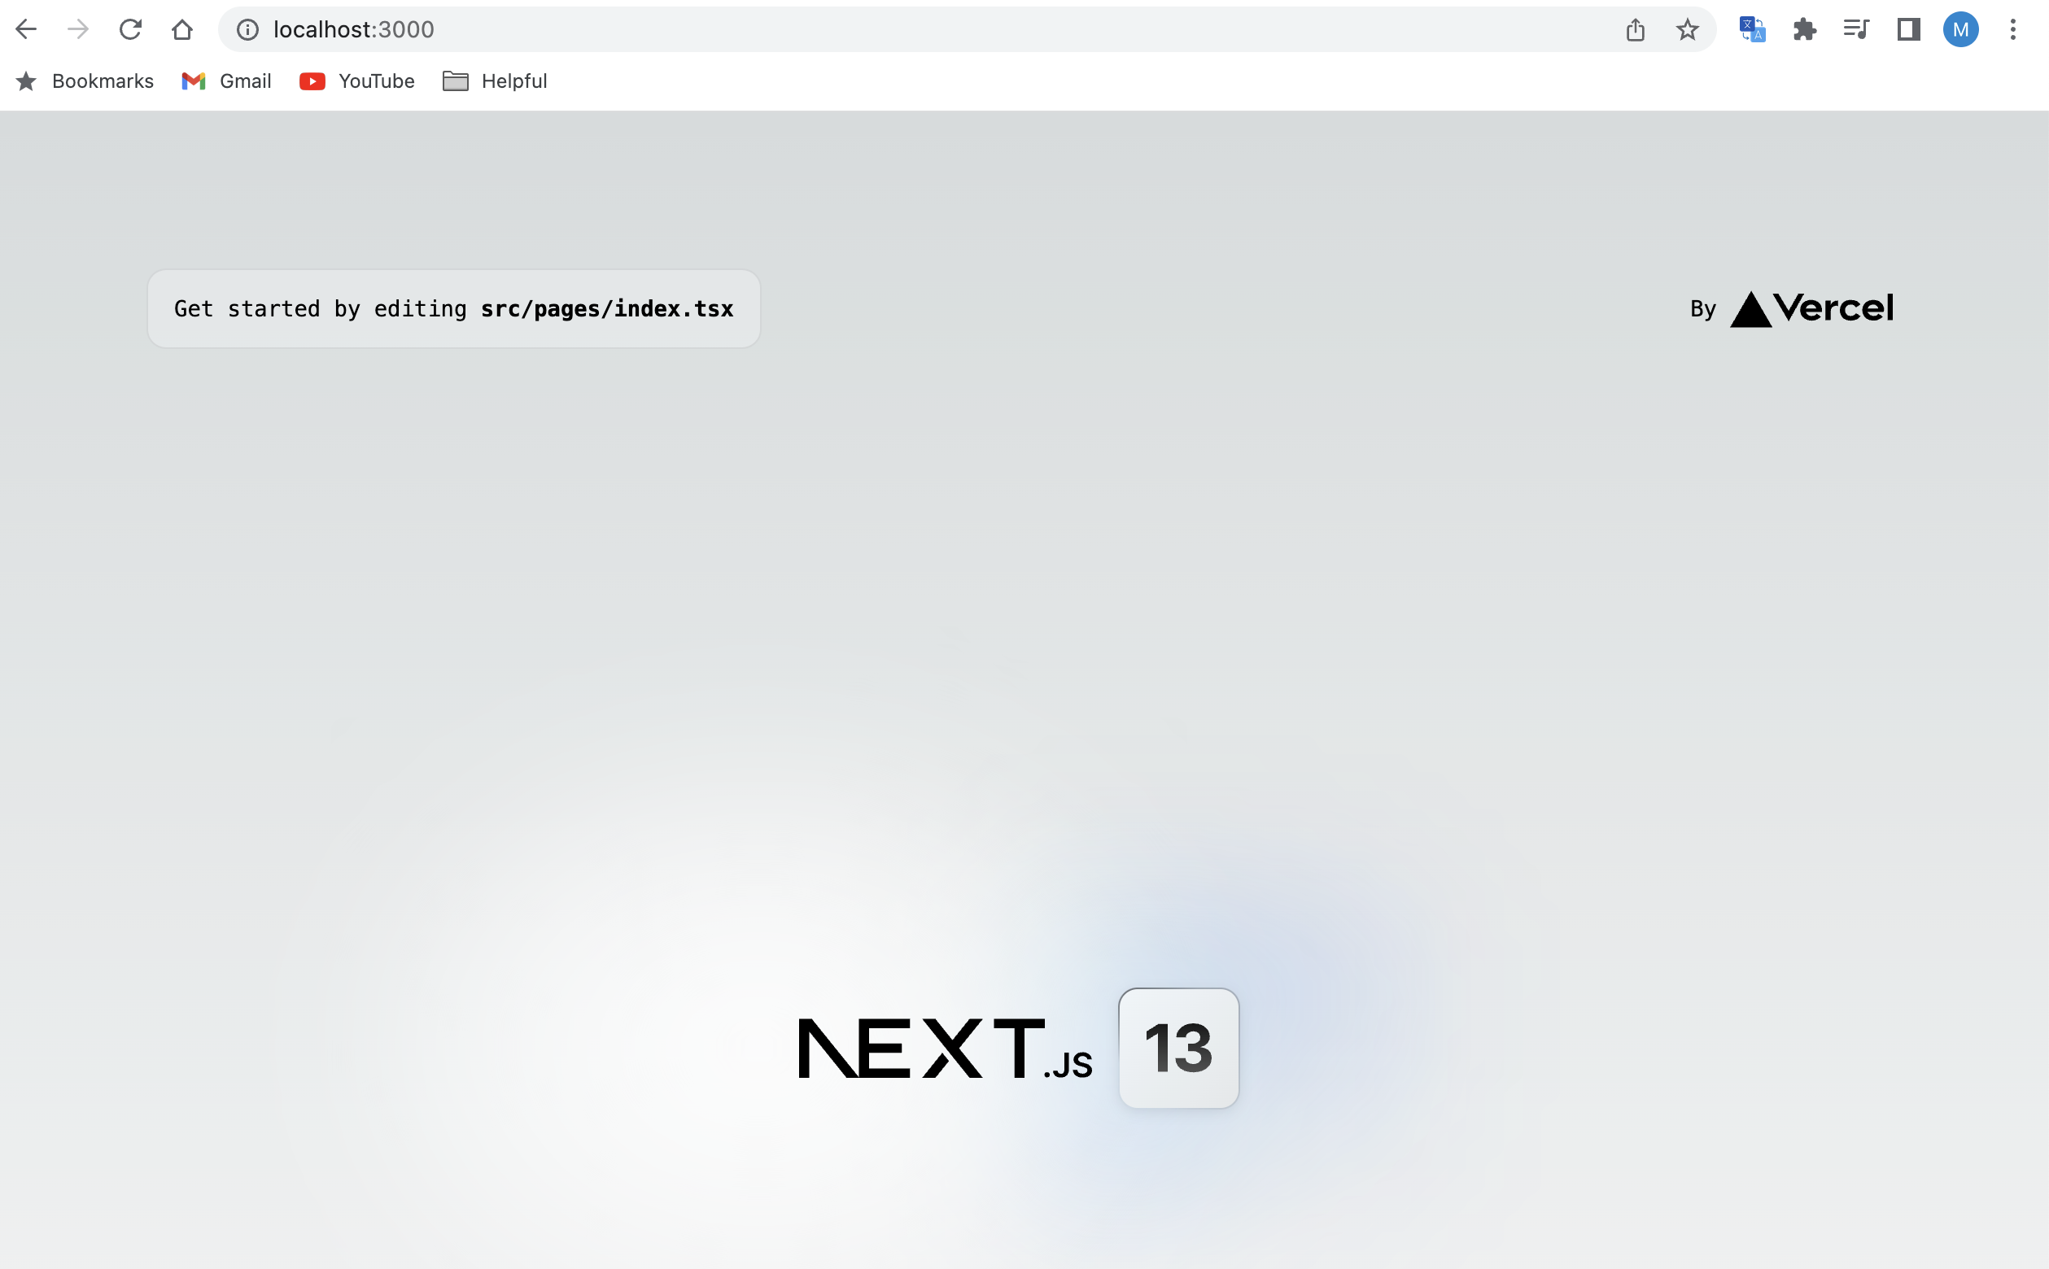

1. Inside the nextjs folder, also install the bootstrap server using command:

**npm i** [**bootstrap@5.3.0-alpha3**](mailto:bootstrap@5.3.0-alpha3)

1. Bootstrap server, we use for responsive websites. So, we have added it into nextjs project. To load this dependency, inside the project, import it inside the **“_app.tsx”**

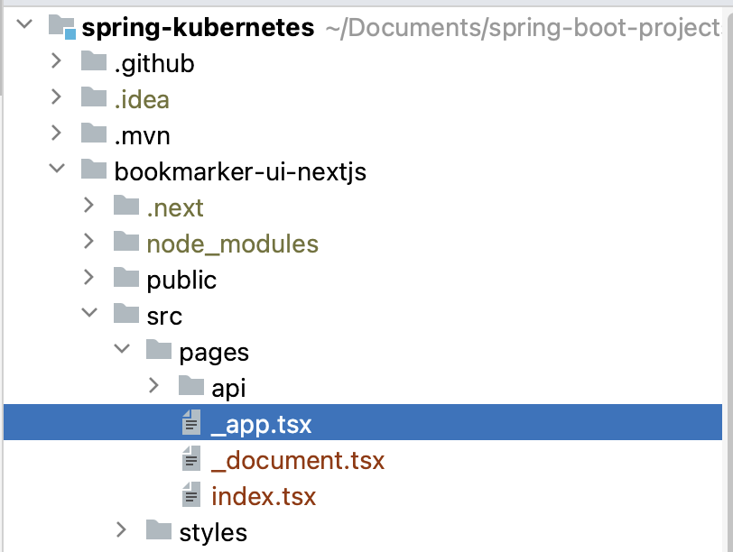

1. Import the bootstrap server in this file:

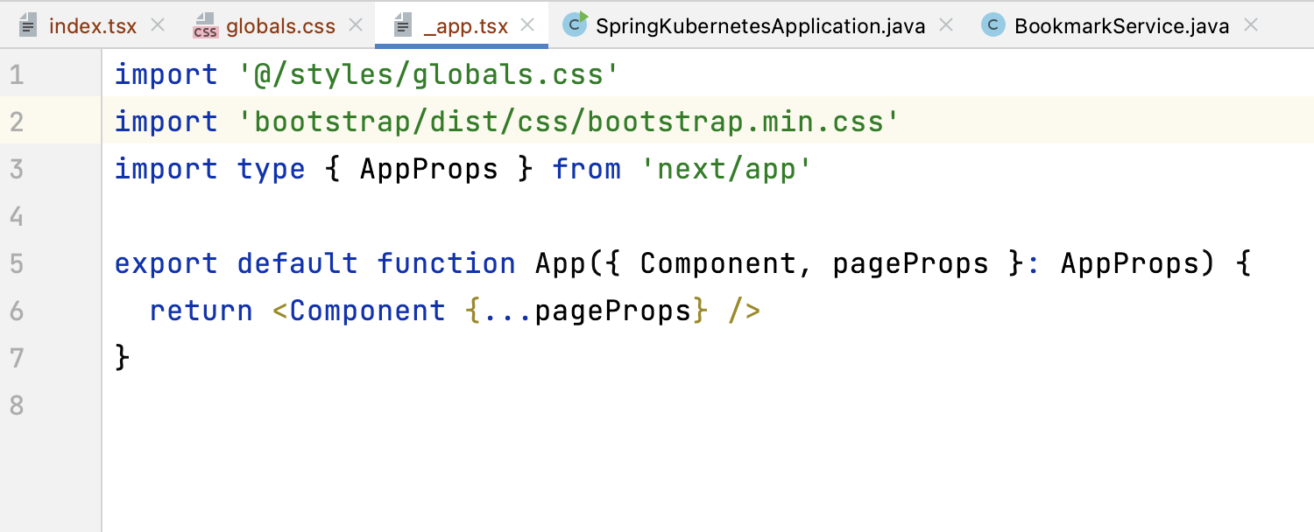

1. Once, bootstrap is imported. Now we can use it in global project:

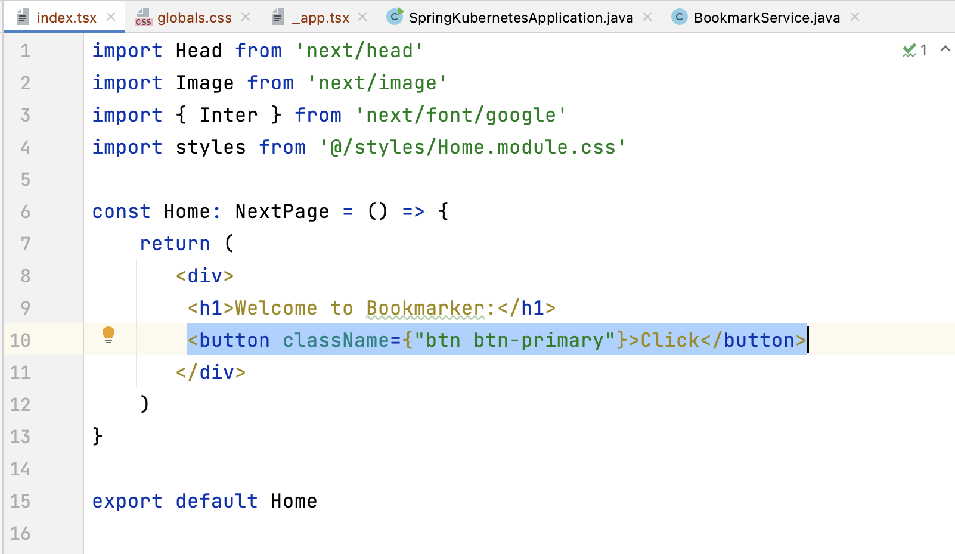

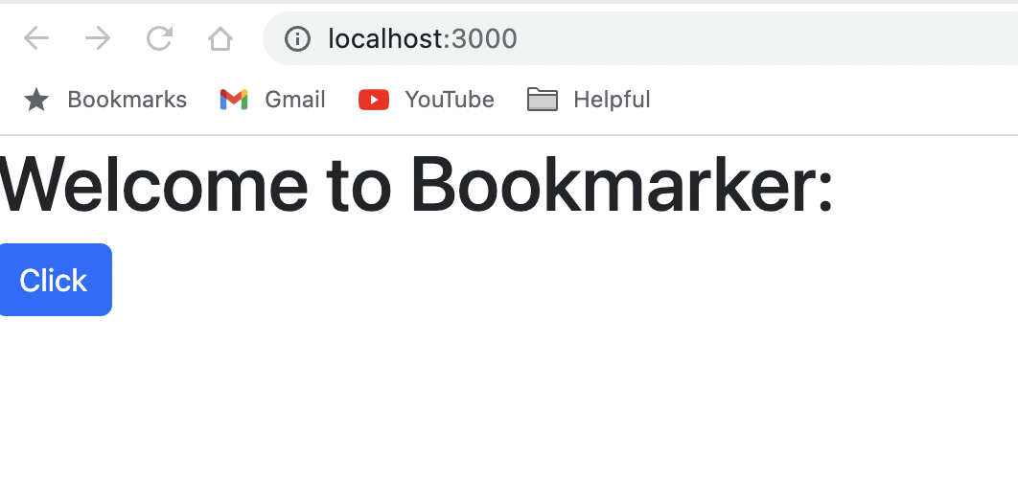

1. Check the button, bootstrap server is working as expected.
2. Meantime, not doing the UI work as we need to learn about next, react.

For creating the cluster, we will create the shell scripts for it:

**Kind-config.yml:**

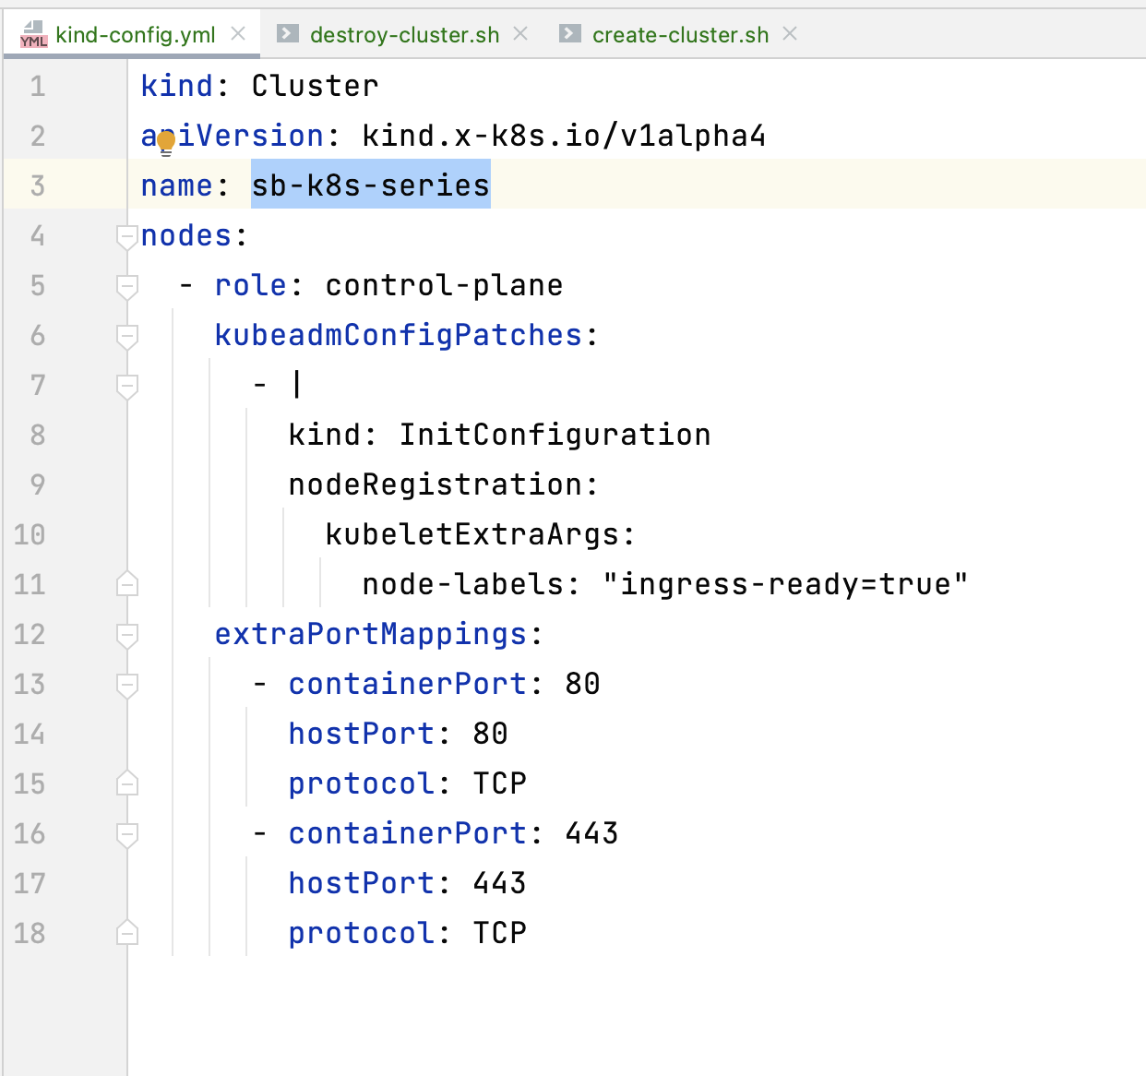

**create-cluster.sh:**

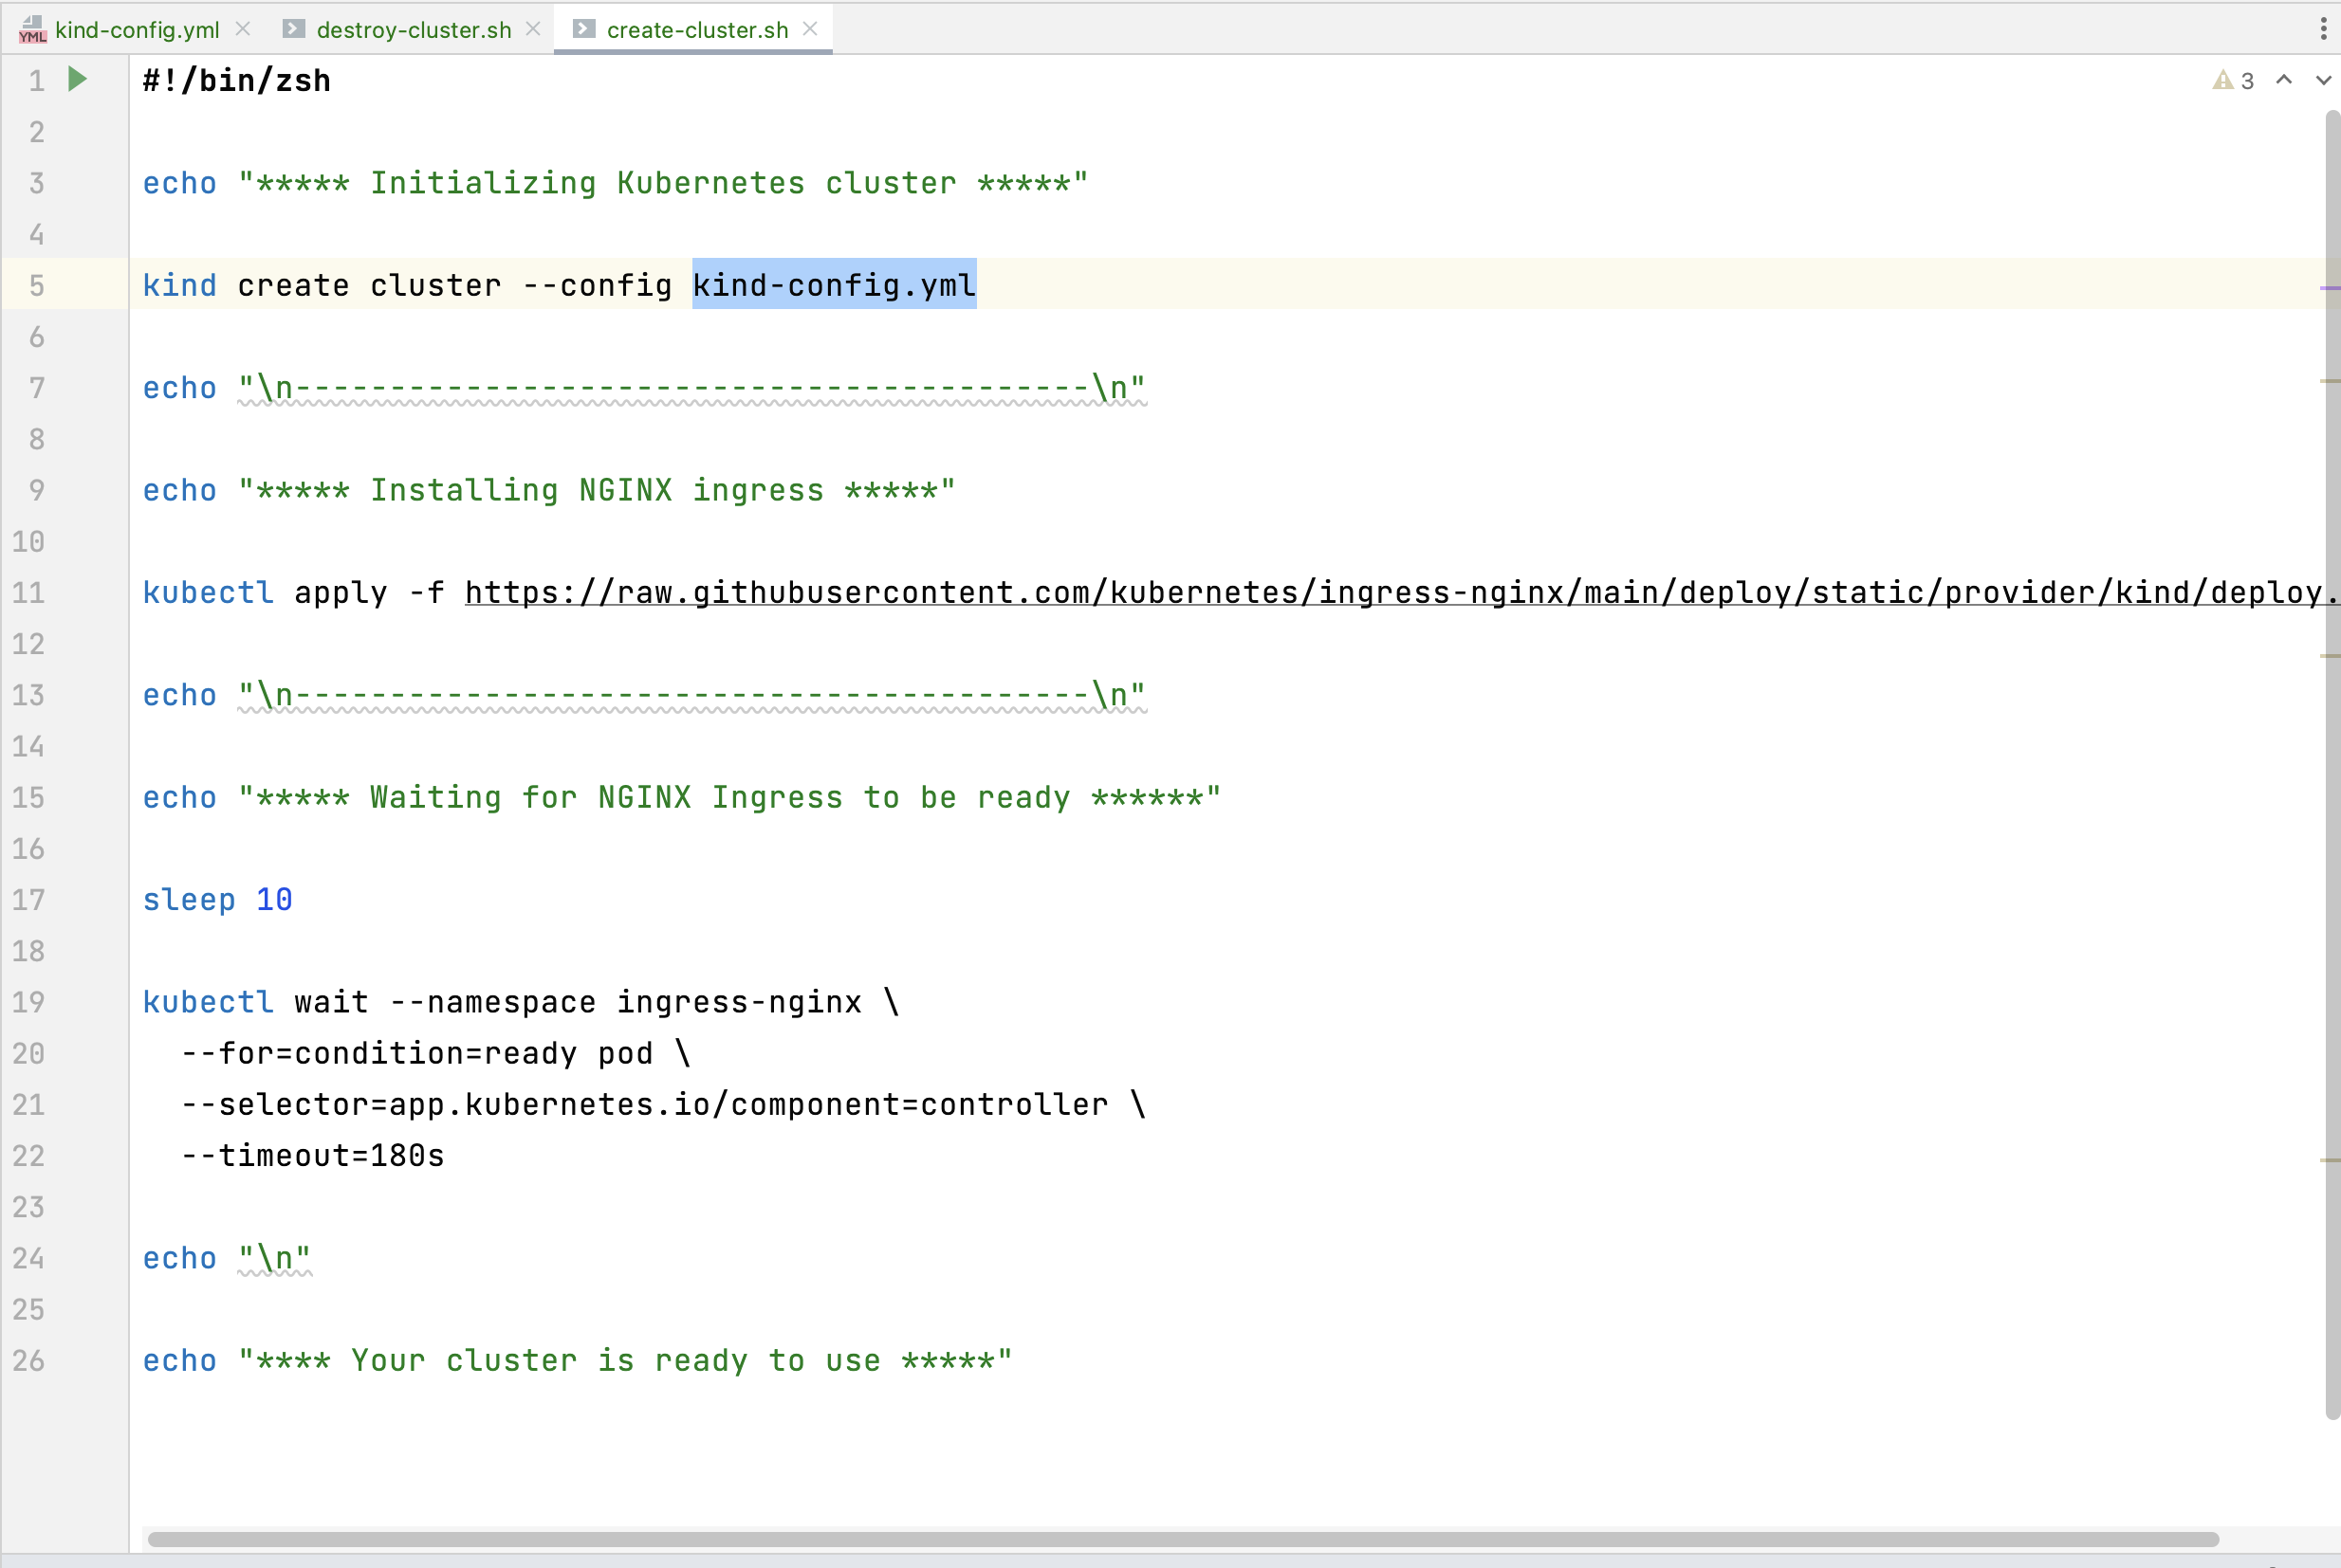

**delete-cluster.sh:**

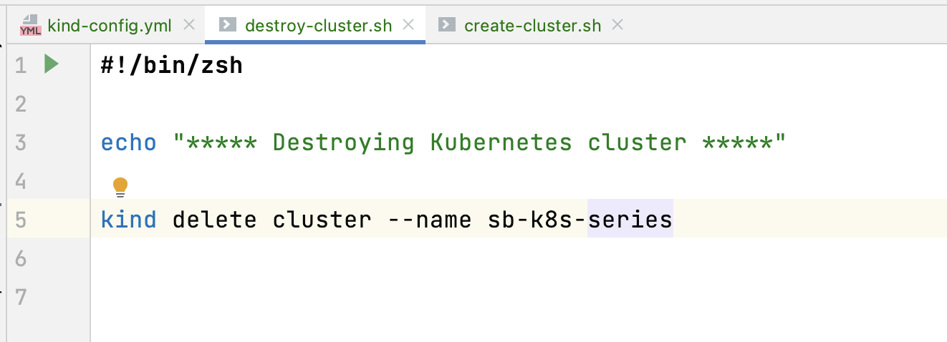

Once you create the cluster, download “lens” software for Kubernetes UI:

Download link: <https://k8slens.dev/>

Credentials:

Email: mani*****

Pass: Si****1

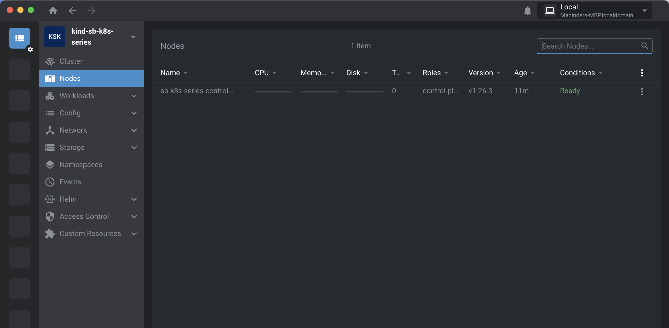

Commands for Kubernetes:

1. To check does pods exist:

**kubectl get pods**

1. To create pods:

**kubectl run bookmarker-api --image=maninder40407/bookmarker-api-jib --port=8080**

**bookmarker-api:** pod name

**maninder40407/bookmarker-api-lib:** image name

The command which we are running above is creating the pod but if you want to see the

Configuration inside this while creating pod, we can use command:

**kubectl run bookmarker-api2 --image=maninder40407/bookmarker-api-jib --port=8080 --dry-run=client -o yaml**

and we can also store these properties into yml file like this:

**kubectl run bookmarker-api2 --image=maninder40407/bookmarker-api-jib --port=8080 --dry-run=client -o yaml > pod2.yml**

It will print the output like this:

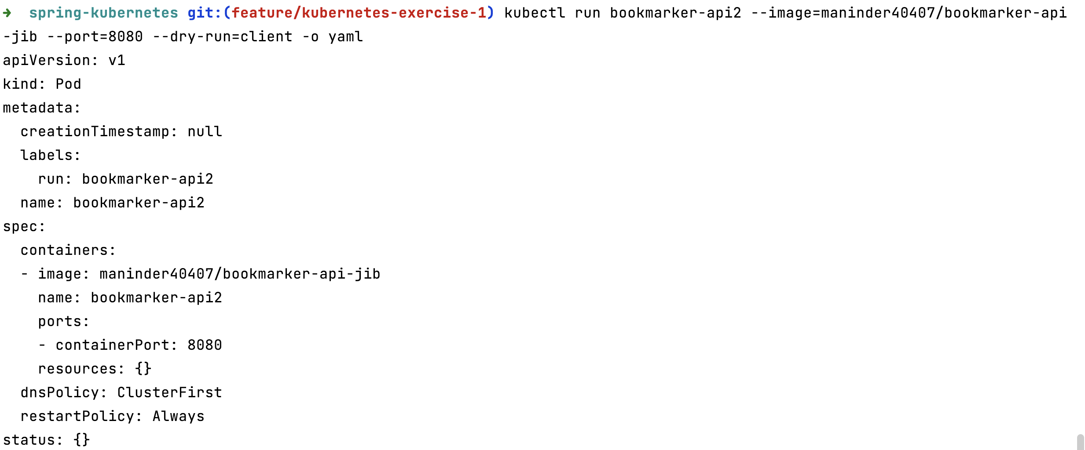

So, now we have yml and there is an alternative way to create the pod:

created one Yml file named as “pod.yml”:

run the command: **kubectl apply -f pod.yml**

pod.yml:

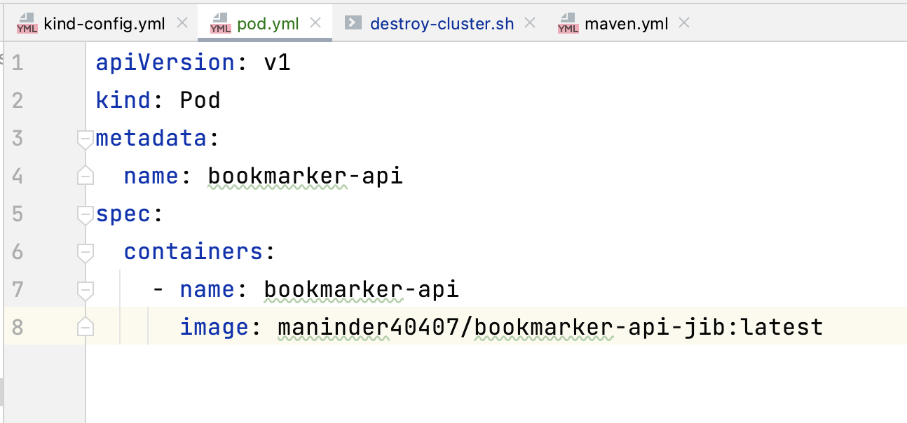

In this, I have mentioned the docker image name and now if I check the status of pod, it is working fine:

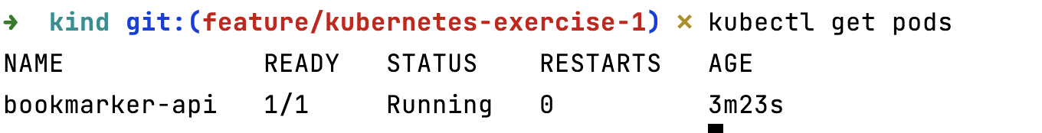

If you want to check the logs of pods you can use command:

“**kubectl logs bookmarker-api**”

“**kubectl logs bookmarker-api -f**”: it will load the logs continuously.

Now, let’s check either the pod can access the localhost:

Go inside the pod, using command:

kubectl exec -it bookmarker-api -- /bin/sh

install curl, if not installed:

apk --no-cache add curl

Able to access localhost:

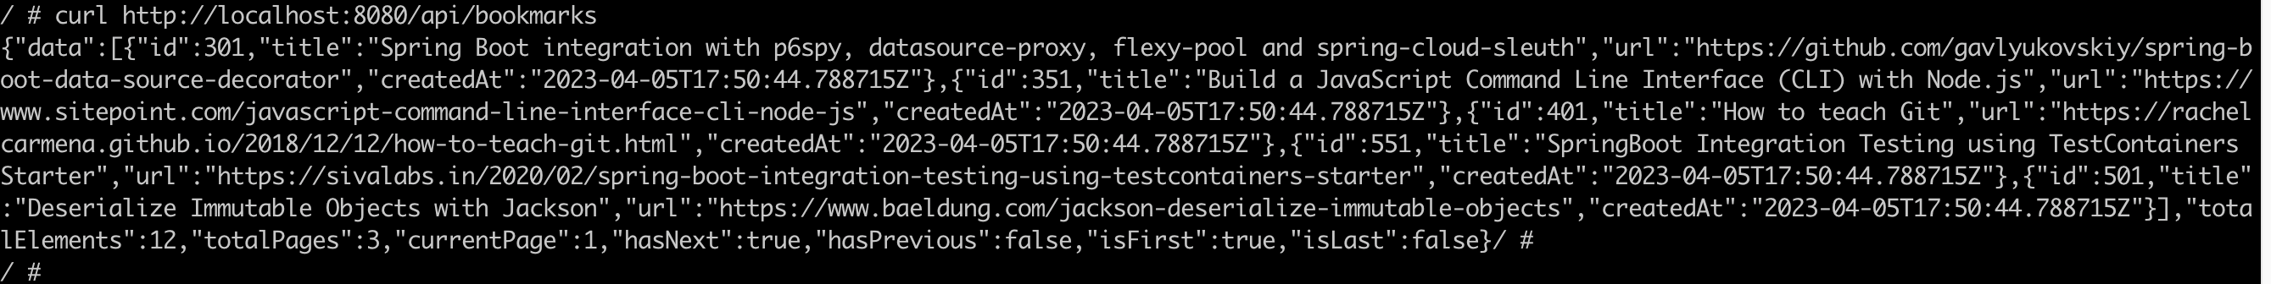

**How to create deployment:**

**kubectl create deployment bookmarker-api --image maninder40407/bookmarker-api-jib**

When this command run, it will create pod, deployment, replica set for you.

you can check it using:

**kubectl get all**

2. **delete deployment**:

kubectl delete deployment.apps/bookmarker-api

3. **create yml file from deployment command**:

kubectl create deployment bookmarker-api --image maninder40407/bookmarker-api-jib --dry-run=client -o yaml > deployment.y

ml

o is output, means output type is yaml file.

**Deployment Yml file:**

Inside this deployment yml, we removed the unwanted parameters that were not required.

Line: 10 to 12 are very important in below mentioned screenshot. As we know, when we create the deployment during that time it also creates the pod, replica set and deployment.

All the things were done on the behalf of label that we mention line no: 12.

Template line no:13 matches with label of line no: 12 and create the pod for it:

Deployment line 6 matches with label of line no: 12 and create deployment for it.

By default, the replica set is 1.

Our spring boot app is using postgres DB as backend so we will create 2 deployments for our project. One is for spring boot app and other is for postgres DB.

Run the command: kubectl apply -f deployment.yml

You can scale up and down the replicas any time. One way is just change the replica set count in yml file mentioned above and deployed again.

kubectl apply -f deployment.yml

Another way is using command:

kubectl scale deployment bookmarker-api --replicas=3

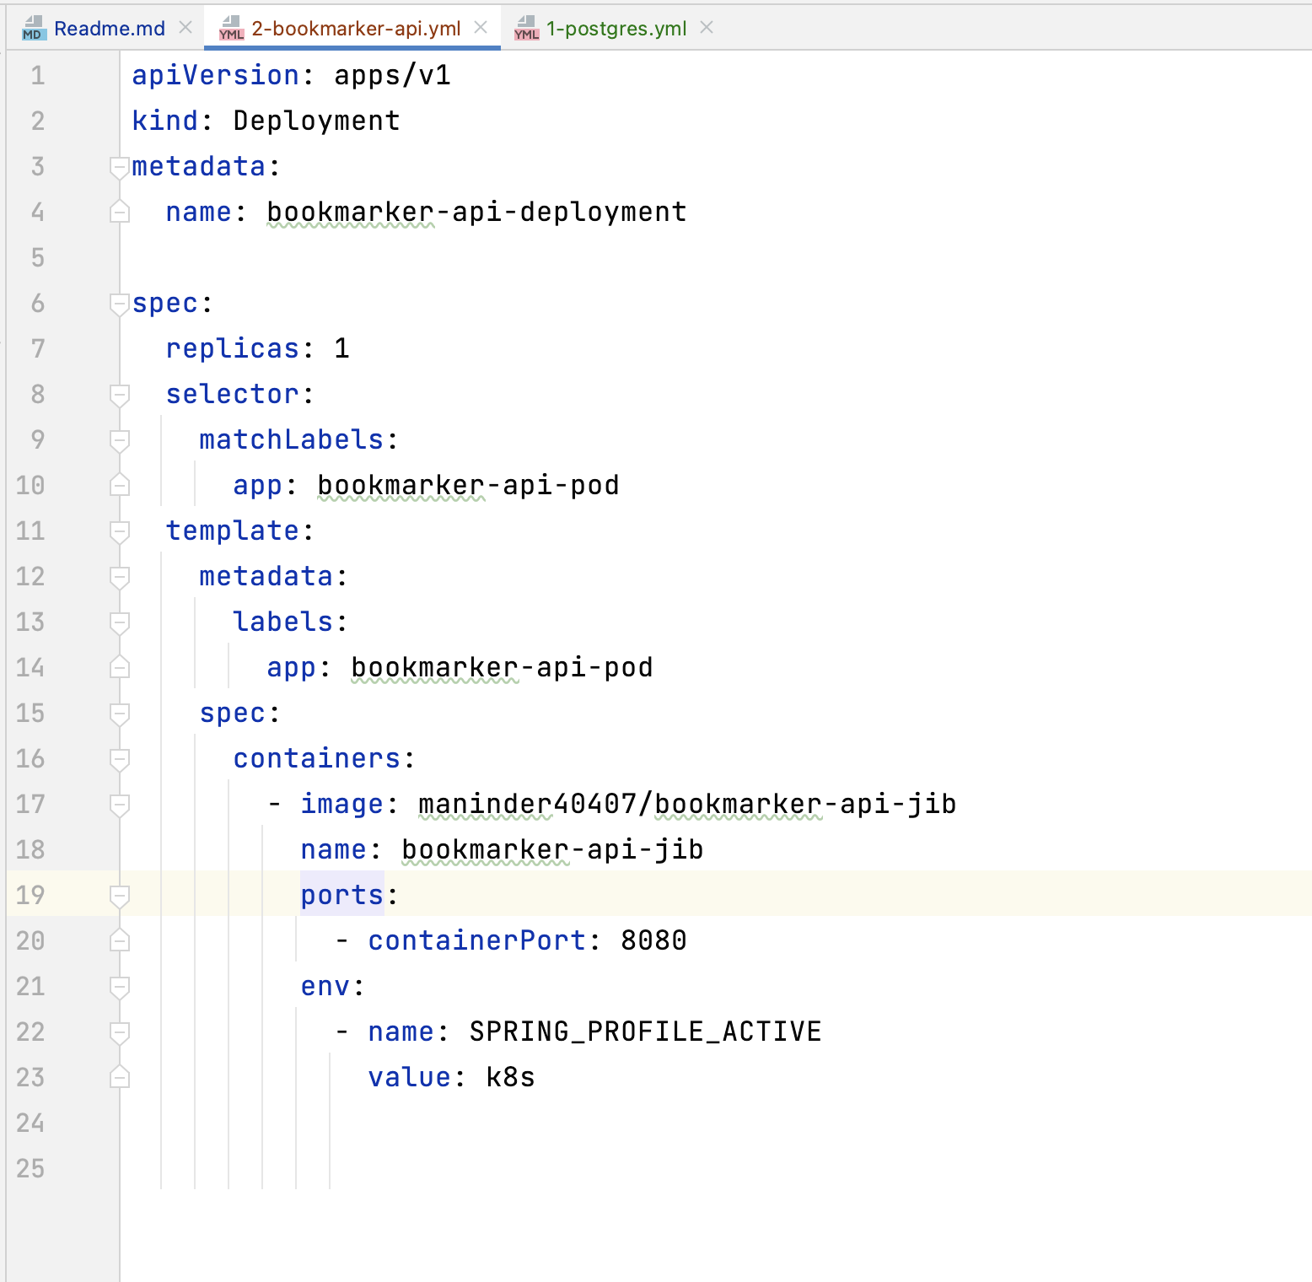

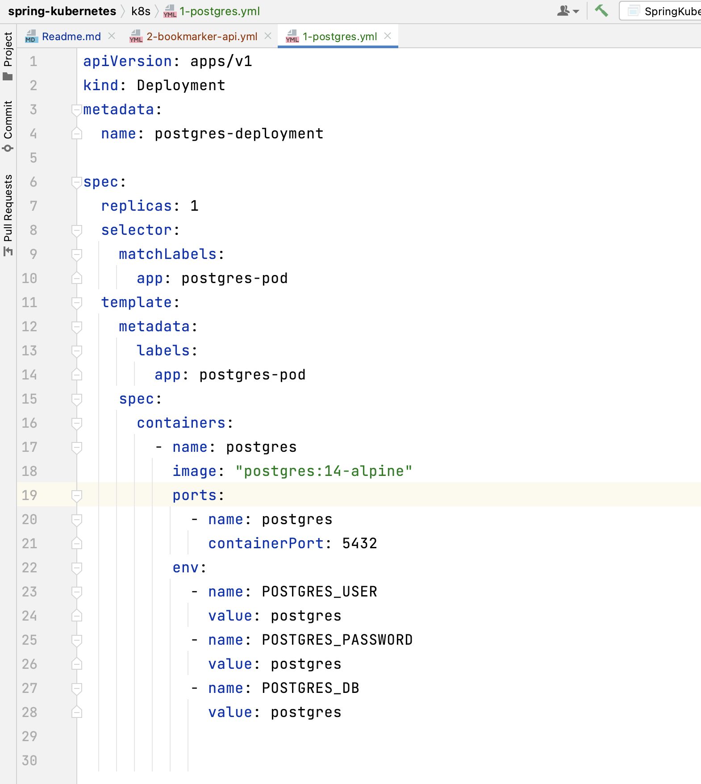

In above screenshot, line no: 24 to 28, we have shared the postgres credentials in yml file, that’s not a right approach to do it. So, for this, we need to configure ConfigMap and secret.

**ConfigMap and Secret:**

**providing host, DB, username, password.**

Meantime, we did not setup the secret, so we are also storing the database name and password in ConfigMap. Once we configure the secret, then we will move database name and password in secret as these are sensitive data.

**Command**:

kubectl create configmap bookmarker-config --from-literal=postgres_host=postgres --from-literal=postgres_username=postgres --from-literal=postgres_password=postgres --from-literal=postgres_db_name=appdb --dry-run=client -o yaml > 1-config.yml

**run command:** kubectl apply -f 1-config.yml

Yml file looks like:

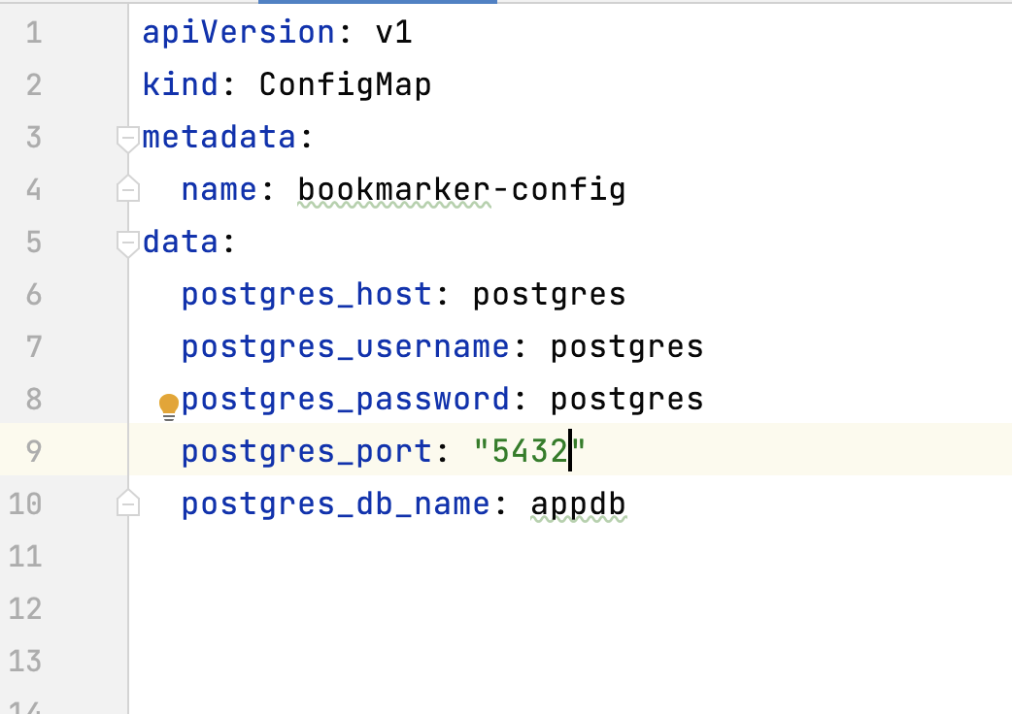

**you can see it:**

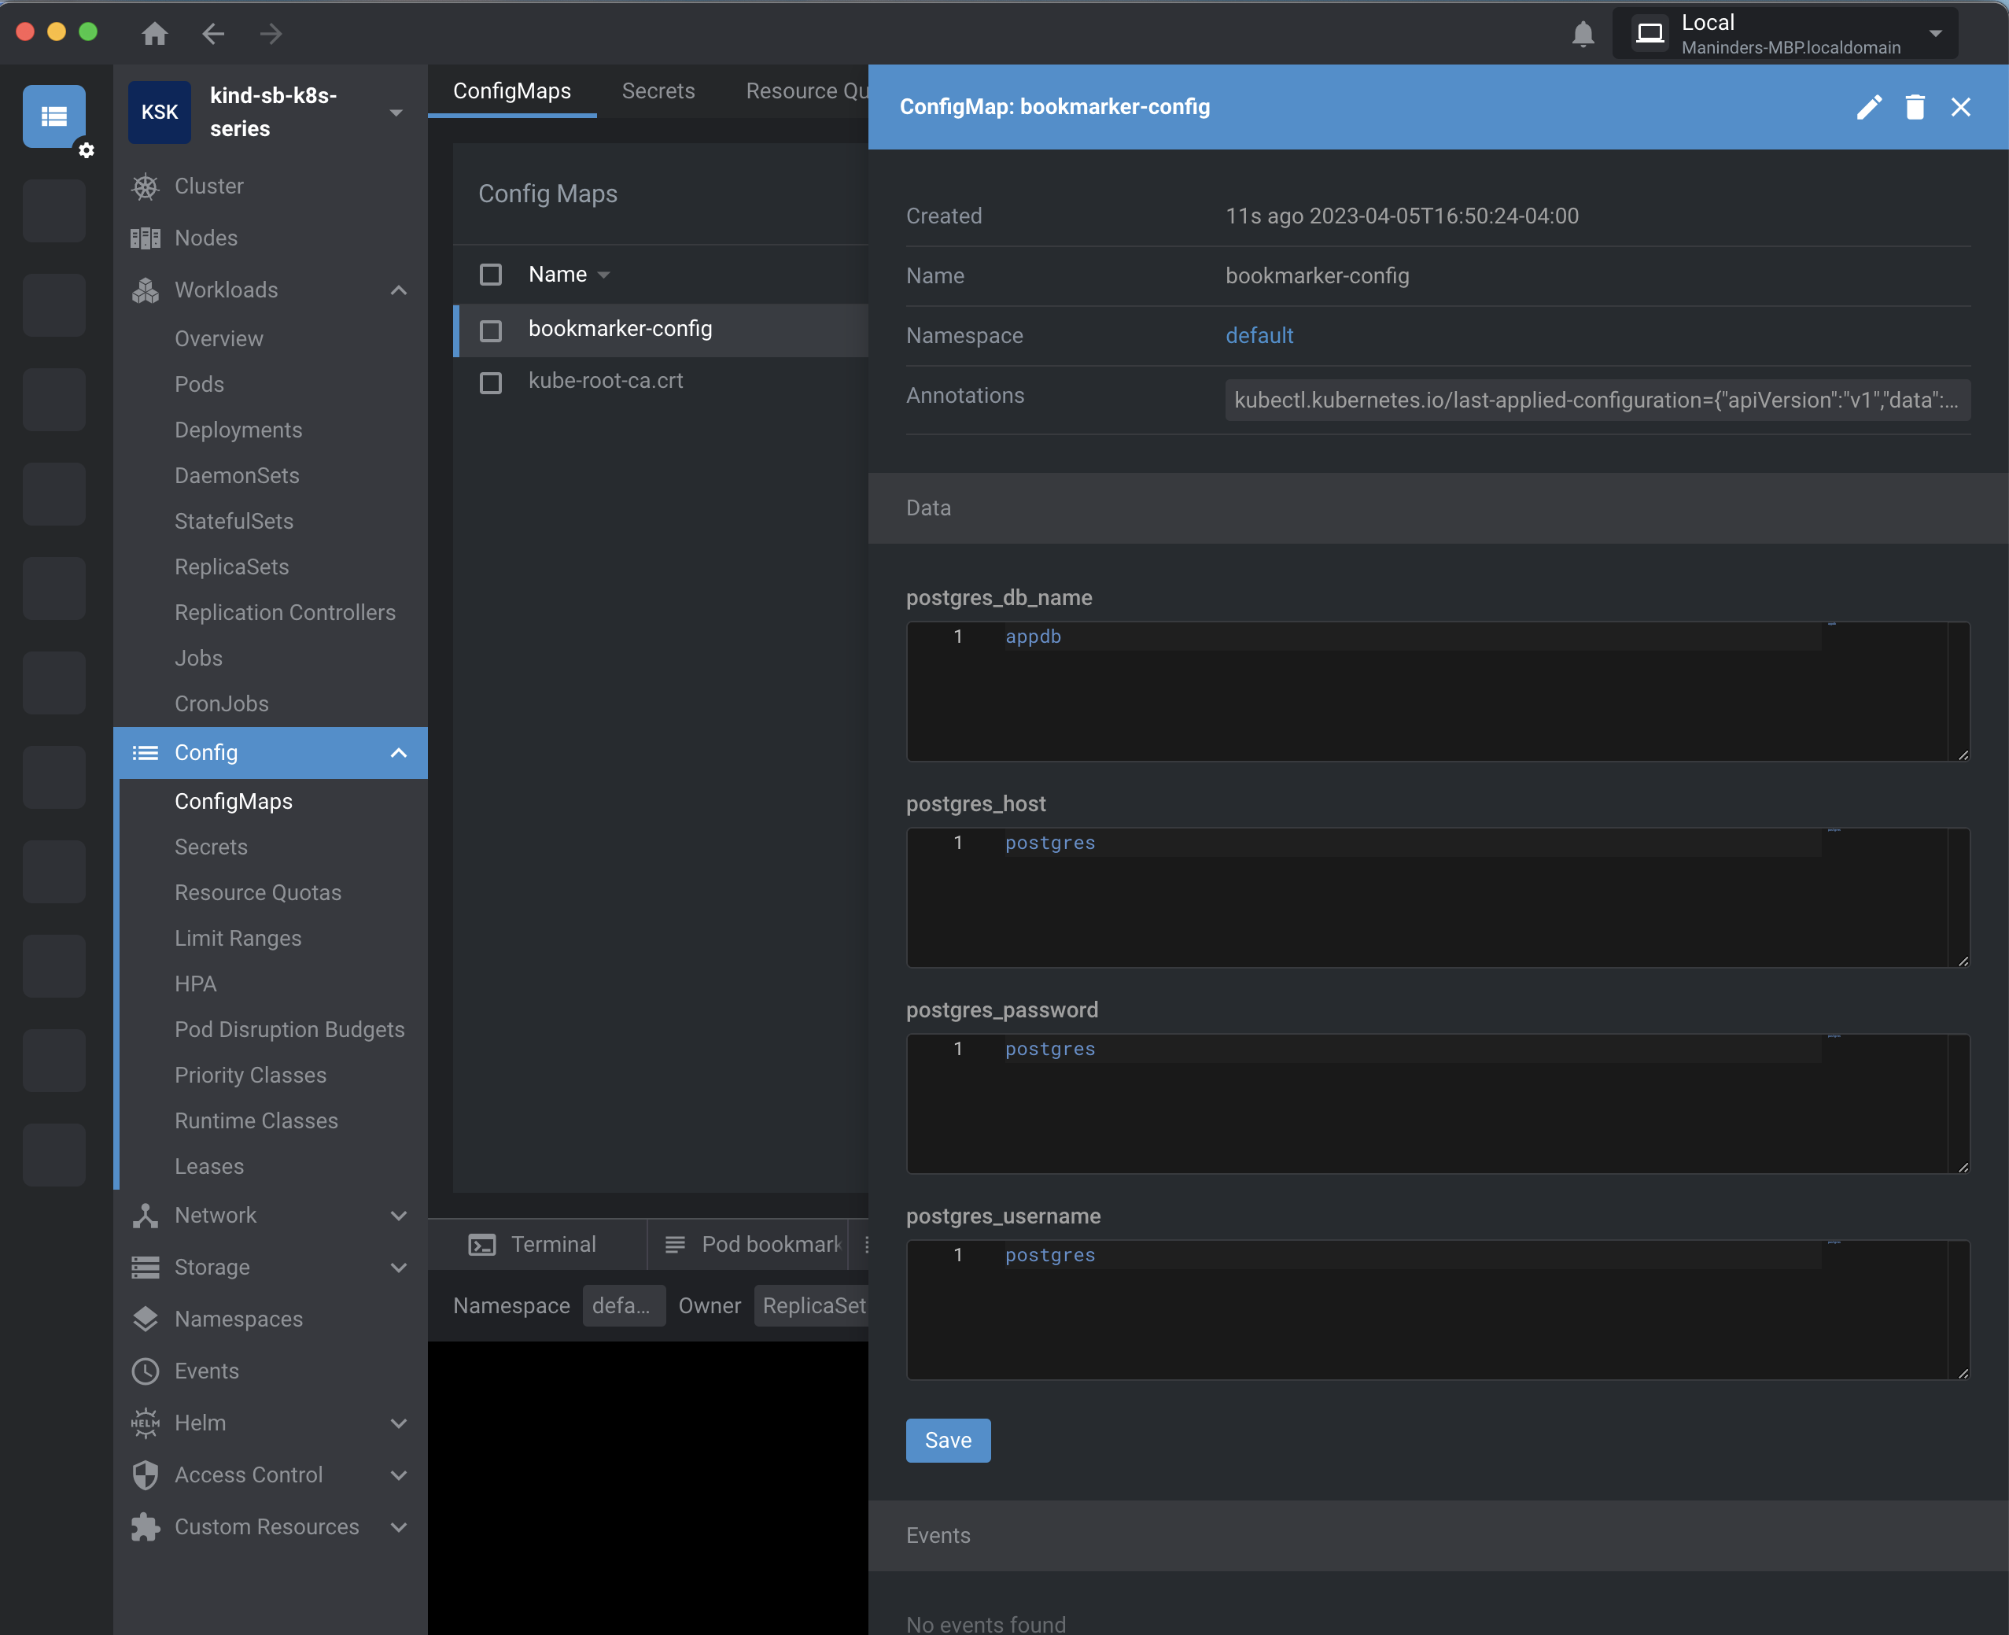

As we implemented the ConfigMap, it time to use these properties in our deployment files:

**postgres.yml file:**

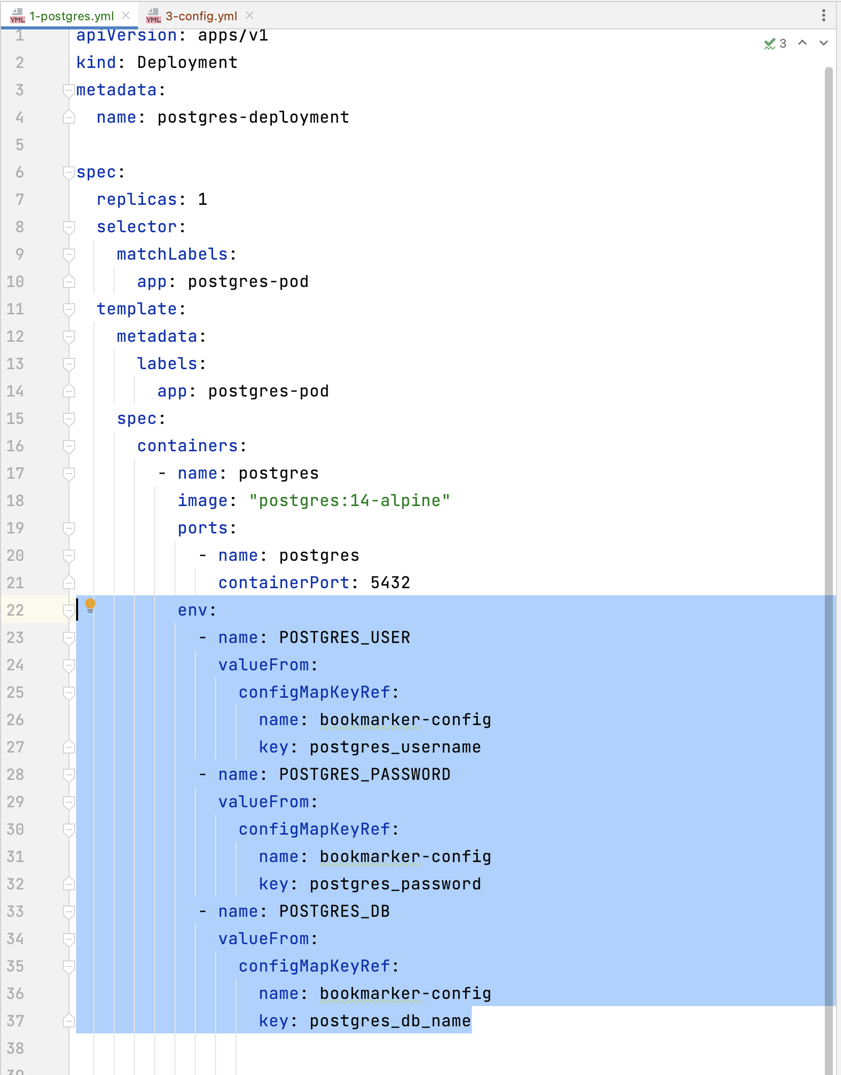

Redeploy the deployment again using:

**kubectl apply -f .**

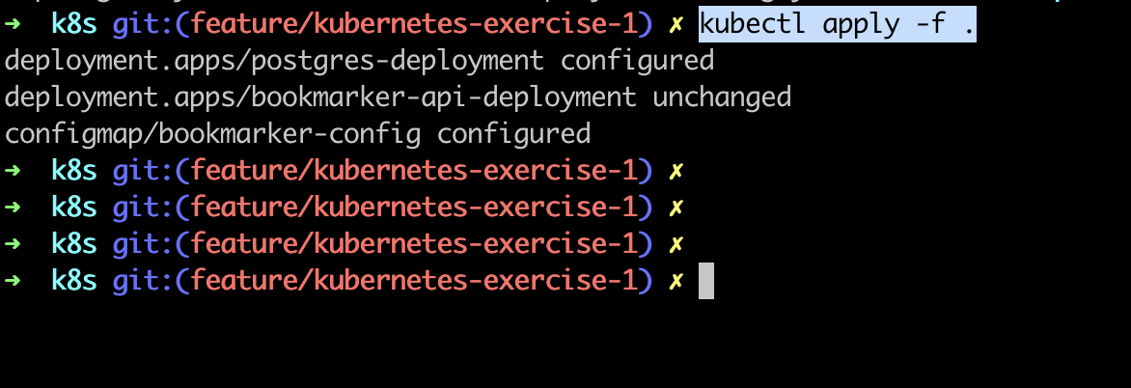

Now, see the environment properties for postgres:

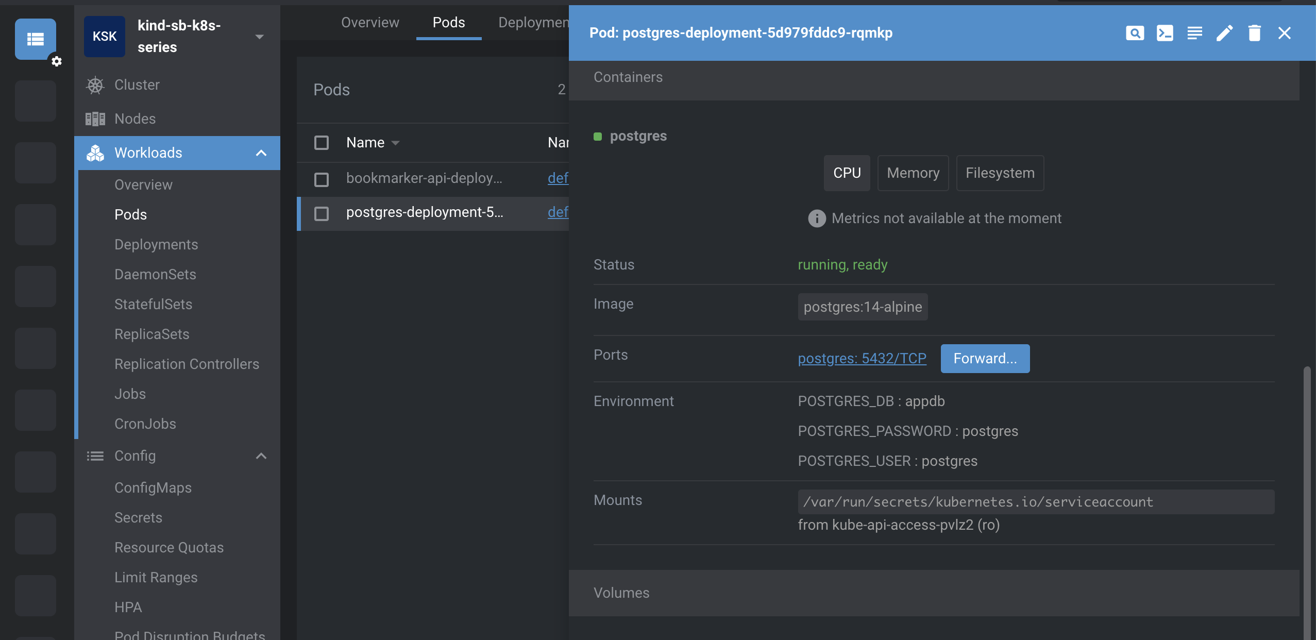

It is picking values from ConfigMap.

**Secret:**

Command:

**kubectl create secret generic bookmarker-secrets --from-literal=postgres_username=postgres**

Meantime, we are only put the username under secret.

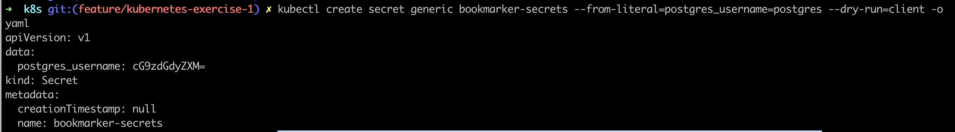

Sample.txt: This is same as mentioned above. For better seeing, copying below:

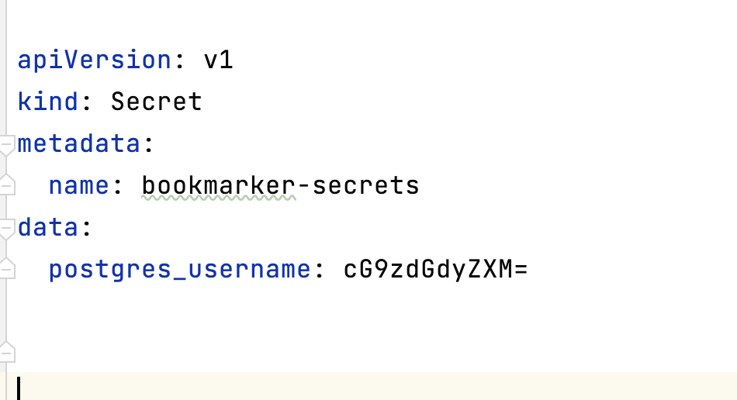

**Postgres_username** is generated in encrypted form but still it is not safe because we can decode this encrypted data using Base64. For instance:

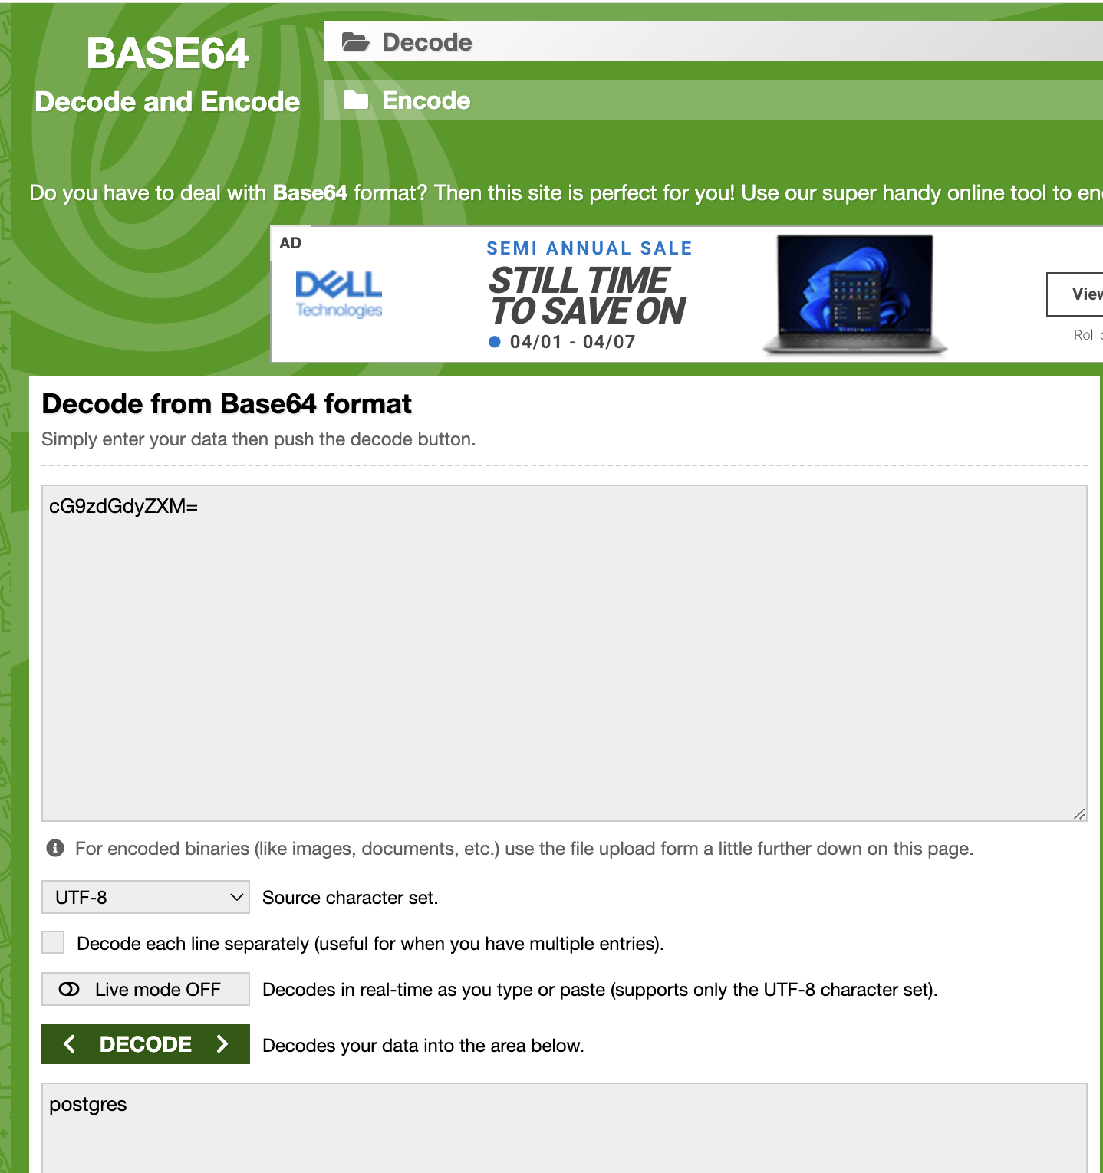

It is telling you that encrypted data is postgres.

There are multiple types of secret, so we need to mention that we are using this type of secret.

For instance: we are using “Opaque” type of secret:

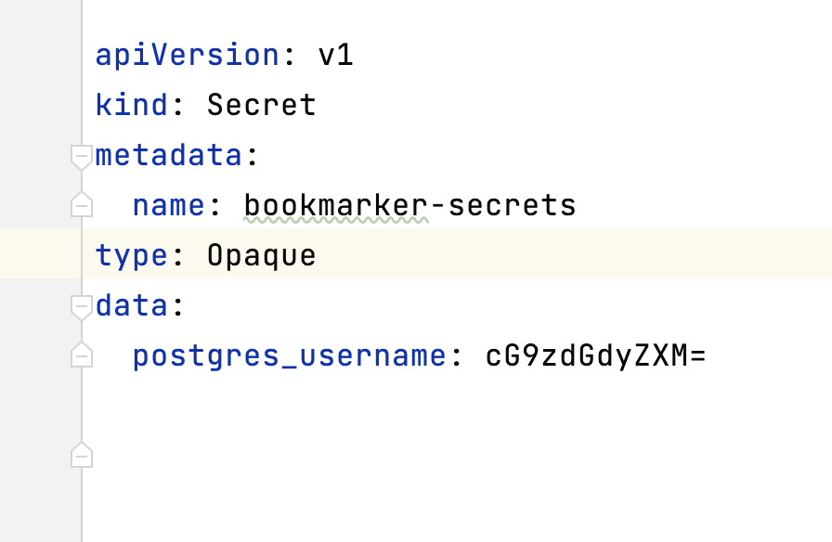

I want postgres username and password as sensitive data so moving it to the secret section:

The base64 code for “postgres”, I put in username and password. After changes, file looks like:

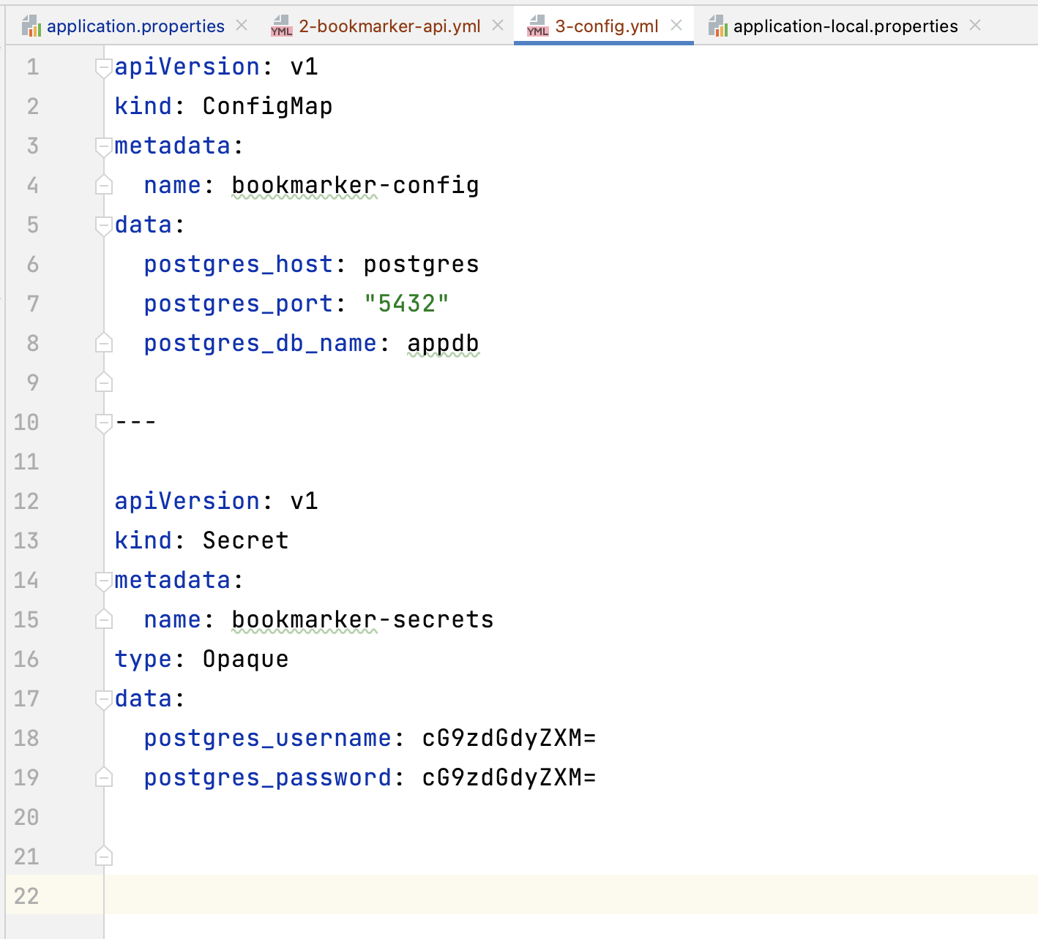

Line no 18 and 19 decrypted form is “postgres”.

So, now we have moved the postgres username and password in, secret section. Now, we need to change the same under postgres deployment yml file:

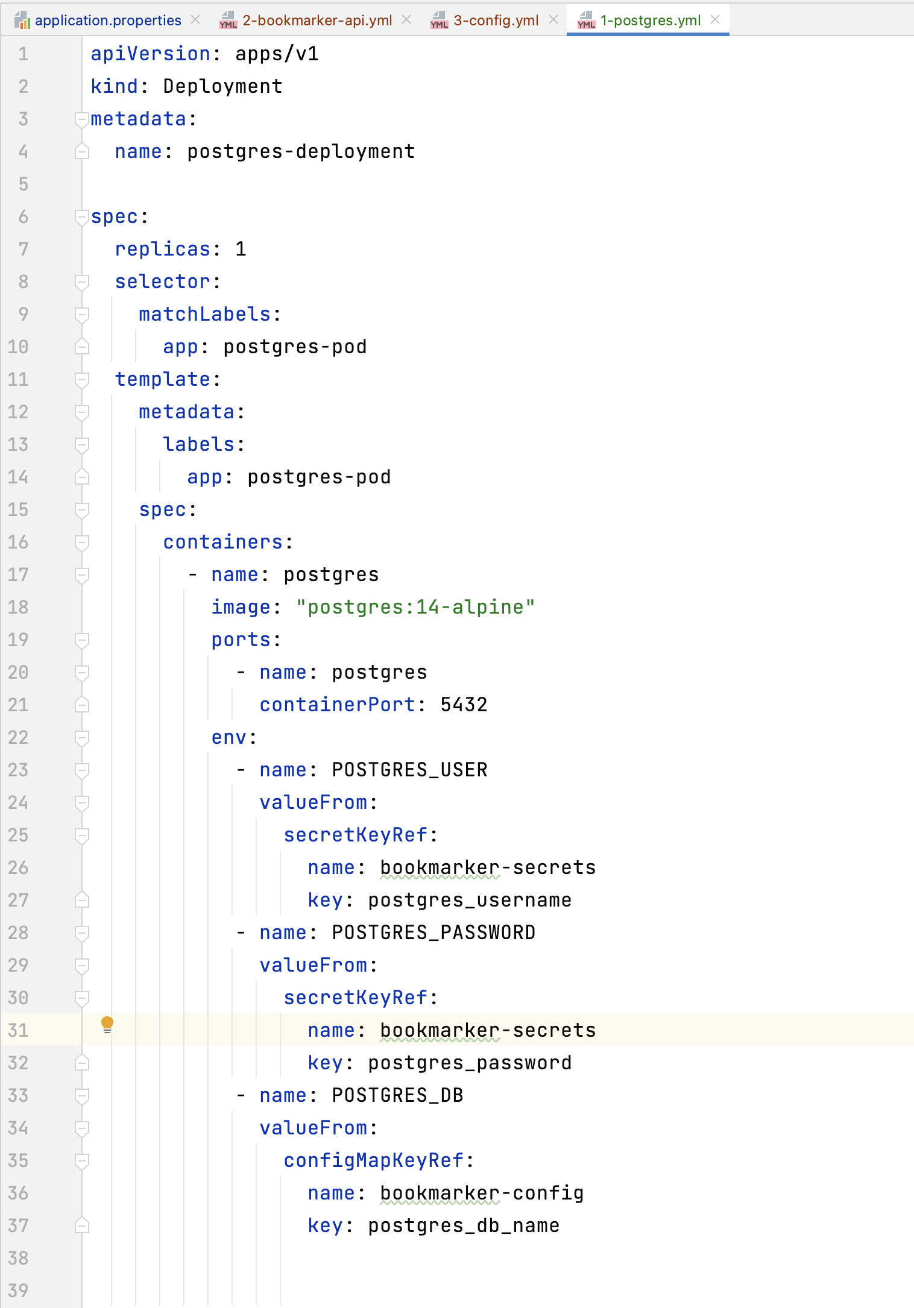

Line no 25 and 30 changed from ConfigMap to secrets.

Same thing we need to change it for bookmarker deployment yml file:  
On line 41 and 46 replaced ConfigMap with secrets:

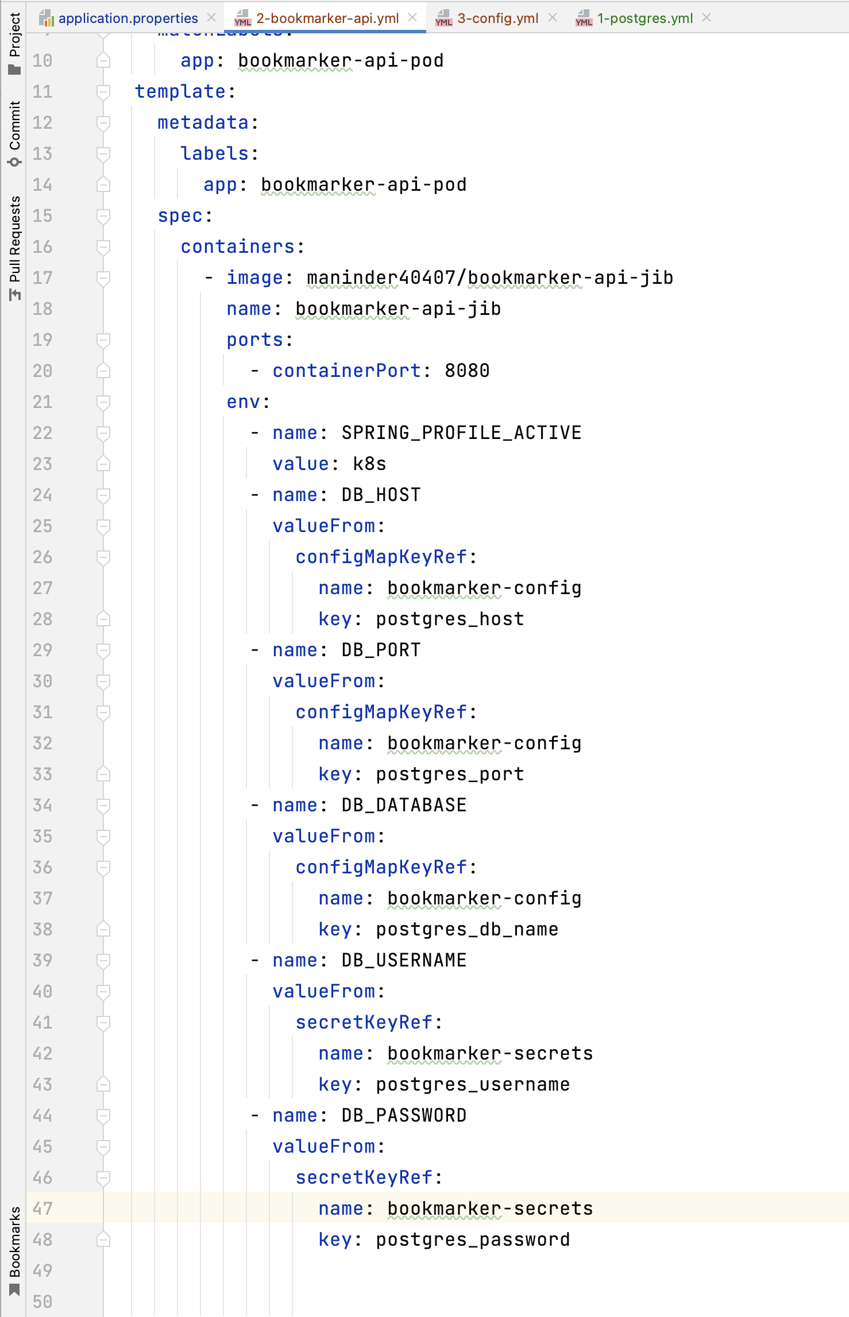

Now apply the changes using:

“kubectl apply -f .”

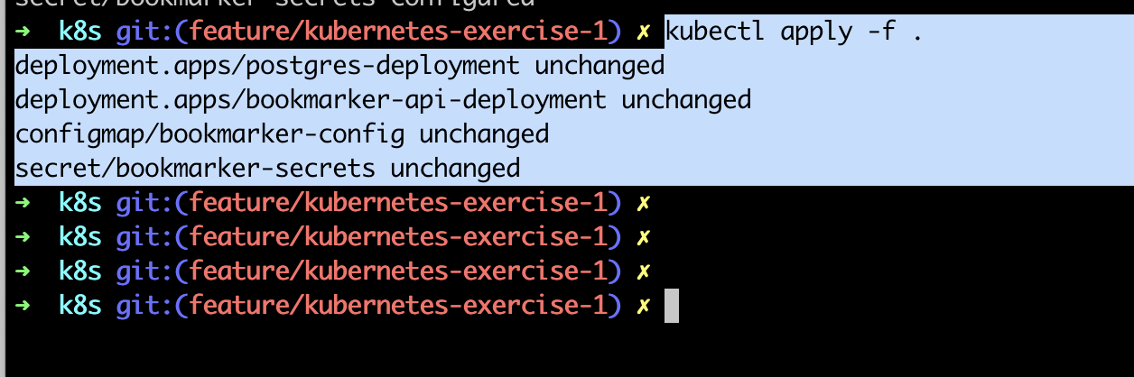

**Secrets values**:

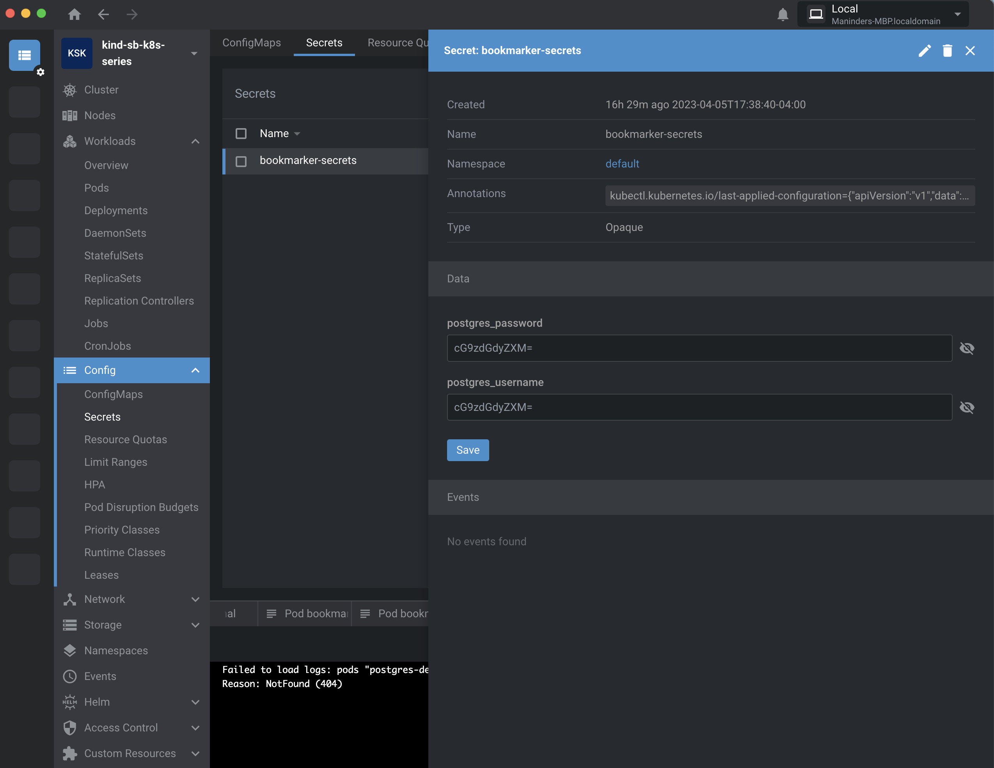

**ConfigMap**:

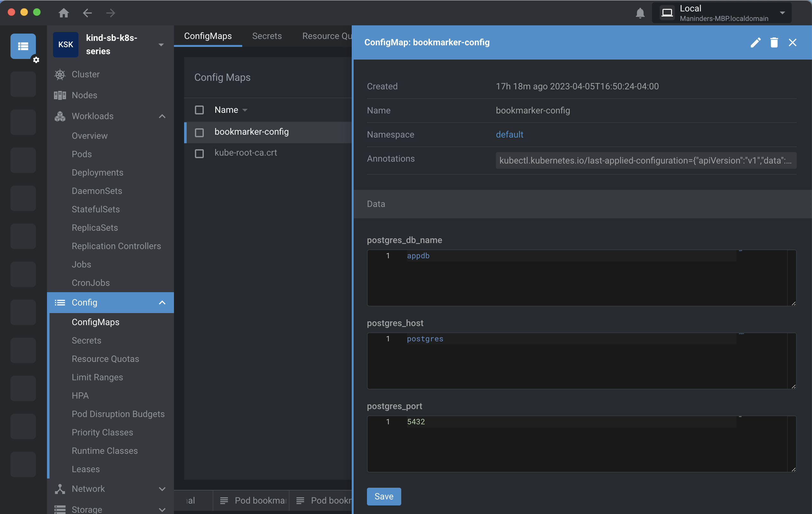

Check the postgres pod environment values: picking values from secrets.

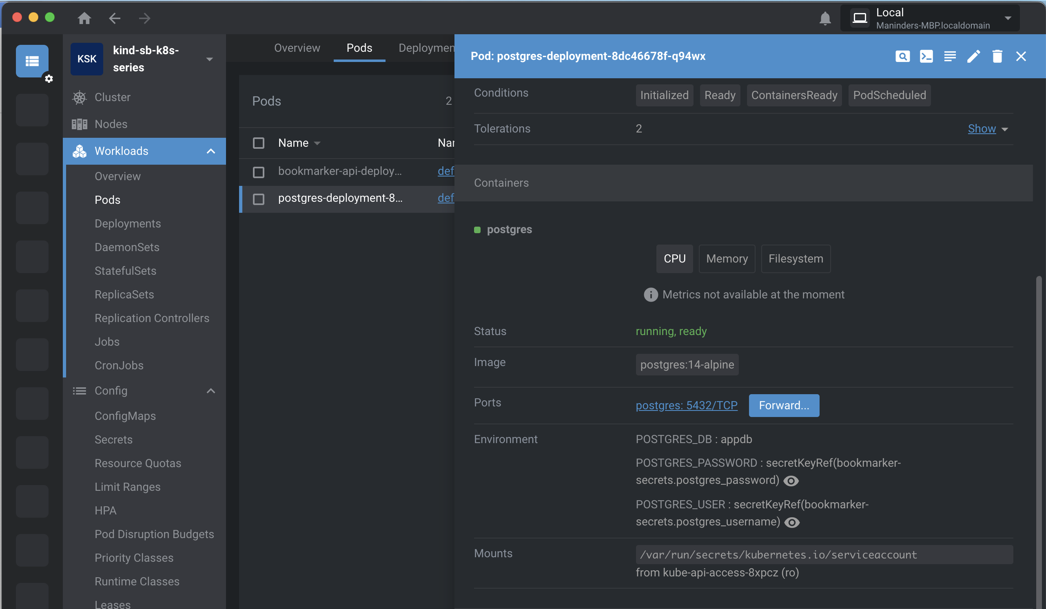

**Volumes:**

As of now, we have implemented pods, but we haven’t implemented the volume for any pod. So, in case if we restart the pod then the entire data will be deleted and data is more important than pods. Docker has a concept of volumes though it is somewhat looser and less managed.

Docker volume is a directory on disk or in another container. Docker provides volume drivers, but the functionality is somewhat limited. Ephemeral volume types have a lifetime of a pod, but persistent volumes exist beyond the lifetime of a pod. When a pod ceases to exist, Kubernetes destroys ephemeral volumes; however, Kubernetes does not destroy persistent volumes. For any kind of volume in each pod, data is preserved across container restarts.

Below is the example to define persistent volume and persistent volume claim for postgres DB:

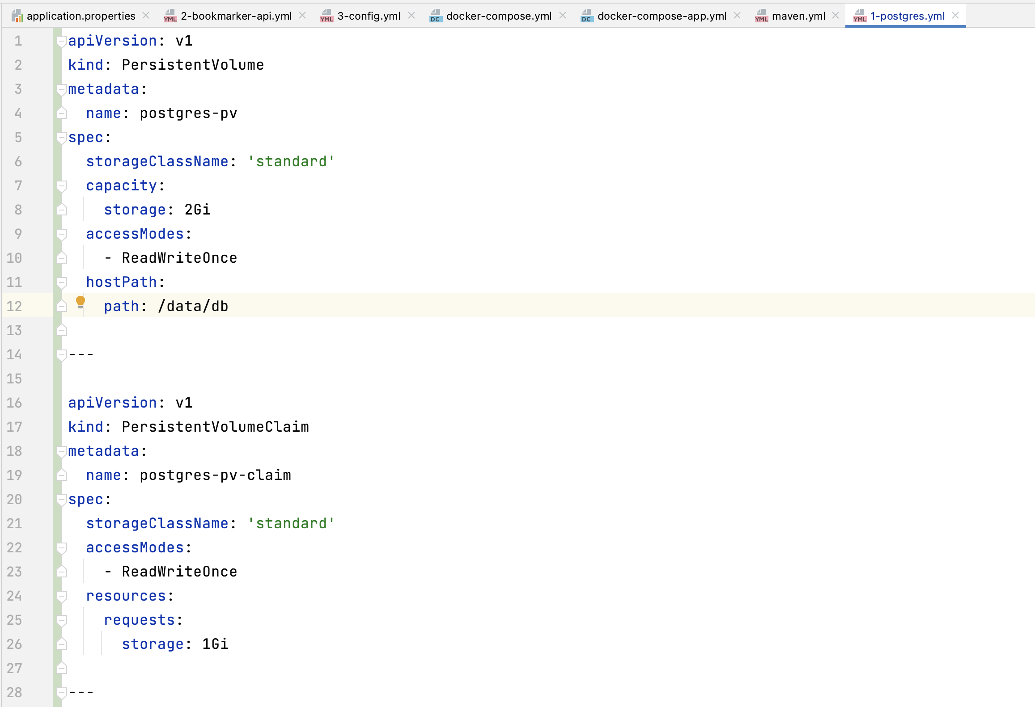

We can define multiple properties under same yml file using “---” between these properties.

We have added persistent volume and persistent volume claim in above yml file:

Basic understand you can get it from:

<https://kubernetes.io/docs/concepts/storage/volumes/>

persistent volume claim is basically if a user wants more GB to store the data then we need to declare the persistent volume claim.

When a pod needs a piece of storage, it creates a PVC, specifying the size and access modes that it requires. **The PVC then looks for an available PV that can satisfy its requirements**. If a matching PV is found, the PVC is bound to it. In above example, persistent volume claim looks for persistent volume specification. If it’s same, then it will use it. In our case persistent volume claim need storage of 1GB and our persistent volume has the storage of 2GB. So in this case our persistent volume claim will use this persistent volume because spec are same and also met the criteria but suppose persistent volume claim needs the memory of 3 GB but out persistent volume has only 2GB limit then in this case it will create the new persistent volume that meets the criteria.

If there is no matching PV, the cluster dynamically provisions a new one that satisfies the PVC's requirements.

The PVC is responsible for the lifecycle of the volume it requests. It can be deleted, resized, or bound to a different PV. The PV, on the other hand, is responsible for the lifecycle of the underlying storage.

In summary, a PV is a piece of storage that is provisioned in the cluster, while a PVC is a request for storage made by a pod. A PVC is used to dynamically provision a PV and manage its lifecycle.

These properties we have defined it in our yml file still not used by our postgres deployment. Let’s do it:

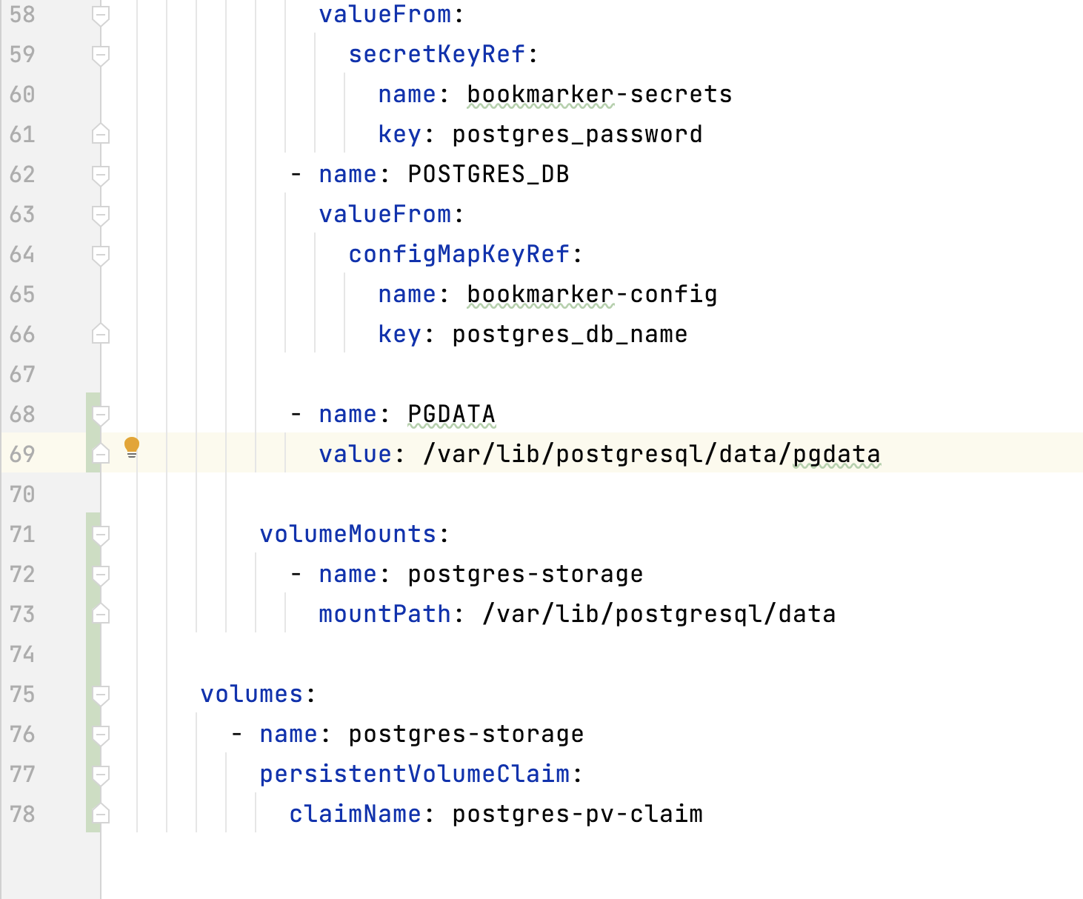

We have added the code from line no: 68 to 78.

First define, the volume and in which we mention the volume name and looking for “**persistentVolumeClaim**”, it will look for “**postgres-pv-claim**”, that we created above.

Then we mount the volume using its name. we used “**volumeMounts**”, in which we are mentioning the volume name that we goanna use it. In our case it’s “**postgres-storage**”

In short:

1. Persistent volume claim we created above.
2. Using this persistent volume claim in “volumes” by passing its name.
3. Then we are using volumes and mount it to the “**volumeMount**” by passing its name.

Once we are done, apply the changes using command:

“kubectl apply -f .”

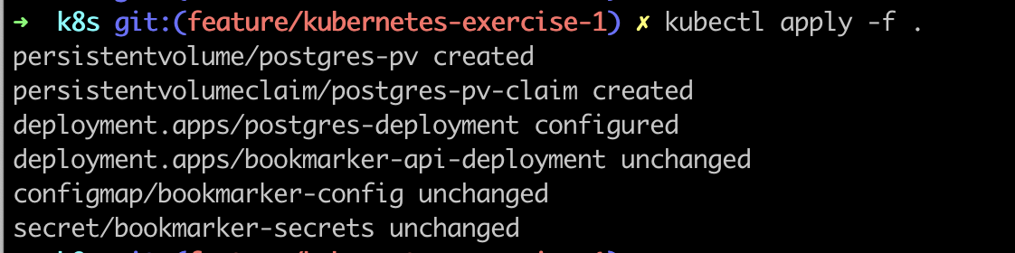

Now verify, the volumes:

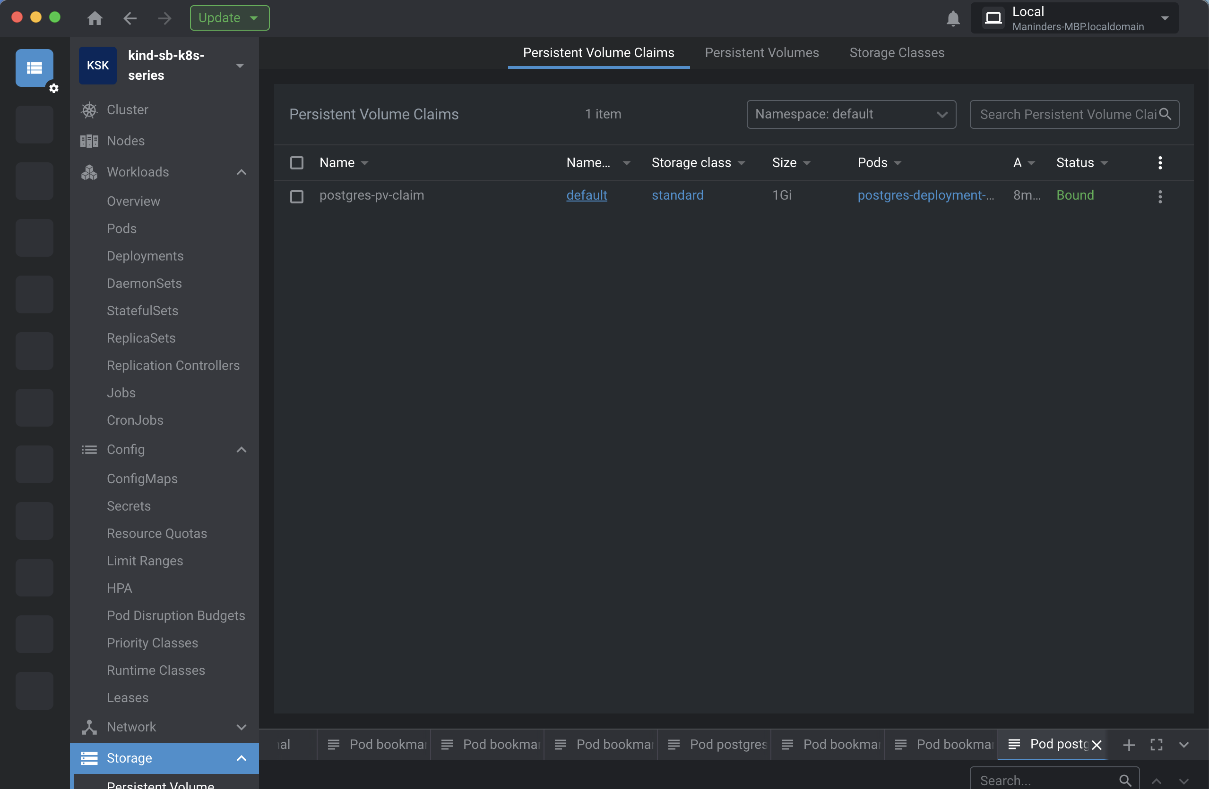

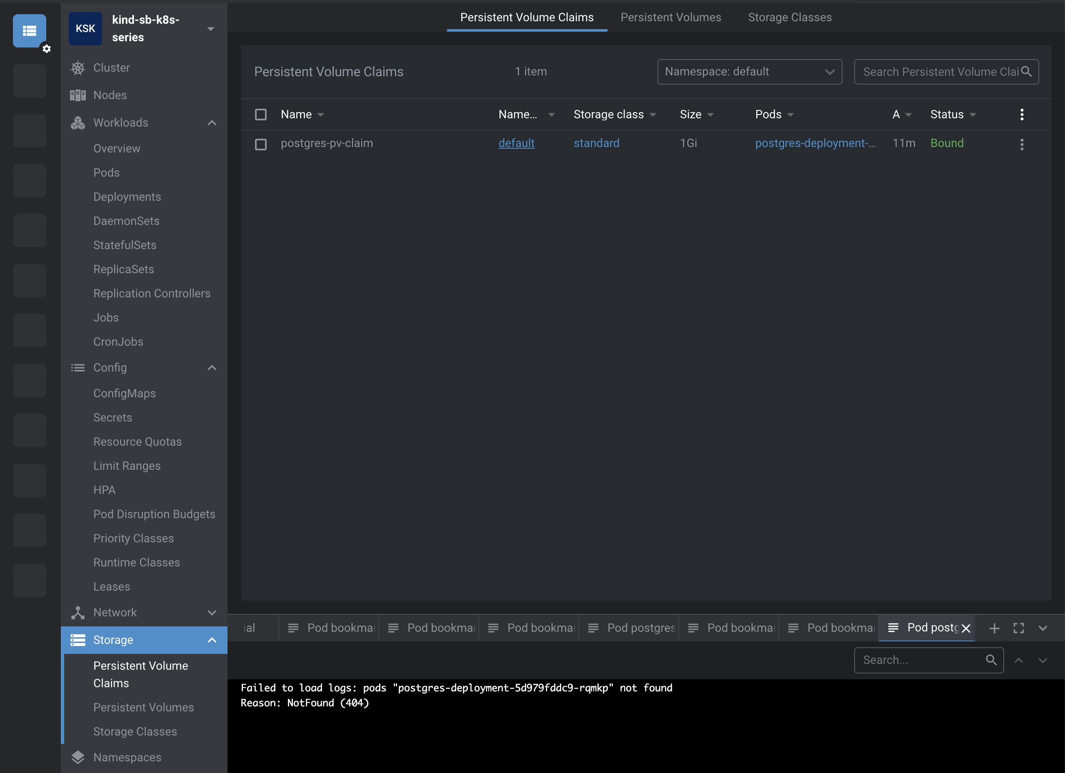

If you see its status, it is “**Bound**” it means it is bound with pod named start with “postgres-deployment”. It is not free. If it’s not used by anyone, then it’s status will be available.

**How to expose pods using service:**

Suppose you are running an application having 5 instances means 5 pods are running for that application. So how client reach out to your application when it has 5 instances. I have explained above, how the service in Kubernetes provides 1 IP address for the clients even there are multiple IP running at the backend.

How to define service in yml file:

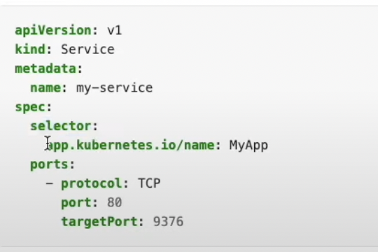

**Name**: name of service

**Selector**: is the main key of this configuration. Here we are saying that any pod which have label “**MyApp**”, will be use this service. When someone hit this port: 80 then it will call the pod which have label “**MyApp**”. The service will be available on port 80. Whenever it receives a call on this port then it will be forward to port 9376.

There is various type of services:

1. clusterIP
2. nodePort
3. loadBalancer
4. externalName

**clusterIP**: this is default service layer if you don’t provide anything. This is available only inside the cluster. For example: your backend DB is postgres so you don’t want to expose this DB to outside so you will mark it as a clusterIP service. Any public cannot be access to this service.

**nodePort**: It is also like the clusterIP, but it is also accessible on the static port. You can reach to this node port using the cluster IP. Suppose we created an API so user wants to access it so we need to provide him an IP address which he can use to access our application. On the other side, like spring boot app using postgres as DB but we don’t want to access this DB from outside, so we marked it as **clusterIP**.

If you are working on cloud platform then mostly you will use loadBalancer, externalName but if you are working local then you will use clusterIP and nodePort.

Here is the sample in which we are using service in our postgres yml file:

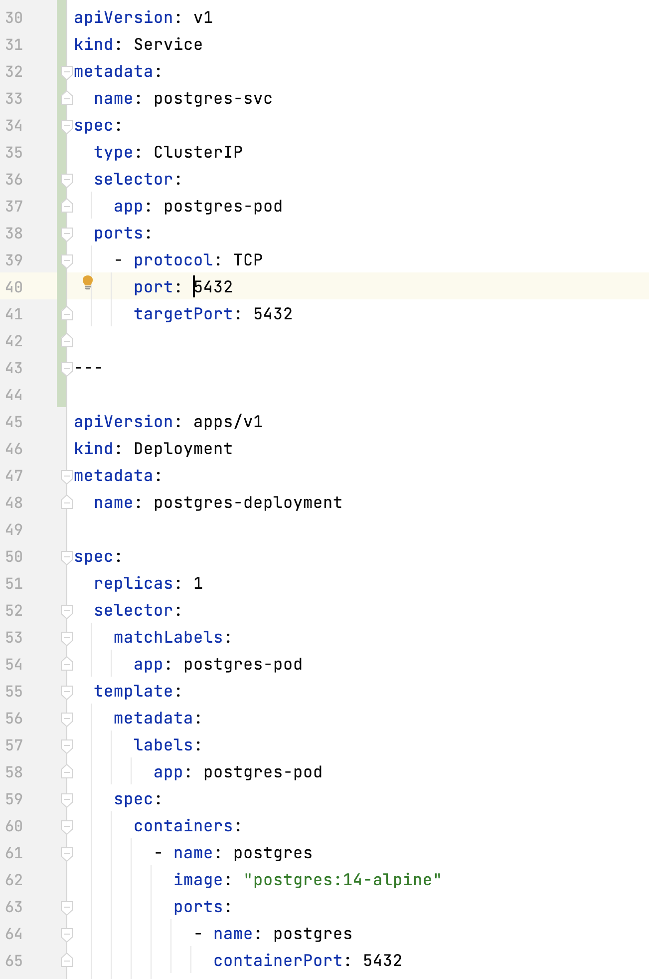

Line 30-40, we have defined the service line no:37, label is mentioned on the behalf of this label, service should know which pod is going to use this service. This label should be also defined in deployment as we did online: 54.

In short, service will use “**label**” of deployment. Our deployment label was “**postgres-pod**” that we mentioned on line 54. So same label name, we defined in our service on line 37.

Now, our postgres pod will connect using service and service name is “postgres-svc”.

So now postgres pod is connected using postgres-svc, so we need to change the host name in our config file:

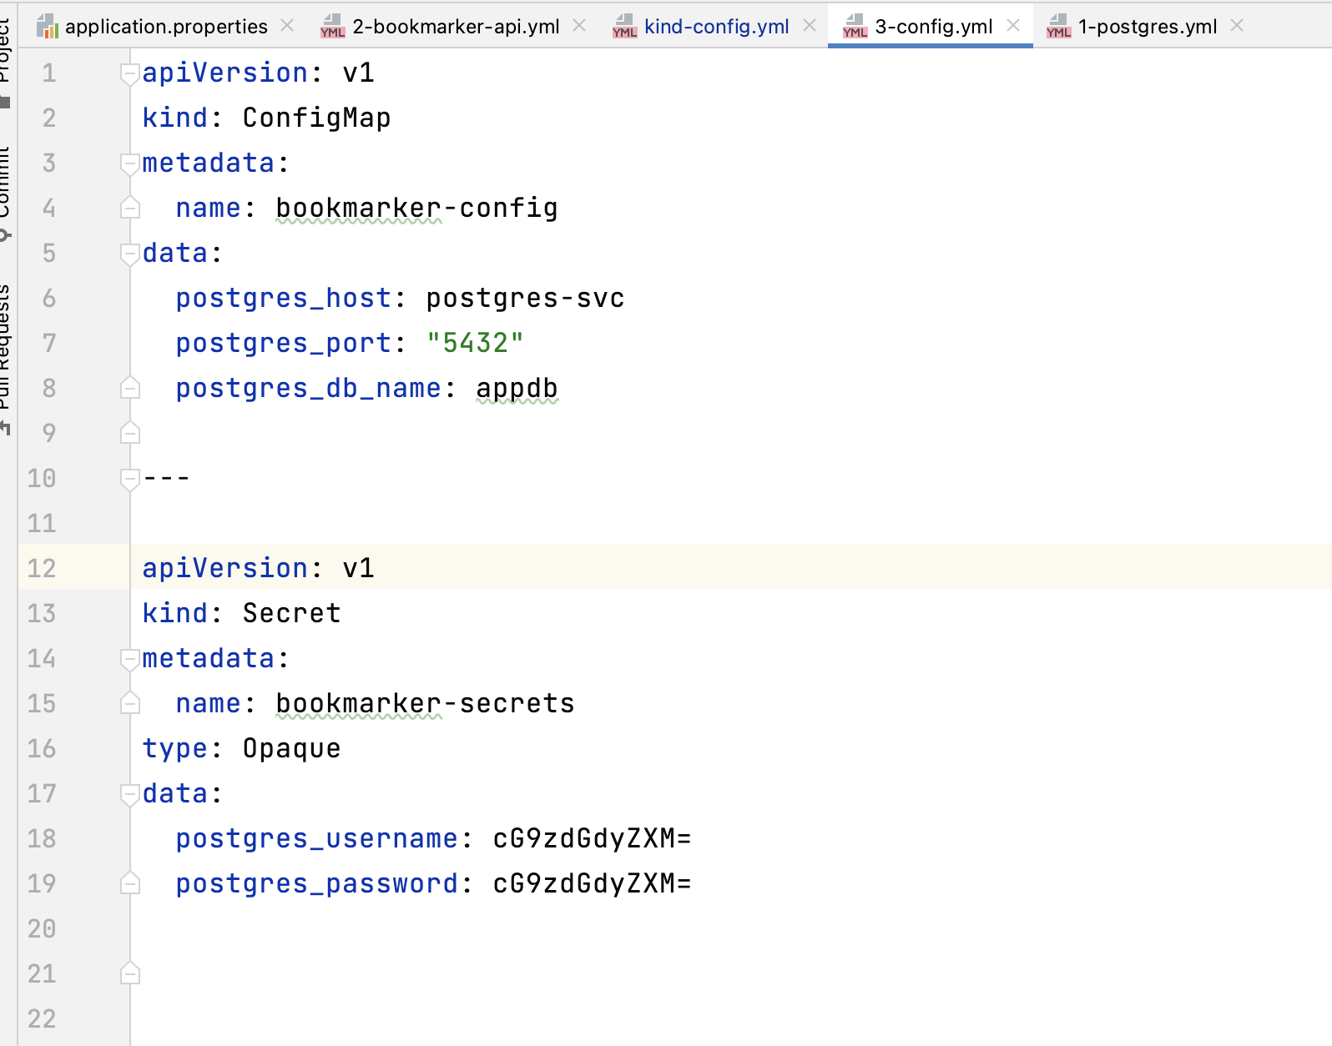

Line no: 6 we changed the **postgres_host** with “postgres-svc” from postgres.

Same approach we will use in our bookmark API to make it service layer:

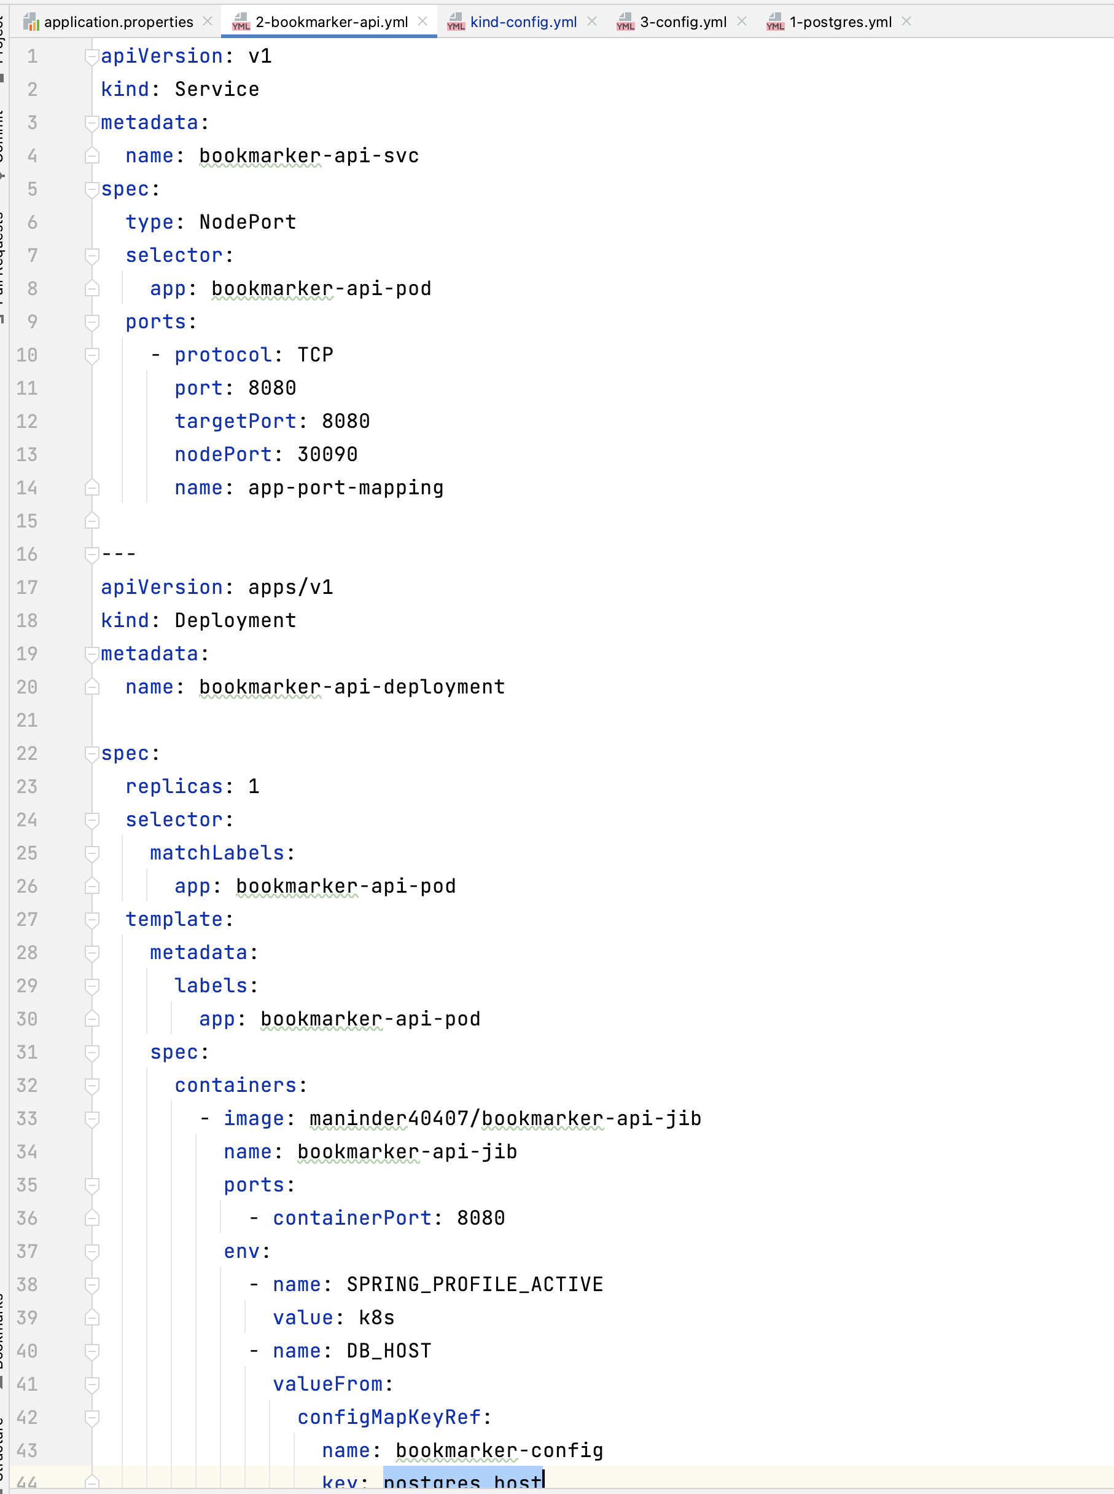

Line 1 to 14 is our service layer and below is our deployment for bookmark application.

Line 8, we mention the label name which we used in our bookmark application on 26 line.

In this service, we use NodePort as service type because we want an IP address which user will use to hit our API.

So, for it, we also provided the nodePort on which our application will work. In our case the port is **30090**.

One thing more we need to do as we are using Kind Kubernetes cluster. This is only specific to the Kind cluster. We need to configure this port in our cluster yml file so that it will be accessible from outside. For doing this, go to kind yml file:

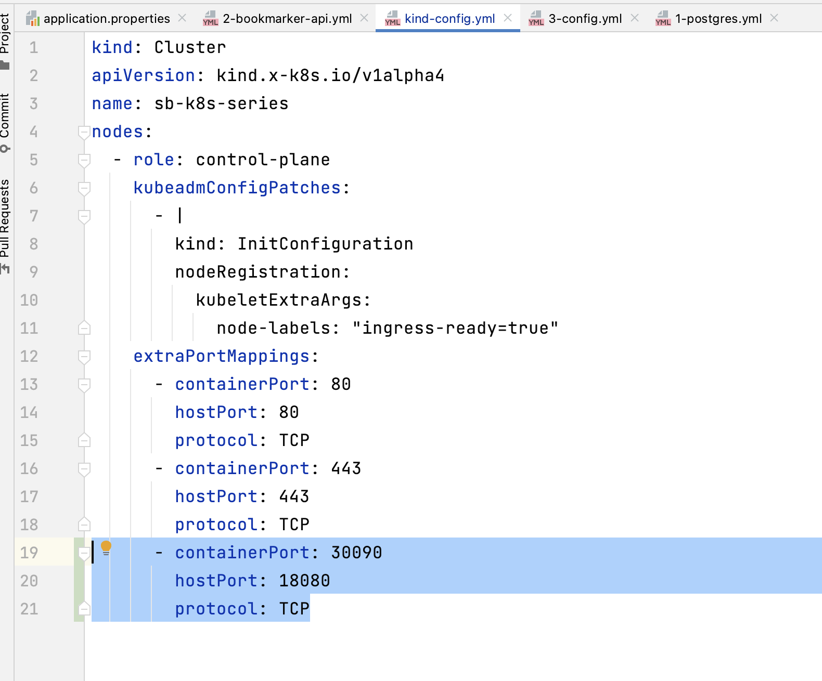

Line no: 19 and 20, we provided the node port and from where it is accessible from localhost. So, it means this port will be accessible from local machine on port 18080.

1. Restart the cluster.
2. **kubectl apply -f .**

you are good to go:

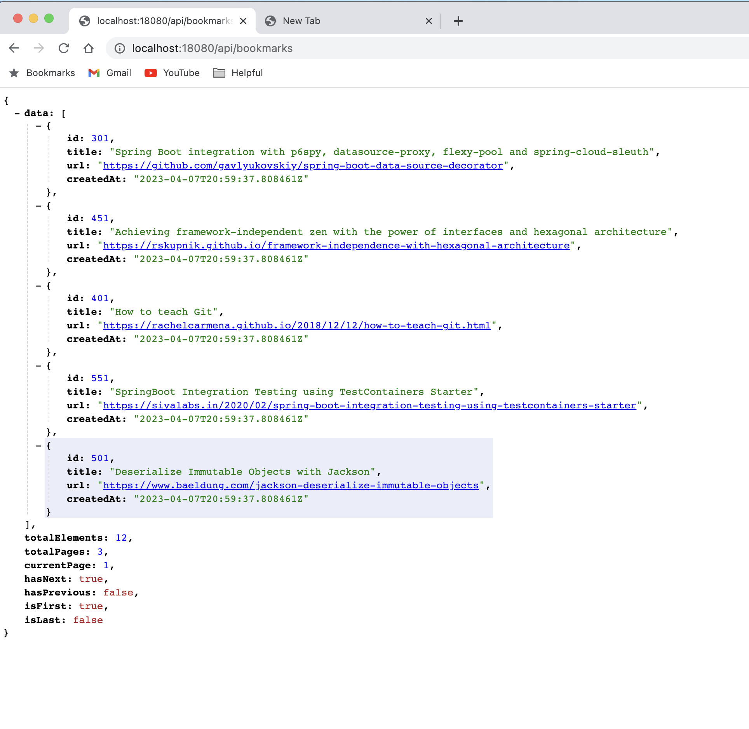

**Ingress:**

It is used to route the request to various services based on path prefixes.

Let’s take an example, we have 2 microservices (product and promotions). How can we expose these 2 APIs?

One way to create the URL like these:

**One approach**:

All our **products** APIs will be come from:

**Api.products.mycompany.com/**

All our **promotion’s** APIs will be come from:

**Api.promotions.mycompany.com/**

**Second approach**:

Api.mycompany.com/**products**/

Api.mycompany.com/**promotions**/

Domain name is common in second approach. We can do filter on the behalf of “/**products**” and “/**promotions**”. So, to do this, we can use ingress.

By default, ingress don’t come with Kubernetes. There is various type of implementation we can follow to achieve ingress. In our case, we are going to use “**NGINX ingress controller**.”

When we configured the kind cluster that time, we also mention to install this:

Line no: 11, we mention it:

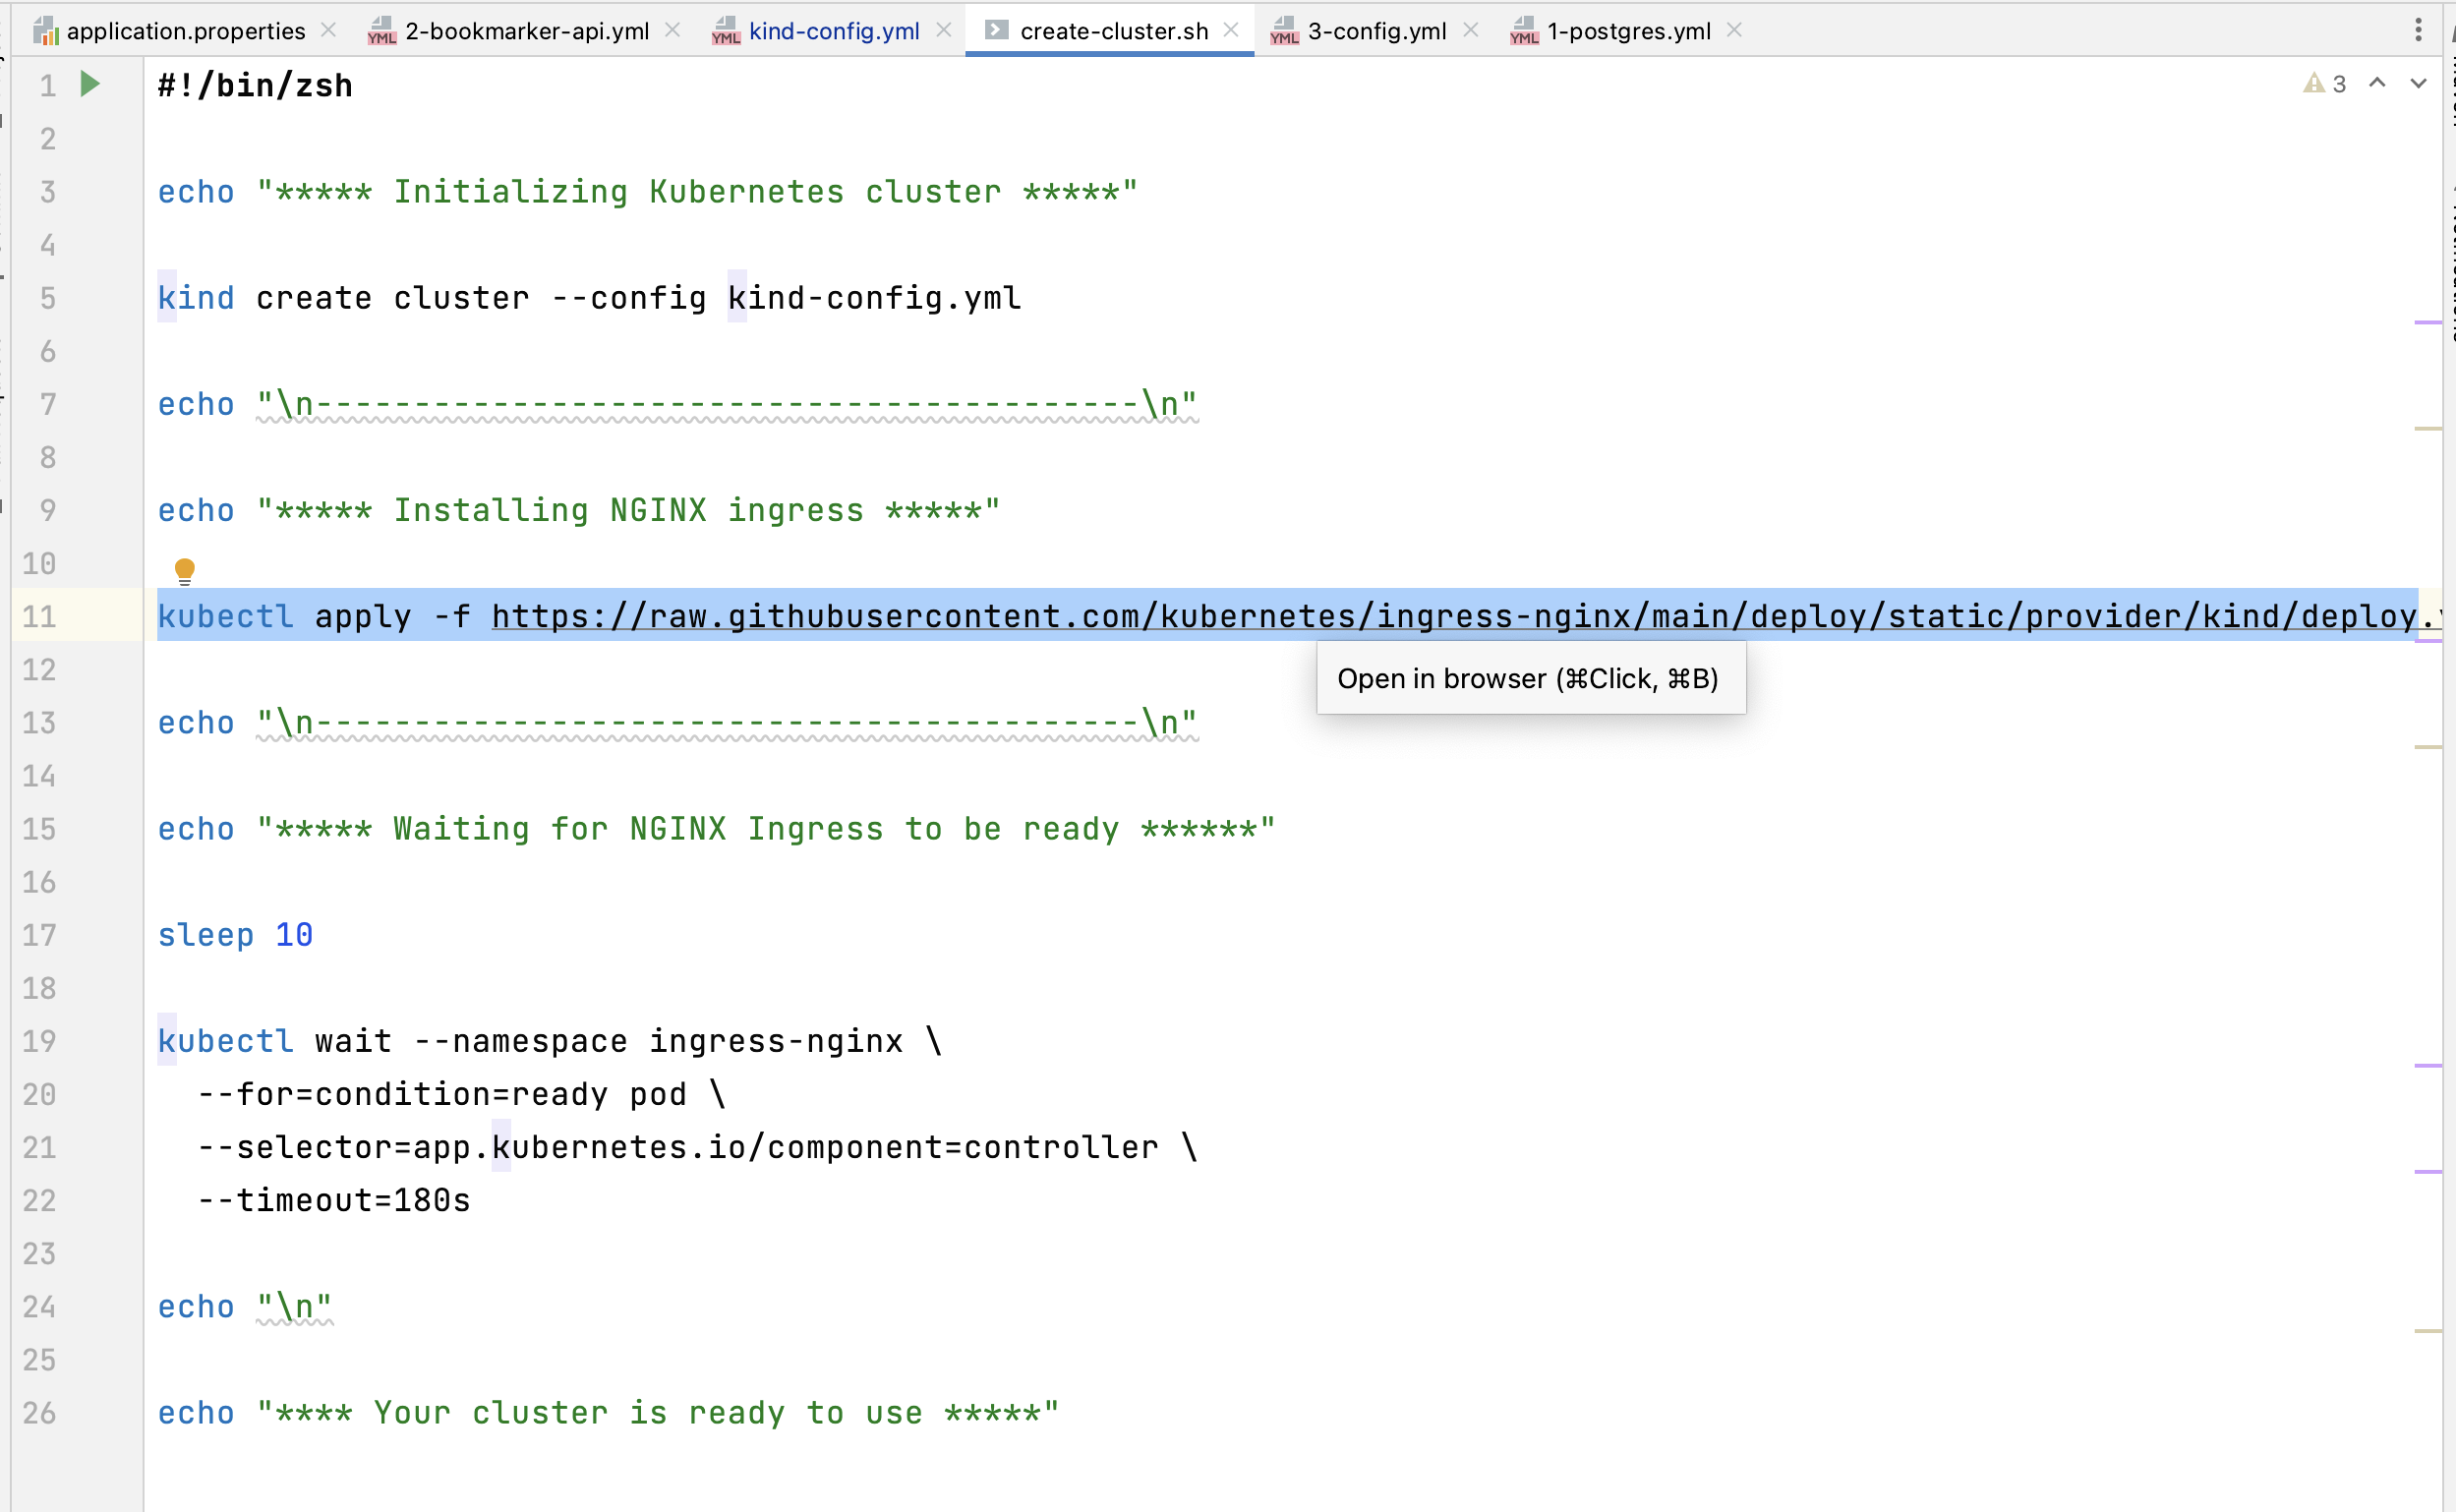

Here is the sample to configure ingress:

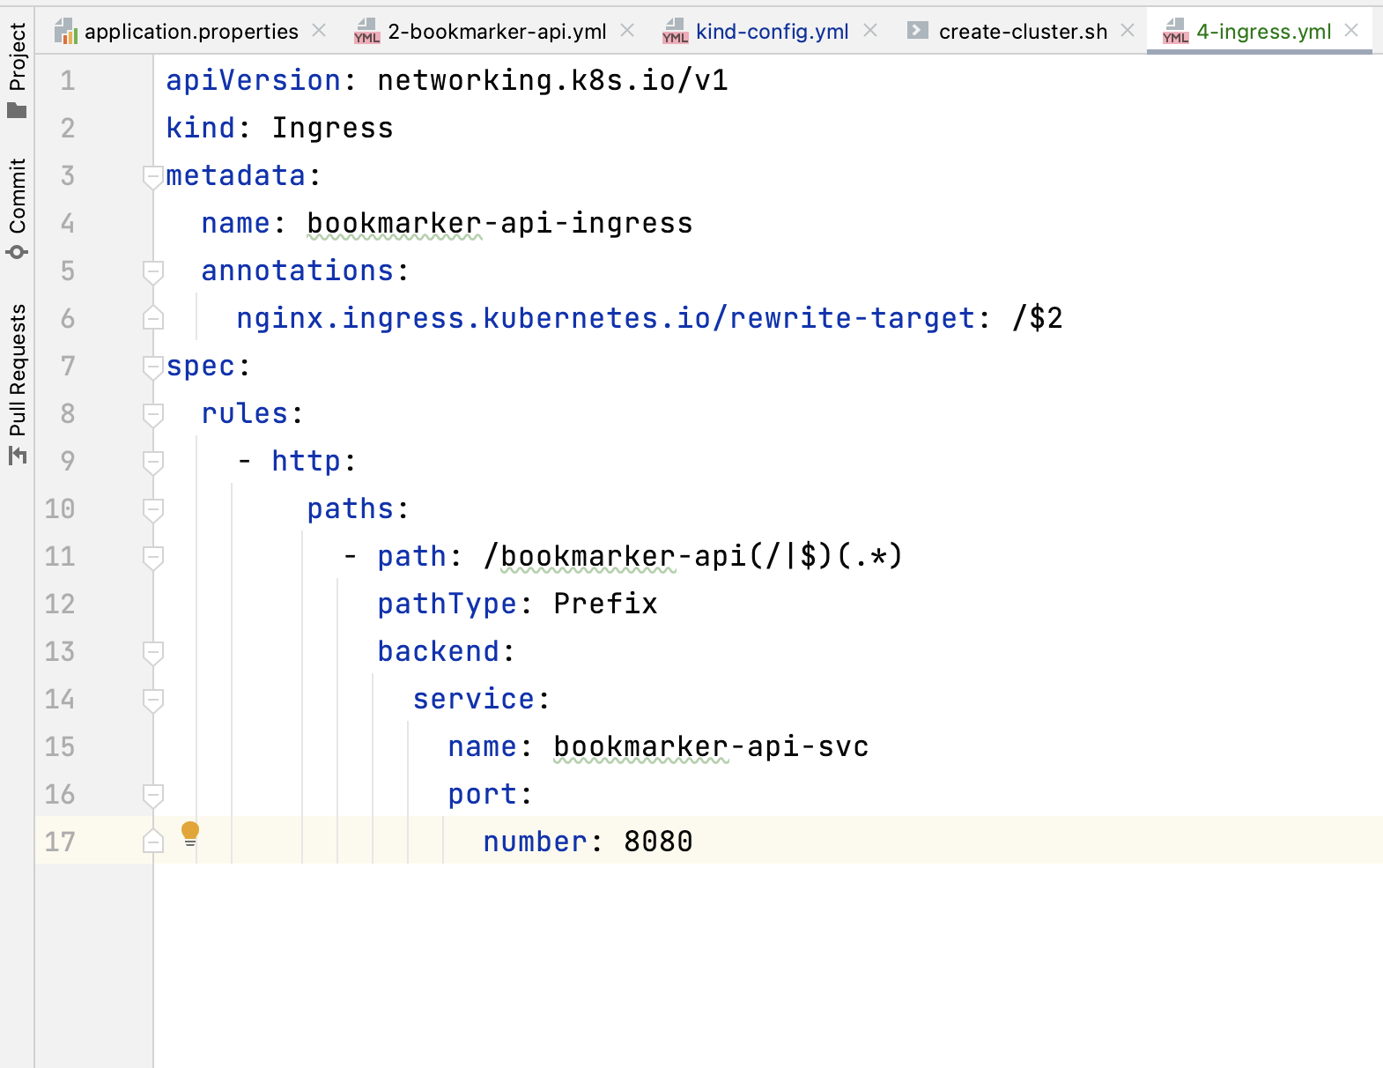

Line 15, we provide the service name of our deployment.

Line 11, we are saying that when this URL hits, then forward this request to the service mention on line-no 15. The $ symbol represents on 11 line value is 2 that we defined on line 6.

Check the URL:

<http://localhost/bookmarker-api/api/bookmarks>

baseURL is: **http://localhost/bookmarker-api**

2 means, after our URL there is: **“/api/bookmarks**” that we need to hit.

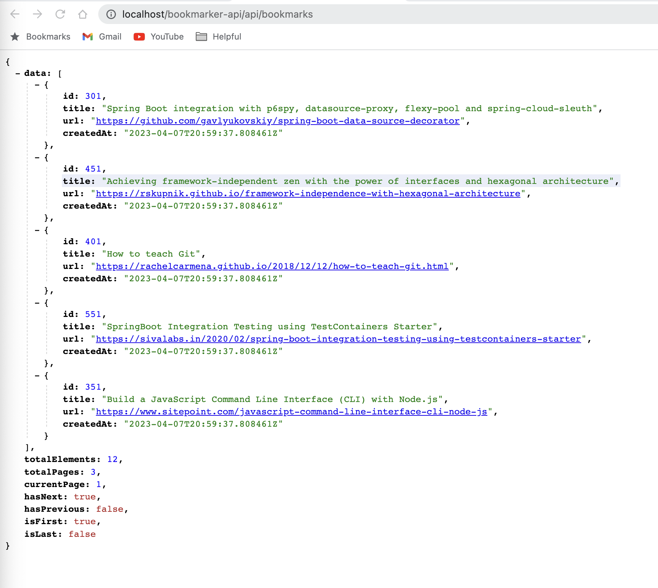

Right now, we are exposing our application on nodePort. When we use ingress then we don’t need to expose our API on node port.

